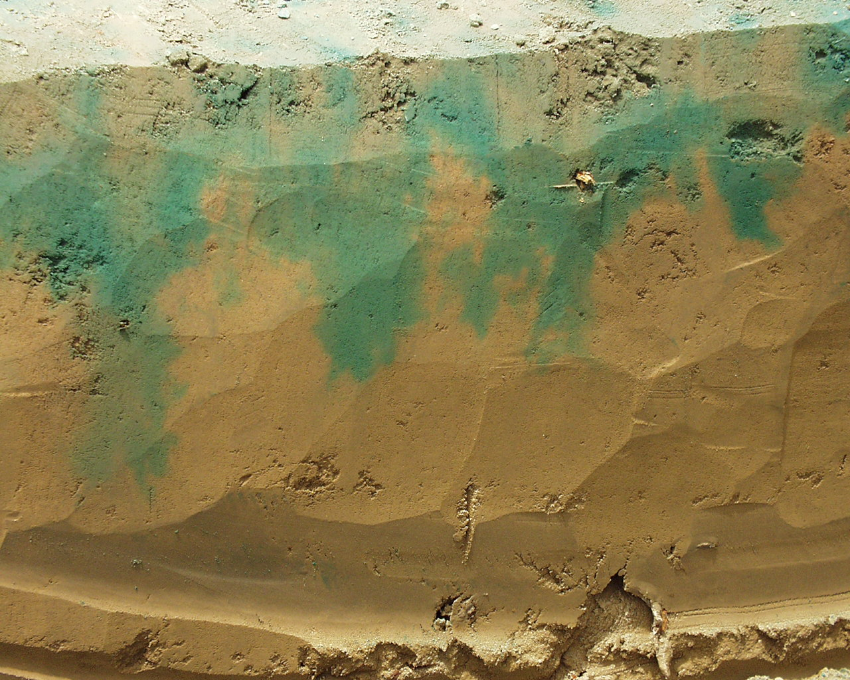

ANNUAL REPORT OF REGIONAL RESEARCH PROJECT W-1188

January 1 to December 31, 2006

1. PROJECT: W-1188 CHARACTERIZING MASS AND ENERGY TRANSPORT AT DIFFERRENT SCALES

2. ACTIVE COOPERATING AGENCIES AND PRINCIPAL LEADERS:
Arizona A.W. Warrick, Department of Soil, Water and Environmental Science, University of Arizona, Tucson, AZ 85721
W. Rasmussen, Department of Soil, Water and Environmental Science, University of Arizona, Tucson, AZ 85721
P. Ferre, Department of Hydrology and Water Resources, University of Arizona, Tucson, AZ 85721
Marcel Schaap, Dept. of Soil, Water and Environmental Science, University of Arizona, Tucson, AZ 85721
California S. A. Bradford, George E. Brown, Jr. Salinity Lab - USDA-ARS, Riverside, CA 92507
T. Harter, Dept. of LAWR, Hydrologic Science, University of California Davis, CA 95616
J.W. Hopmans, Dept. of LAWR, Hydrologic Science, University of California Davis, CA 95616
W.A. Jury, Dept. of Environmental Sciences, University of California, Riverside, CA 92521
D.R. Nielsen, Dept. of LAWR, Hydrologic Science, University of California Davis, CA 95616
P.J. Shouse, George E. Brown, Jr. Salinity Lab - USDA-ARS, Riverside, CA 92507
J. Šimůnek, Dept. of Environmental Sciences, University of California, Riverside, CA 92521
T. Skaggs, George E. Brown, Jr. Salinity Lab - USDA-ARS, Riverside, CA 92507
M.Th. van Genuchten, George E. Brown, Jr. Salinity Lab - USDA-ARS, Riverside, CA 92507
Z. Wang, Department of Earth and Environmental Sciences, California State University, Fresno, CA 93720
L.Wu, Dept. of Environmental Sciences, University of California, Riverside, CA 92521
Colorado L.R. Ahuja, USDA-ARS, Great Plains System Research Unit Fort Collins, CO 80522
T. Green, USDA-ARS, Great Plains System Research Unit Fort Collins, CO 80522
G. Butters, Dept. of Agronomy, Colorado State University, Ft Collins, CO 80523
Delaware Y. Jin, Dept. of Plant and Soil Sciences, Univ. of Delaware, Newark, DE 19716
Idaho Markus Tuller, Dept. of Plant, Soils & Environ. Sci. Univ. of Idaho, Moscow, ID 83844
Illinois T.R. Ellsworth, University of Illinois, Urbana, IL 61801
Indiana J. Cushman, Mathematics Dept., Purdue University, W. Lafayette, IN 47905
P.S.C. Rao, School of Civil Engineering, Purdue University, W. Lafayette, IN 47905
Iowa R. Horton, Dept. of Agronomy, Iowa State University, Ames, IA 50011
D. Jaynes, National Soil Tilth Lab, USDA-ARS, Ames, IA 50011
Kansas G. Kluitenberg, Dept. of Agronomy, Kansas State University, Manhattan, KS 66506
Minnesota J. Nieber, Dept. Biosystems and Agricultural Eng., University of Minnesota,
St. Paul, MN 55108
T. Ochsner, USDA, Agricultural Research Services, St. Paul, MN 55108-6030
Montana J. M. Wraith, Land Resources and Environ. Sciences, Montana State University, Bozeman, MT 59717-3120
Nevada T. Caldwell, Desert Research Institute, University of Nevada, Reno, 89512
S.W. Tyler, Hydrologic Sciences Graduate Program, University of Nevada, Reno, NV 89532
M.H. Young, Desert Research Institute, University of Nevada, Las Vegas, NV 89119
J. Zhu, Desert Research Institute, University of Nevada, Las Vegas, NV 89119
New Mexico J.H.M. Hendrickx, New Mexico Tech, Dept. of Geoscience, Socorro, NM 87801
North Dakota F. Casey, Dept. of Soil Science, North Dakota State University, Fargo, ND 58105-5638
Oregon Maria Dragila, Oregon State University, Dept. of Crop and Soil Science, 3017 Agriculture and Life Aciences, Corvallis, Oregon 97331-7306
Tennessee J. Lee, Biosys Engin & Envir Sci., University of Tennessee, Knoxville, TN 37996
E. Perfect, Dept. of Geo. Sciences, Univ. Tennessee Knoxville, TN 37996-1410
Texas S.R. Evett, USDA-ARS-CPRL, P.O. Drawer 10, Bushland, TX 79012
R.C. Schwartz, USDA-ARS-CPRL, P.O. Drawer 10, Bushland, TX 79012
Utah S. Jones, Dept. of Plants, Soils & Biomet., Utah State University, Logan, UT 84322
Washington M. Flury, Dept. of Crop & Soil Sciences, Washington State University, Pullman, WA 99164
J. Wu, Dept. of Biological System Engineering, Washington State University, Pullman, WA 99164
P. D. Meyer, Battelle Pacific Northwest Division, Portland, OR 97204
M. Oostrom, Battelle Pacific Northwest Division, Richland, WA 99352
M. L. Rockhold, Battelle Pacific Northwest Division Richland, WA 99352
A. L Ward, Battelle Pacific Northwest Division, Richland, WA 99352
Z. F. Zhang, Battelle Pacific Northwest Division, Richland WA 99352
Wyoming Thijs Kelleners, Dept. of Renewable Resources, University of Wyoming, Laramie, WY 82071
CSREES R. Knighton, USDA-CSREES, Washington, DC 20250-2200
Adm. Adv. Jeff Jacobsen, Dean and Director, 202 Linfield Hall, P.O. Box 172860, College of Agriculture, Montana State University, Bozeman, MT 59717-2860
3. PROGRESS OF WORK AND ACCOMPLISHMENTS

OBJECTIVE 1: To develop and improved understanding of the fundamental soil physical properties and processes governing mass and energy transport, and the biogeochemical interactions these mediate.

California State University Fresno

Collaborators: Zhi Wang

Theoretical Re-analysis of Unstable Flow in the Upward and Horizontal Directions and the Effect of Soil Water Repellency:
We have continued our studies on unstable flow in porous media. In an early paper by Wang et al., (1998), theoretical derivations of fluid displacement involving immiscible oil, water and air/gas in a porous medium by Chuoke et al. (1959) were generalized. Twenty-four specific criteria for the onset of unstable flow were developed. The downward water flow displacing air in the vadose zone was predicted to be unstable (producing fingers) when the infiltration rate I is < V_{grav} -V_{cap}, where V_{grav} is fluid velocity driven by gravity (V_{grav} = K_{s}|cosβ|), β is the angle between the direction of flow and the direction of gravity, V_{cap} is fluid velocity driven by the capillary forces [V_{cap} = (0.00015 ~ 5.7)K_{s}, the coefficient value varies with soil texture ranging from coarse sand to silt clay]. The upward flow was predicted to be unstable when the flow is too fast or if I is > V_{grav}+V_{cap}. The horizontal flow was predicted to be unstable if I is > V_{cap}.
Our reexamination of the complex derivations and parameter definitions by Chuoke et al. (1959) led to a new set of 24 criteria (Javaux et al., 2005). For the upward and horizontal flow of water displacing air in soils, the new criteria predicted unconditional stable flow (unstable only if infiltration rate is negative), consistent with Philip’s prediction. Further more, we realized that the occurrence of unstable flow is only related to two factors: (i) the position of the heavier fluid in the system (either above or blow the lighter fluid), and (ii) the relative viscosity of the driving fluid (either more or less viscous than the displaced fluid), see the specific criteria in Table 1. Soil water repellency was not a factor influencing the instability criteria. Tests are still needed to verify some of the new criteria. In addition, a review paper on finger flow studies was published in a Chinese journal SOIL (Li et al., 2006). This will promote awareness of theoretical and experimental studies in China. Further studies are being proposed.

Table 1. Conditions for occurrence of unstable flow, derived from Javaux et al. (2005)
Viscosity  contrast | Relative position of the fluids |  | C  horizontal/capillary
Viscosity  contrast | A  Heavy over light | B  Light over heavy | C  horizontal/capillary
1. μ_{driving}>μ_{displaced} | |V|<V_{crit}-V_{cap} | |V|< -V_{crit}-V_{cap}  stable | |V|< -V_{cap}  stable
2. μ_{driving}<μ_{displaced} | |V|>-V_{crit}+V_{cap}  likely unstable | |V|> V_{crit}+V_{cap} | |V|> V_{cap}
Impact: Our results have revealed important processes that may help identify unstable displacement during water/oil flow and contaminant transport in the vadose zone and variably saturated aquifers.
Iowa State University and USDA-ARS National Soil Tilth Laboratory

Collaborators: Toby Ewing, Dan Jaynes, and Bob Horton

Predicting Thermal Conductivity at Low Water Contents:
Soil thermal conductivity λ increases with increasing water content θ, with three rather distinct phases. The addition of a small amount of water to completely dry soil often gives no discernible increase in λ. Subsequent addition of water gives a sharp increase in λ up to some medium water content, after which further addition yields only slight increases in λ. The mechanisms behind this behavior have not been explored. The following is a correction to and extension of our findings from last year.
Accomplishments. We hypothesized that the initial “ineffective” water simply satisfies the soil’s surface sorption demand. Adding further small quantities of water to a dry granular soil increases λ by increasing the effective cross-sectional contact area between neighboring grains. Because λ_{water} is much greater than λ_{air}, and water naturally forms pendular rings (capillary bridges) between grains at low water content (Fig. 1), small amounts of water increase λ_{soil} far more than the increase in water fraction might suggest. However, once the effective contact area is no longer the main bottleneck to heat flow, further additions of water increase λ_{soil} simply by replacing low-λ air with higher-λ water.

Figure 1. Two solid spheres in point contact, with a pendular ring of water increasing the cross-sectional area through which heat flows.

Outcome. The soil’s thermal conductivity at low water content, assuming point contact, is given by λ(θ) = λ_{solid} θ ^{b}, where the exponent’s value varies according to the relative conductivities of air, water, and solid. If we allow the spheres to be compressed and deformed, for a given set of values for λ_{solid}, λ_{water}, and λ_{air}, a more general expression is
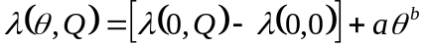
where Q is the ratio of the radii of the contact area and the curved portion of the solid, λ(0,0) is the dry, non-compressed soil thermal conductivity, and λ(0,Q) is the dry, compressed soil’s thermal conductivity. In other words, when the compressing is accounted for, all λ(θ,Q) lines have the same slope in log space. Again, the exponent’s value varies according to the relative conductivity of the components.

The FEM program gave incorrect values when the contrast between component thermal conductivities was too great, but the values can be corrected if λ(0,0) is known (Fig. 2). At volumetric water contents above about 9% (for point contacts; lower for compressed spheres), the capillary bridges coalesce and the pore body fills with water. Soils, having a wide range of pore sizes, do not show this discontinuity. However, the method can be adapted to soils by assuming hydraulic equilibrium. At equilibrium the meniscus curvature is constant throughout the soil, allowing calculation of the degree of saturation for each particle size “bin”. Thermal conductivities of the individual bins can then be used to calculate the whole soil conductivity via composite theory. In essence, this approach implies that the spatial arrangement of solid, water, and air is important to thermal conductivity at the scale of the individual grain, but larger-scale soil structure is not important.
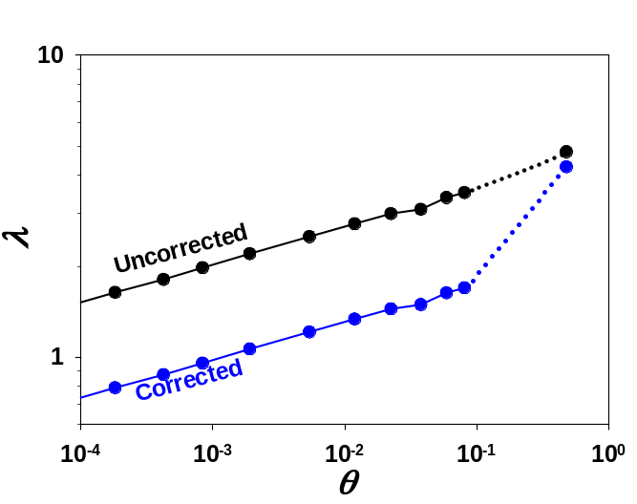

Figure 2. Thermal conductivity as a function of water content for a “soil” made of cubic-packed single-sized spheres. The correction is required because of the high conductivity contrast (λ_{solid} = 20 λ_{water}). The discontinuity occurs when menisci coalesce and the pores saturate.

Impact. The predictions of this method contrast with predictions of widely used methods (e.g., de Vries), wherein no sharp increase in thermal conductivity is seen at low water contents. The method both clears a long-standing puzzle about thermal conductivities, and provides groundwork for a more robust, physically-based theory of thermal conductivity.

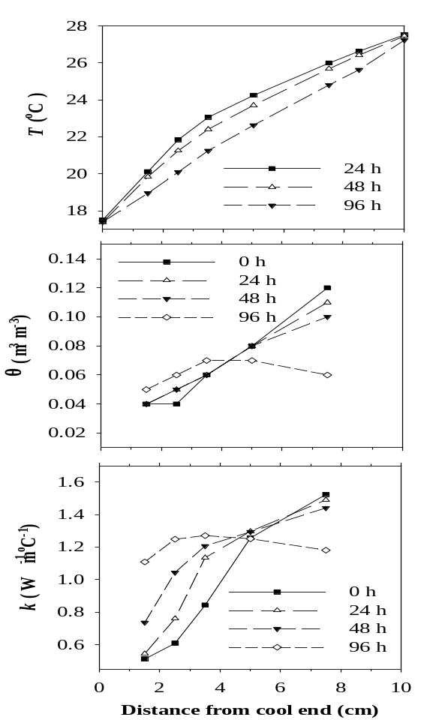
Characteristic Curves of Two Wettable Soils and Matched Hydrophobized counterparts:
λ (W m⁻¹ ºC)
Fig. 3. Measurement of transient temperature (top), water content (middle), and thermal conductivity (bottom) following reversal of the imposed temperature gradient at 0 h.
Accomplishments. A study was performed to examine the dry end of the soil water retention curve where surface adsorption is the critical component in determining the amount of water retained. Two naturally hydrophilic soils were used. Two additional soils were studied by hydrophobizing the two naturally hydrophilic soils with dichloromethylsilane. Two methods were used to measure wetting and drying curves of the soils. The vapor equilibration method was applied to soil samples contained in air space above salt (NaCl) solutions to achieve equilibrium at selected osmotic potentials. Soil samples were allowed to equilibrate starting with relatively dry (wetting curves) or wet (drying curves) conditions. The second method is known as the controlled water content method. Water was either added to soil samples to achieve known water content (wetting curves), or initially saturated soil samples were dried by evaporation to obtain the desired water content (drying curves). The equilibrium water potentials associated with the different soil water contents were measured with a Decagon WP4 DewPoint Potentiometer. Outcome. Overall, soil water hysteresis was not observed. We hypothesize that a decrease in osmotic potential occurred during the hydrophobizing process due to mineral dissolution. Water droplets were visible on the surface of the hydrophobic soil samples indicating not only their hydrophobicity but also the impact of solute. Solute concentration differences prevent adequate comparison of the water curves. Impact. Further research is needed to separate the osmotic effects and wettability effects on the water retention for the hydrophobic soils.

Measuring Coupled Heat and Water Transfer in Soil:
Accomplishments. We (Iowa and Minnesota) studied unsaturated coupled heat and water transfer in 2 soils each with 2 wettabilities, 2 water contents, 3 mean temperatures, and 3 constant imposed temperature gradients. Thermo-TDR sensors (combined heat-pulse and TDR) were installed within closed soil cells for observing transient temperature, thermal properties, and moisture conditions throughout the experiments. Boundary temperature gradients were applied using programmable water baths and heat-exchangers. The nondestructive techniques used in these experiments allowed for transient measurements of moisture and temperature for a given volume of soil under a variety of conditions. Outcome. Consistency was observed between temperature, thermal conductivity, and water content distributions, highlighting the coupling of heat and water transfer. The thermo-TDR probes successfully measured transient distributions during periods of rapid heat and moisture redistribution (Fig. 3). Analysis is on-going for measurements of the hydrophobic soils. Impact. The results provide a comprehensive data set suitable for testing existing and developing new coupled heat and water flow models.

Montana State University
Collaborators: Jon M. Wraith and Paolo Castiglione

Field Gas Transport Processes:
A fundamental understanding of the gas transport processes in soils, and their coupling to the atmosphere, is crucial for assessing the aeration properties of soil profiles, and for investigation of sequestration/release phenomena important to greenhouse gases. Soil gas transport properties are chiefly determined by the effective diffusion coefficient (D_{s}). Many models exist relating D_{s} to physical and environmental soil properties, such as the soil volumetric water content, texture, and structure. However, these models may not be applicable in field conditions, due to the heterogeneity of soil profiles, or to other conditions such as the seasonal presence of a snow cover. Outcome: Montana is engaged in a comprehensive field project to investigate the evolution and emission of greenhouse gases in a forested mountain watershed environment. The first part of the project seeks to evaluate different methods for measuring and/or monitoring the gaseous diffusion coefficients for soils and associated snow cover in the field, and the resulting gas efflux to the atmosphere. Characteristics of both soil and snow which affect their diffusional gas transport properties change in space and with time, including the temperature and wetness which also impact microbial activities critical to production and consumption. Impact: Most current measurement and estimation methods for gas transport and emission from soils are based on assumed uniform soils having uniform moisture distribution, and with negligible concurrent production or adsorption of gas. We are analyzing the effective gas transport properties of field soil and snow cover profiles using conventional in situ and laboratory measurement approaches. We are also investigating the potential impacts of non-uniform soil conditions and concurrent biotic activity through numerical simulation of gas evolution and transport processes. For the latter we utilize field and laboratory measurements as well as the Hydrus 1-D code to simulate transport phenomena under different field scenarios. The results will inform our knowledge concerning the seasonal evolution of greenhouse gases, the potential limitations of conventional measurement and simulation methods, and may partly explain the divergence often observed between efflux values measured at the soil surface and those estimated based on gas concentration profiles.

North Dakota State University

Collaborator: Frank Casey

Estimating Solute Transport Parameters using Stochastic Ranking Evolutionary Strategy:
It is a significant challenge to identify unique fate and transport parameters for solutes that undergo complex processes. Evolutionary optimization techniques allow unique process parameters to be identified for complicated problems. One evolutionary optimization technique, the stochastic ranking evolutionary strategy (SRES), was used in this study to find the global or near global optimal parameters for two solute breakthrough curve experiments. The uncertainties of the estimated parameters were assessed using a nonparametric bootstrap resample method. The two miscible-displacement cases considered were 1) a simulated experiment of a solute undergoing transformation, and 2) an actual experiment of trichloroethylene undergoing chemical non-equilibrium transport and transformation. In both cases, multiple breakthrough curves were produced from the parent and metabolite solutes, and the SRES was used with an appropriate convective-dispersive model to inversely identify model parameters. The SRES inverse method provided an excellent model fit to the experimental data, and the model parameter estimates had minimal uncertainty (Fan and Casey, 2006).

Field and Laboratory Studies on the Fate and Transport of Manure-Borne Hormones:
Man-made and natural sources of steroidal hormones are consistently detected in the environment. Persistent hormone concentrations as low as the part per billion level can disrupt the endocrine systems of aquatic organisms. The goal of this study was to examine the persistence and fate of 17β-estradiol and testosterone, the two primary natural sex hormones. Incubation microcosm experiments were conducted under aerobic and anaerobic conditions using [4-¹⁴C]-radiolabeled 17β-estradiol and testosterone. The results indicated that 6% of 17β-estradiol and 63% of testosterone could be mineralized to ¹⁴CO₂ in native soils under aerobic conditions. In native soils under anaerobic conditions, 2% of testosterone and no 17β-estradiol was methanogenized to ¹⁴CH₄. Essentially, no mineralization of either testosterone or 17β-estradiol to ¹⁴CO₂ occurred in autoclaved soils under aerobic or anaerobic condition. Results also indicated that 17β-estradiol could be transformed to an unidentified polar compound through abiotic chemical processes; however, 17β-estradiol was only oxidized to estrone via biological processes. The TLC results also indicated that testosterone was degraded, not by physical-chemical processes but by biological processes. Results also indicated that the assumed risks of estrogenic hormones in the environment might be over-estimated due to the soil’s humic substances, which can immobilize majority of estrogenic hormones, and thereby reduce their bioavailability and toxicity (Fan et al., 2006b).
In another study on the fate and transport of hormones, the objective was to achieve a better understanding of the complex fate and transport of testosterone in undisturbed agricultural soil. This was done using batch and miscible-displacement experiments, and a comprehensive model. Degradation and transformation processes of testosterone were discerned using various batch experiments. Multiple first-order models were used to successfully describe batch experiments where simultaneous degradation and sorption processes occurred. An evolutionary global optimization strategy was used to estimate the process parameters from these batch experiments and provided high confidence in these parameter estimates. The independently determined batch parameters were then incorporated into a solute transport model and used to describe an undisturbed soil column experiment. The final modeling result was a unique identification of individual biological (e.g., degradation) and physical (e.g., sorption and transport) processes that simultaneous combined in the complex fate and transport of testosterone in soil. The estimated parameters and process model from this study were then used to simulate transport of testosterone under field conditions and provided a reasonable prediction of actual field concentrations (Casey et al., 2006b; Fan et al., 2006c).

Fate and Transport of Dioxins in Soil-Water Systems:
The most toxic dioxin is 2, 3, 7, 8-tetrachlorodibenzo-p-dioxin (2378-TCDD), and obtaining comprehensive experimental data is challenging. However, several nontoxic isomers of 2378-TCDD exist, and can provide significant experimental evidence about this highly toxic dioxin, 2378-TCDD. The goal of this study was to obtain experimental evidence for the fate and transport of 2378-TCDD in natural soils using its nontoxic isomers, 1, 2, 7, 8-tetrachlorodibenzo-p-dioxin (1278-TCDD), 1, 3, 7, 8-tetrachlorodibenzo-p-dioxin (1378-TCDD), and 1, 4, 7, 8-tetrachlorodibenzo-p-dioxin (1478-TCDD). Batch sorption and miscible-displacement experiments, in various soils, were done using [¹⁴C]-radiolabeled TCDDs, while metabolism of these compounds was monitored. The results from the batch experiments indicated a high adsorption affinity of all the TCDD isomers to soils and a strong correlation to organic matter (OM) content. 1278-TCDD, 1378-TCDD and 1478-TCDD (TCDDs) were more tightly bound to the soil with high OM than to the soil with low OM; however, it took a longer contact time to approach sorption equilibrium of TCDDs in the soil with high OM. Miscible-displacement breakthrough curves indicated chemical nonequilibrium transport, where there was a rate-limited or kinetic sorption likely caused by OM. Combustion analyses of extracted soil from the soil columns showed that most TCDDs were adsorbed in the top 1–5 cm of the column. These column combustion results also showed that adsorption was correlated to specific surface and soil depth, which suggests possible colloidal transport (Fan et al., 2006a).

Transport Through Clay Liners:
An explicit determination of concentration correlations and auxiliary parameters for solutions may be paramount in assessing the geometry of concentration polarization layer (CPL) during dead-end hyperfiltration and transport of ions through low permeability clays. Different models have been proposed for hindered transient transport of water and ions. Most of these models depend on solute permeability, solute diffusivity, and reflection coefficient of the membrane. Some models can predict various parameters for simple ionic molecules well but few of these can be immediately extended to organo macromolecules without special modifications. A model that estimates effluent concentrations for simple molecules and macromolecules like ionic azo dyes prior to the gelation period on homoionic membranes is proposed. The proposed model depends on evolution of the CPL of whose evolution can also be estimated from Karman–Pohlhausen and film model methods. Sensitivity analyses indicated relative dependence of this model on the diffusion coefficient (Oduor et al., 2006a; Oduor et al., 2006b).
Project Outputs to Stakeholders:
- Three manuscripts published in Chemosphere, Science of the Total Environment, and Journal of Membrane Science.
- Two manuscripts in review in at the Journal of Environmental Quality and Water Resources Research.
- Two abstracts and corresponding presentations at the ASA-SSSA-CSSA annual meetings and the Geological Society of America annual meetings.
Project Outcomes to Stakeholders:
- Improved parameter identification will improve the understanding and prediction of fate and transport processes.
- This information will improve the knowledge of the fate and transport of these and other similar labile compounds.
- This information improves the understanding for the potential of contamination of surface and subsurface water by these chemicals.
Knowledge of the sorption, fate, and mobility of hormones and dioxins can help to develop strategies to improve treatment (e.g., composting) or remediation of soils and water.

Oregon State University
Collaborator: Maria Inés Dragila
This project is part of a larger effort focused on elucidating the mechanisms that govern the movement of liquid and solutes when cracks are present in a soil profile. The 5-year project is studying the mechanism of: (1) convective thermal venting of soil cracks and open fractures; and (2) the effect this thermal venting has on enhanced evaporation from the vadose zone and on precipitation of salts along the walls of soil cracks and fracture. The project is comprised of four distinct activities:
(A) Theoretical approaches will be used to delineate the minimal conditions under which open (air-filled) cracks will vent convectively, and quantify the matrix conditions under which convective venting will drive redistribution of solutes within the matrix and precipitation of solutes onto the surface of crack/fracture walls.
(B) Numerical work will be used investigate four important questions assuming convective venting exists: (1) What is the expected evaporative flux rate from a fractured matrix as a function of matrix properties and climatic conditions? (2) How much salt is expected to be deposited on fracture walls as a function of time, for different matrix properties and climatic conditions? (3) What is the impact of this salt mechanism on salt dynamics at the basin scale? and (4) What is the potential impact on salinization of a phreatic aquifer by the presence of precipitated salt on fracture walls?
(C) Field work to test the validity of the theoretical construct, specifically answer the question, is convective venting observed in the nature? It will quantitatively determine the time-of-day and climatic conditions that trigger convective venting. It will be used to map a convection cell to determine whether the convective pattern is a plane-circular cell or siphon-style (convective patterns control the flux venting efficiency).
(D) Laboratory work will quantify very accurately the net amount of deposited salt, the decrease in evaporation rate and salt deposition rate as the salt crust thickens, and the change in permeability as salt is deposited. Because of the highly controlled nature of laboratory work, it will be used to test the theoretical constructs and also to refine the numerical models.
Background: Soil cracks can significantly enhance the amount of evaporation from agricultural soils. This understanding evolved from an extensive series of field and laboratory experiments in the 1970’s (e.g., Ritchie and Adams, 1974). However, at the time, and since then, no mechanisms were suggested for the observed enhanced evaporative flux, limiting our ability to predict flux quantities beyond the specific field conditions tested. As part of this project, we proposed a mechanism for enhanced evaporation consisting of thermally driven convective venting of the fractures occurring at night when soil at depth is warmer than near-surface soil. Convective venting leads to evaporative fluxes that can be far greater than those driven by diffusive venting. Recent work has demonstrated that this enhanced evaporative flux, caused by the presence of cracks, may be responsible for the formation of salt crusts along fracture walls in semi-arid areas (Weisbrod and Dragila, 2006). During precipitation events, these salts may dissolve and move further down the soil profile, affecting soil chemical development, and providing a concentrated saline plume that may migrate to the water table. Being able to quantify the salt redistribution will permit more accurate quantification of evaporative fluxes, infiltration rates, and solute transport rates important for field-scale water balance and contaminant migration calculations.

Project work: During 2004, we investigated the theoretical constraints of the mechanism and tested the concept of nighttime venting. (Dragila, 2005a, 2005b; Weisbrod and Dragila, 2006). During 2005, we began development of a numerical model to investigate the redistribution of solutes within the matrix caused by evaporation and convective venting and the proportion of downward salt flux expected for different matrix permeabilities. (Dragila 2006a, 2006b)

Progress in 2006: Project efforts in 2006 focused on field work. A fracture was selected and instrumented with RH and temperature probes. One line of RH and T probes had been installed in 2005 at 40 cm intervals to a depth of 120 cm. In 2006, a second set of thermistor probes was installed to create 60 cm x 60 cm map of the convection cells. A section of fracture wall was instrumented with a grid of temperature probes at 15 cm x 15 cm spacing (Fig 1). Data was collected from these probes every 10 minutes for the last four months of 2006 and continues to be collected. Data clearly showed the development of plane-circular cells, the timing during which the cells were active, the wavelength of convection, and the stability of the cells (Fig 2). Portions of the fracture opening were obstructed to study the effect of partial fracture opening on venting dynamics. This data is still being analyzed. The results of the study will be published in a manuscript under preparation. In summary the following results were obtained from the work in 2006:
- The existence of convective venting was verified to occur in natural fractures, and was observed to occur every day over a 4 month period.
- For the specific fracture studied, convection cell morphology is plane-circular
- Convection cell wavelength of ~50 cm. Convection cell wavelength can be used to calculate fracture air venting fluxes. These calculations are in progress.
- Timing of convection cell formation coincides well with what was calculated theoretically; convection is not seen during the day when the thermal gradient is stable (Fig. 2a); convection starts at dusk and ceases near dawn (Fig. 2b); and convection is associate with the difference in air density between atmosphere air and fracture air.
- There are dramatic differences between summer and winter in the intensity and duration of convective venting. Winter convection may be stronger and persist during the day (i.e. not limited to nighttime conditions).

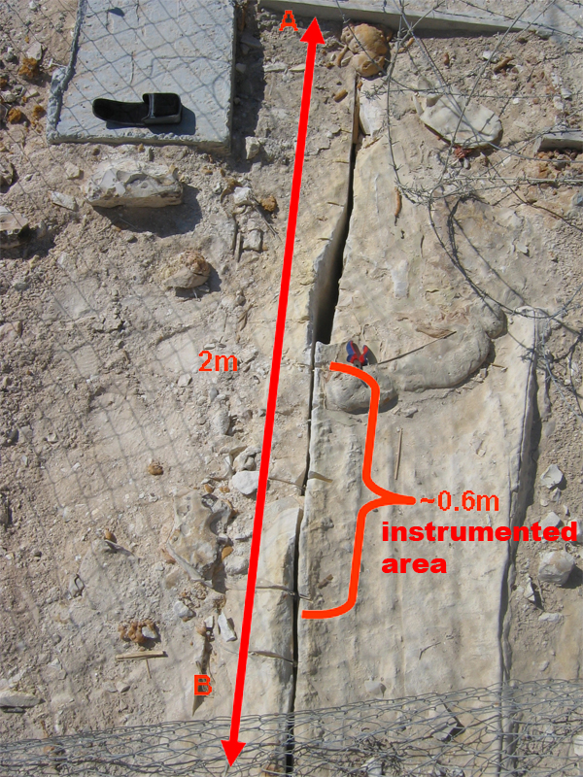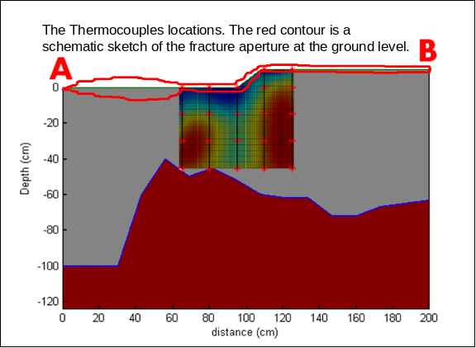
Figure 1a Figure 1b

Figure 1a. Aerial photograph of fracture selected for the study. Fracture location is in the Negev desert in a chalk unit. Distance between A and B is 2 meters. Red bracket shows location where the thermal probes were placed to make the thermal map of convection cells.
Figure 1b. Schematic of the plane of the fracture wall showing topographic relief of the matrix-atmosphere interface, the region where fracture was open (gray area), the region where the fracture aperture was too small to detect with our rod probe (brown colored section), and the aperture of the fracture trace at the surface (red lines). Sketch also shows a representative thermal map to aid the reader in visualizing the spatial association for the data shown in Figure 2.

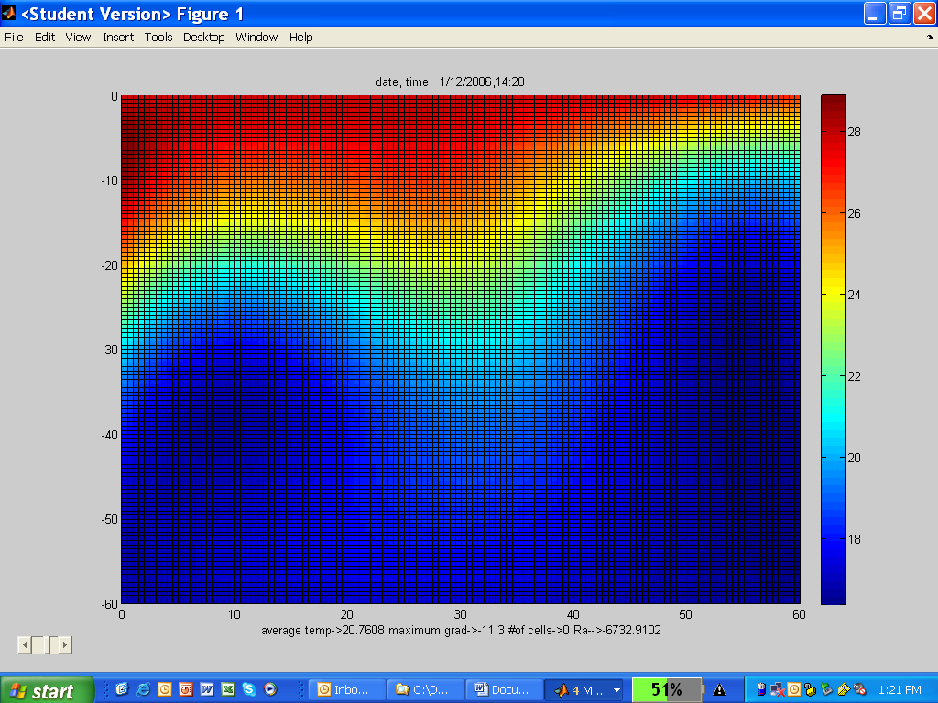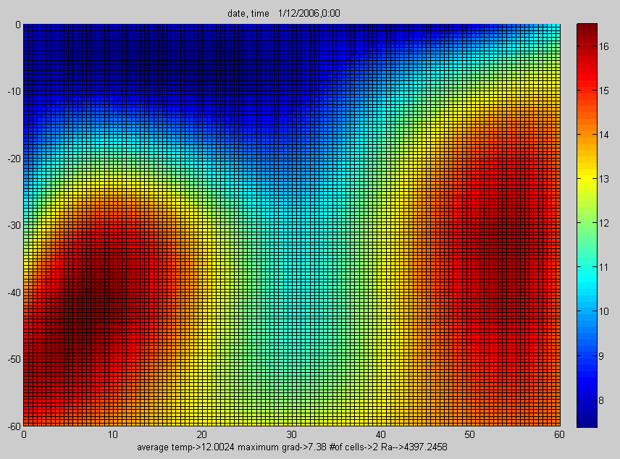
Figure 2a. Figure 2b

Figure 2a. Thermal map of air within the fracture at 2:40 pm. No convection seen during the day. (red is hotter, blue is cooler). Vertical axis shows soil surface at the top and 6 cm depth at the bottom. As expected air within the fracture is warmer near the surface and cooler further down, reflecting soil temperature gradient with depth. No
Figure 2b. Thermal map of fracture air at midnight. Two convection cells are clearly seen with a cool plume moving down the center of the data frame.
Concluding Remarks
An important result from the 2006 work is that the field data shows the functionality of this mechanism under natural conditions. While the behavior can be observed in the laboratory under ideal conditions, characterizing the dynamics in a natural system is important because the effect that natural complexity can have on the formation of convection cells, complexities such as: irregular aperture; dissolution holes and cavities in carbonate rocks; surface roughness; surface skin with different physical and chemical properties; and the host of filling materials that in some cases generate an effective “secondary porous media” within the aperture. Furthermore, variable water content around the fracture surfaces could significantly affect the mechanism by controlling the thermal mass of the system.
Much of 2006 was spent installing instrumentation at the field site, gathering the first four months of data (12 months of data are required to assess seasonal effects), and reproducing the fracture in the laboratory to quantify cell dynamics and corresponding Re numbers and fluid fluxes. Field observations will continue through 2007. Data analysis is underway and includes quantifying the relationship between cell morphology and Rayleigh numbers (under natural fracture conditions) and comparing this to a laboratory setting. The laboratory fracture is made of two glass plates with no texture or aperture variability, which can bridge field observations with textbook fluid dynamics.
This project continues to quantify a mechanism for evaporation that has not been considered previously in calculations of land-atmospheric water fluxes, or the impact this has on salt redistribution and transport within the vadose zone. The project has further resulted in a strong infrastructure of expertise and tools, which provides a solid foundation for future theoretical, numerical, laboratory and field investigations of the following questions:
- What physical mechanisms govern the processes within the fractured vadose zone?
- What role do these fractures play in earth processes?

University of Arizona

Collaborator: Marcel Schaap

A Modified Mualem-van Genuchten Formulation:
In Schaap and Van Genuchten (2005) we provide a parameterization of the Vogel-Cislerova-van Genuchten (AWR, 2000) extension to the traditional Mualem-van Genuchten model. In essence the VCvG model introduces a ficticious “air-entry” value (h_{s}, between 0 and 10 cm) in the traditional MvG model to prevent sharp rises of unsaturated hydraulic conductivity near saturation for “n” values < 2. The main intention of the VCvG modification was to increase numerical stability of the MvG model in numerical simulation models. Using data from the UNSODA database, our work determined that the optimal value of h_{s} was – 4 cm. An examination of residuals between the fitted VCvG model and the data showed systematic deviations near saturation, indicating that further modifications to the VCvG model were needed for pressures between -40 and 0cm. These additional modifications were implemented by making the matching point conductivity pressure head dependent. The resulting model provides a very good match to observed data without introducing additional free parameters. The traditional MvG model, however, shows large deviations near saturation and in dry conditions.
-4
-3
-2
-1
0
1
ME (-)
All (235)
Number of measurements
0
500
1000
1500
2000
MVG model (K_{o}=K_{s}, L=0.5)
FMVG model (fitted K_{o} and L)
New model (fitted K_{o} and L)

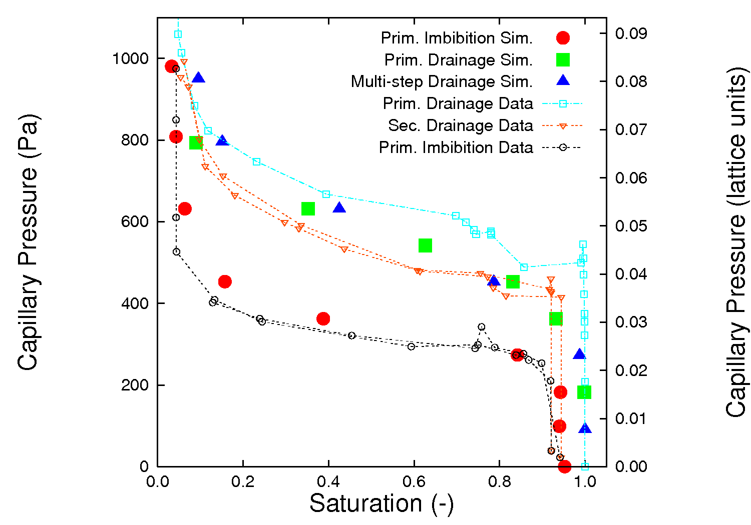
Comparison of Pressure-Saturation Characteristics Derived from Tomography and from Lattice Boltzmann Simulations:
Schaap et al. (2006) present results from a modeling study that successfully computed an water retention characteristic using a Lattice Boltzmann (LB) pore-scale model. In this case we obtained pore-scale solid-phase and fluid geometries in the GSECARS Computed Microtomography setup at the Argonne National Laboratory synchrotron facility (Chicago). The Shan-Chen LB model is parameterized for the surface tension of water and for a zero-contact angle. The observed solid phase geometry was exposed to nine drainage or imbibition capillary pressure steps and the resulting saturations were compared to the observed data (no calibration to data was carried out). As the figure shows, there is a very high degree of similarity between the observed and simulated data. It should be pointed out, however, that the LB simulations are extremely computationally intensive. It is estimated that, on a single CPU basis, the calculations are about 1000 times slower than the actual measurements. Nevertheless, this result presents a significant advance! Future plans are to compare simulated and observed interfacial area's, wetted solid fractions and contact angles, as well as dynamic (rate-dependent) effects.

University of California Davis

Collaborators: Jan W. Hopmans and Thomas Harter

Microirrigation Evaluation:
Microirrigation with fertigation provides an effective and cost-efficient way to supply water and nutrients to crops. However, less-than-optimum management of microirrigation systems may cause inefficient water and nutrient use, thereby diminishing expected yield benefits and contributing to ground water pollution if water and nitrogen applications are excessive. The quality of soils, ground and surface waters is specifically vulnerable in climatic regions where agricultural production occurs mostly by irrigation such as in California. Robust guidelines for managing microirrigation systems are needed so that the principles of sustainable agriculture are satisfied. Studies were conducted using an adapted version of the HYDRUS-2D computer model to develop irrigation and fertigation management tools that maximize production, yet minimize adverse environmental effects. This software package can simulate the transient two-dimensional or axi-symmetrical three dimensional movement of water and nutrients in soils. In addition, the model allows for specification of root water and nitrate uptake, affecting the spatial distribution of water and nitrate availability between irrigation cycles. Recently, we analyzed 4 different micro-irrigation systems in combination with 5 different fertigation strategies for various soil types using a nitrate-only fertilizer, clearly demonstrating the effect of fertigation strategy on the nitrate distribution in the soil profile and on nitrate leaching. Most recently, the HYDRUS-2D model was used to model the distribution of soil nitrogen and nitrate leaching using a urea-ammonium-nitrate fertilizer, commonly used for fertigation under drip irrigation. In addition, the distribution of phosphorus and potassium was modeled. Model simulations are presented for surface drip and subsurface drip tape, each associated with a typical crop in California.

Pathogen Transport in Porous Media:
Outbreaks of enteric diseases are increasingly traced to pathogens in drinking water supplies and to pathogens in irrigation or runoff water that comes into contact with fresh produce. The source of these waterborne pathogens are wastes from infected wild animals, from farmed and domesticated animals, and from human waste discharged through septic systems and municipal wastewater treatment plants. Environmental pathways of waterborne pathogens from these sources to the point of water use can be classified into two groups: Treated or untreated fecal wastes are either discharged directly to streams, or are applied on the ground. Fecal wastes from animal farming operations (AFOs) and from wastewater treatment plants are typically land applied to forage crops or pastures. Except for fecal deposition into surface water bodies, soils are therefore an important and central component of the complex environmental pathways of waterborne pathogens in surface water and groundwater. Understanding the dynamic role of soils in the transmission of these pathogens to groundwater or, via interflow or tile drainage, back to surface water is critical to improving land management practices that protect water resources. One of the most common gastrointestinal pathogens is Cryptosporidium parvum, a protozoic oocyst that is resistant to chlorination and highly effective in resisting environmental influences. We have implemented a suite of laboratory experiments to determine the transmission of C. parvum through saturated sandy soil columns under highly controlled conditions in various hydraulic and chemical environments. We show that the early, bulk transmission behavior of the oocyst is well described by a classic filtration theory equation that also includes dynamic first-order sorption-desorption processes (Harter et al., 2000). In our recent set of experiments, we have also shown that oocysts are capable of long-term remobilization that is not captured by current filtration theories. Instead, it appears that the long-term transmission of oocysts, and perhaps that of other pathogens, is subject to significantly less filtration (and straining) and significant remobilization at a wide spectrum of sorption-desorption rates. By measuring oocyst transmission through the saturated sand columns over a dynamic concentration range exceeding six orders of magnitude, we found that the main breakthrough occurs, as predicted by filtration theory, within the first flushed pore volume of the sand column. After injecting oocysts over a relatively short period of time (the time needed to flush two pore volumes of water through the sand column), the oocyst elution from the column drops significantly, also as predicted near the end of the first (uncontaminated) water flush (one pore volume). However, a smaller, but epidemiologically significant amount of oocysts are remobilized from the sand column over several thousand pore volumes of flushing. The late-time oocyst elution from the column approximately follows a log-log behavior on a concentration vs. time graph. To explain such behavior, we developed a novel filtration theory approach not based on the advection-dispersion principle, but based on the Continuous Time Random Walk theory, which allows us to model a multi-rate sorption-desorption behavior over long periods of time without introducing a large number of additional model parameters. Unlike other filtration models, the CTRW filtration model is capable of simultaneously explaining the early-time, main, and late-time breakthrough of oocysts in the sand column experiments. We show that filtration (permanent attachment) is much lower than would be expected by only evaluating the main part of the breakthrough curve. By comparing the oocyst breakthrough curves to that of a conservative tracer (bromide), we were further able to show that the log-log elution behavior was not due to the physical heterogeneity of the pore-space in the column, but entirely due to local heterogeneities in the physico-chemical surface-surface interactions between the oocyst and the well-round quartz sand grains (Ottawa sand) (Cortis et al., 2006).

Connectivity:
At any scale, heterogeneity of the pore space and soil materials controls the mass flux processes in soils. A critical concept in determining mass flux through heterogeneous media is that of connectivity. In the simple-most heterogeneous system, the system is made of a conducting and a non-conducting phase. Randomly distributed within the system, a key question is, whether or not the conducting phase is connected across the system-scale. In practice, for example, the question arises whether coarse-textured facies in highly heterogeneous alluvial fans are interconnected and would allow for rapid transport of contaminants. Intuitively, connectivity is highly likely, when the randomly distributed conducting phase occupies a large volume fraction. Inversely, when it occupies a low volume fraction, it is unlikely to be connected. Using the mathematical framework of Percolation Theory, it has been shown that connectivity is established at the so-called percolation threshold, which is thought to be 31% completely random, binary heterogeneous media. However, most natural systems, including soils, show significant spatial correlations rather than being completely random. With our work we show that spatial correlations reduce the percolation threshold to 12.6% regardless of the type of random field used. This has important implications for our understanding of mass flux processes in soils. For example, while it has traditionally been understood that about one-third of the volume fraction in a heterogeneous media needs to be highly conductive to allow for good connectivity, our work rigorously explains why strong connectivity has been observed in porous systems at much lower volume fractions (Harter, 2005).

University of California Riverside

Collaborator: Laosheng Wu

Nursery Runoff Study:
One of the best management practices (BMPs) is to use retention ponds to recycle large volumes of runoff water generated by the large production nurseries. Knowledge of pesticide distribution and persistence in nursery recycling pond water and sediment is critical for preventing phytotoxicity of pesticides during water reuse and to assess their impacts to the environment. In this study, sorption and degradation of four commonly used pesticides (diazinon, chlorpyrifos, chlorothalonil, and pendimethalin) in sediments from two nursery recycling ponds was investigated. Results showed that diazinon and chlorothalonil were moderately sorbed [K_{OC} (soil organic carbon distribution coefficient) from 732 to 2.45 x 10³ mL g^{–1}] to the sediments, and their sorption was mainly attributable to organic matter content, whereas chlorpyrifos and pendimethalin were strongly sorbed (K_{OC} 7.43 x 10³ mL g^{–1}) to the sediments, and their sorption was related to both organic matter content and sediment texture. The persistence of diazinon and chlorpyrifos was moderate under aerobic conditions (half-lives = 8 to 32 d), and increased under anaerobic conditions (half-lives = 12 to 53 d). In contrast, chlorothalonil and pendimethalin were quickly degraded under aerobic conditions with half-lives < 2.8 d, and their degradation was further enhanced under anaerobic conditions (half-lives < 1.9 d). The strong sorption of chlorpyrifos and pendimethalin by the sediments suggests that the practice of recycling nursery runoff would effectively retain these compounds in the recycling pond, minimizing their offsite movement. The prolonged persistence of diazinon and chlorpyrifos, however, implies that incidental spills, such as overflows caused by storm events, may contribute significant loads of such pesticides into downstream surface water bodies.
Waters in recycling ponds generally have high concentrations of nutrients, pesticides, and dissolved organic matter, as well as elevated salinity and turbidity. Little is known about pesticide degradation behavior in the unique environment of nursery recycling ponds. In another study, degradation of four commonly used pesticides diazinon, chlorpyrifos, chlorothalonil, and pendimethalin in waters from two nursery recycling ponds was investigated at an initial pesticide concentration of 50 g/L. Results showed that the persistence of diazinon and chlorpyrifos appeared to be prolonged in recycling pond waters as compared to surface streamwaters, possibly due to decreased contribution from biotic transformation, while degradation of chlorothalonil and pendimethalin was enhanced. Activation energies of biotic degradation of all four pesticides were lower than abiotic degradation, indicating that microbial transformation was less affected by temperature than chemical transformation. Overall, the pesticide degradation capacity of recycling ponds was better buffered against temperature changes than that of surface streamwaters.
The fate and transport of Pollutants in fertilizers and reclaimed water:
In sorption experiments, Cd in the solution phase may be surface adsorbed or immobilized and precipitated into mineral phases. The reaction kinetics can be described by a two-site model combining a linear instantaneous model for the surface adsorption and a first-order reaction kinetic model with forward and backward reaction constants for the immobilization and precipitation of the mineral phase. A simplified sequential procedure was developed to study the contribution of these two processes. Results of batch Cd adsorption experiments with two California soils were used to illustrate the model validity. When the Cd sorption was obtained by varying the initial Cd solution concentration and maintaining constant equilibration time, the amounts of Cd in the solid phase as well as the adsorbed and mineral phases increase linearly with the initial Cd solution concentrations. As much as 90% of the sorbed Cd may be in the mineral phase. When the Cd sorption was examined at varying equilibration time and a constant Cd initial solution concentration, the sorbed Cd in the mineral phase increased exponentially to approach a maximum with time. The forward and backward reaction constants were obtained by fitting the sorption data to the model equations. It showed that the forward reaction was five times faster than the backward reaction for both soils and the reaction rates were two times faster in the heavier textured Holtville clay loam soil than the Arlington sandy loam soil.

The possible risks derived from the increasing amount of toxic trace elements such as arsenic and cadmium in cropland soils through application of fertilizers, irrigation water, and other amendments have resulted in growing public health concerns. The fate and transport of these trace elements in agricultural environments is greatly affected by the soil and plant characteristics. A generalized mass balance model was developed to evaluate the long-term fate and transport of trace element in cropland soils. Based on the model simulation results, the normal cropping practices do not have significant effect on the total As content of the soils, but the application of Cd-contained P-fertilizers could have a significant long term effect on the Cd concentration of the soils therefore high risks of transfer through the food chain. Existing regulations are not strict enough to avoid the accumulation of Cd in cropland soils. Sensitive analyses show the solid solution portioning coefficient, Kd, and the plant uptake factor are two key factors that affect the fate and transport of As and Cd in soil. The uncertainties of the model estimates are evaluated by Monte Carlo simulations. Results show great deal of uncertainty associated with trace element fate in soils due to high variability of model parameters.

University of Idaho
Collaborator: Markus Tuller
Hydraulic and Swelling Properties of Clays:
To extend our knowledge regarding the effects of solution chemistry, clay mineralogy, clay content, and confinement on hydraulic and swelling behavior of clay soils we conducted a series of permeability experiments with Na-bentonite – silica sand (F58) as well as Ca-montmorillonite – silica sand (F58) mixtures using 0.5M NaCl and CaCl₂ solutions as permeant liquids.
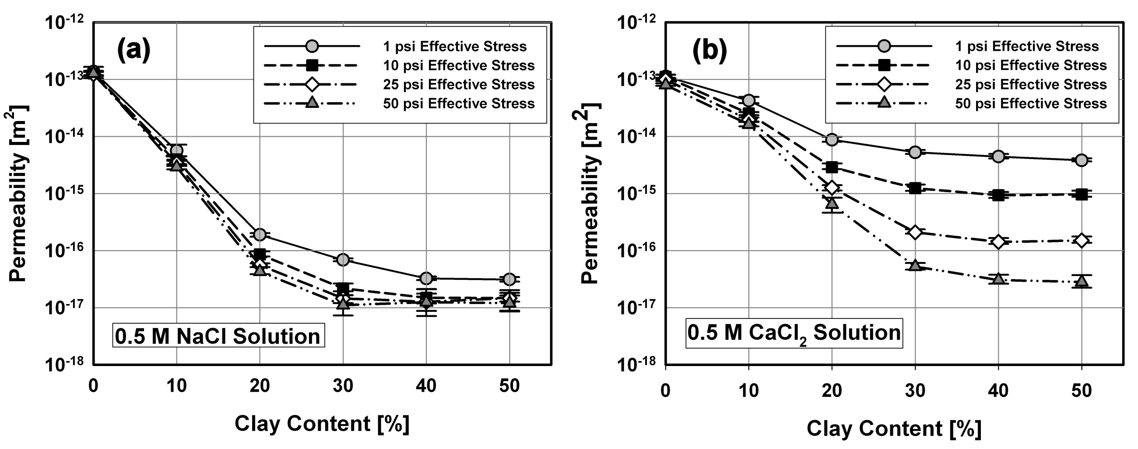
Fig.1: Effects of solution chemistry and confinement stress on intrinsic permeability
Figure 1 depicts effects of effective confinement stress on permeability for clay-sand mixtures permeated with 0.5M NaCl and CaCl₂ solutions. Measurements were conducted for stress levels ranging from 1 to 50 psi. Results for samples permeated with NaCl (Fig.1a) show that there is a distinct decrease in permeability when the confinement stress is increased from 1 to 10 psi. Any further stress increase only leads to a marginal decrease in permeability. CaCl₂ permeated samples show a different behavior (Fig.1b). Each increase in effective stress leads to a significant decrease in permeability. At the 50 psi stress level observed permeabilities are within the range of permeabilities observed for NaCl permeated samples.
Initiation and Evolution of Surface Crack Networks in Active Clay Soils Observed with X Ray Computed Tomography:
Development and evolution of desiccation cracks in bentonite-sand mixtures are strongly dependent on physico-chemical boundary conditions. To investigate effects of solution chemistry and mixture bentonite content on cracking behavior, we conducted well-controlled dehydration experiments and applied X-ray Computed Tomography (CT) in conjunction with Mathematical Morphology to visualize and quantify geometrical features of evolving crack networks. Samples with varying bentonite content were saturated with 0.05 and 0.5 molar NaCl solutions, dehydrated under constant temperature, and scanned with X-ray CT at constant time intervals. Obtained 3-D images were analyzed based on Mathematical Morphology to quantify crack porosity, specific surface area, and aperture distributions of crack networks.
The experiments are primarily motivated by potential applications for bentonite liner design. An ongoing study and data reported by Revil and Cathles [1999] show the existence of a critical bentonite content, which marks the lowest medium porosity and hydraulic permeability. As shown in a recent thesis by Gebrehawariat [2005], this critical bentonite content is strongly dependent on the chemistry of the permeant liquid as well as the effective confinement pressure. Increase in bentonite content beyond the critical value leads to a significant increase in porosity and a slight increase in saturated permeability, which is not desirable for waste containment applications. Mixing bentonite with sand- or silt-like materials furthermore increases the mechanical stability of a potential hydraulic barrier and also reduces susceptibility to formation of desiccation cracks as shown in Fig.2.
Figure 3 depicts changes in water ratios and crack porosities with time for samples initially saturated with 0.05M (Figures 3a and 3b) and 0.5 M (Figures 3c and 3d) NaCl solutions. We observed that crack formation in bentonite containing samples was initiated during the first day of dehydration. While samples with low bentonite content (10-20 %) attained constant crack porosities after approximately 30 days, samples with higher bentonite content (30-50 %) reached a stable value after about 55 days. Determined crack porosity values indicate that samples with 30-50 % bentonite saturated with 0.05 M NaCl solution are more susceptible to cracking. This is clearly evidenced by the evolving aperture distributions depicted in Figure 4. The mixture containing 50 % bentonite saturated with 0.05 M NaCl solution (Figure 4b) shows by far the widest aperture range. Low bentonite content samples (Figures 4a and 4c) have finer and less cracks. In general, higher solute concentrations yield less and smaller cracks in samples with identical bentonite content. Preliminary data show that X-ray Computed Tomography applied in conjunction with Mathematical Morphology is a powerful tool to visualize and quantify geometrical and topological properties of evolving desiccation crack networks. The obtained parameters are crucial for performance based design of economic and safe waste containment systems and are useful for modeling potential preferential flow and transport in cracked barriers. It is clear that more work is required to optimize image analysis as well as to investigate effects of additional solutes and varying drying conditions. We are currently running experiments with different concentrated CaCl₂ solutions to cover potential effects of divalent electrolytes. In addition we are looking at different drying rates and potential amendments such as polyacrylamide (PAM) and polypropylene fibers that can be used to alleviate crack formation.
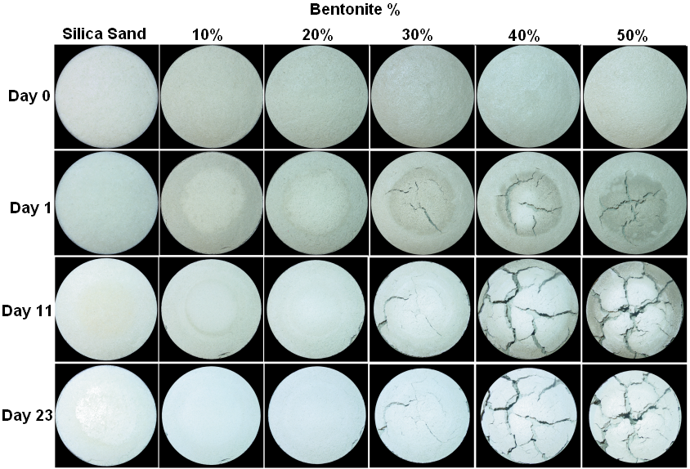
Fig.2: Sequences of digital images illustrating the effect of sand content on initiation and evolution of desiccation cracks (sand content decreases from left to right). For this preliminary experiment Na-bentonite mixtures were saturated with 0.05M NaCl and exposed to a temperature of approximately 40oC.

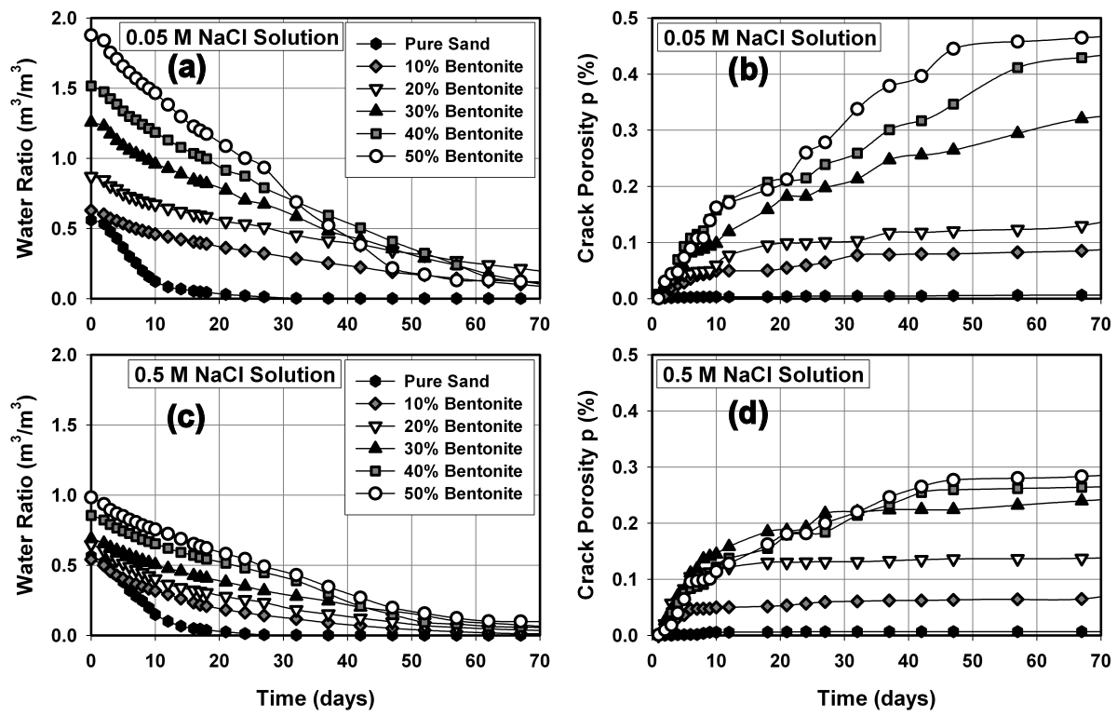
Fig.3: Evolution of water ratios and crack porosities with time. (a-b) Samples saturated with 0.05 M NaCl solution. (c-d) Samples saturated with 0.5 M NaCl solution.

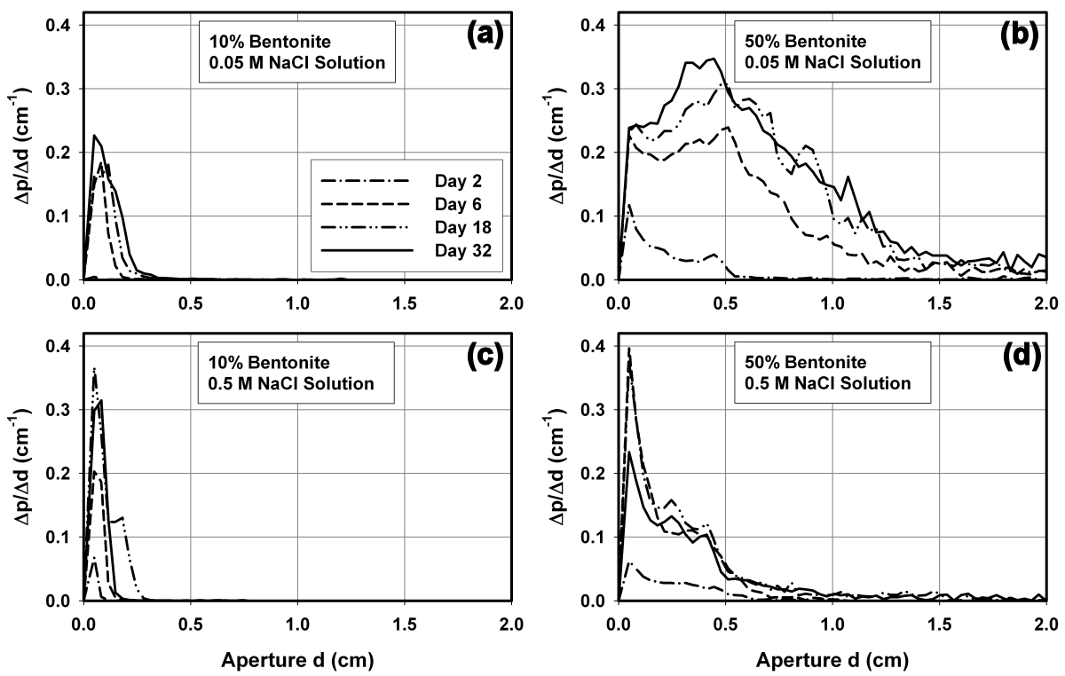
Fig.4: Evolution of aperture distributions with time. (a-b) Samples saturated with 0.05 M NaCl solution. (c-d) Samples saturated with 0.5 M NaCl solution.
University of Nevada and Desert Research Institute

Collaborators: Markus Berli, Todd Caldwell, Scott Tyler, Wally Miller, Michael Young, Jianting Zhu

Improved Understanding of the Fundamental Soil Physical Properties:
Military training exercises at the National Training Center (NTC), Ft. Irwin, California have led to the degradation of large areas of the Mojave Desert. Soil physical properties in areas subjected to low and high disturbance at interspace and plant (Larrea tridentata) mound microsites were quantitatively compared to undisturbed surfaces of both well-developed soils formed on Pleistocene age alluvial deposits and weakly developed soils formed on Holocene age alluvial deposits. Results from multi-tension infiltrometers showed that young coarser textured surfaces had saturated conductivities (K_{sat}) that were nearly twice those of older surfaces. Mound microsites were more sand-rich than interspace locations although K_{sat} was not significantly different. After both low and high disturbance, bulk density was significantly increased from 1.54 to 1.62 and 1.80 g cm⁻³, respectively. Similarly, penetration resistance increased following low and high disturbance from 1.32 to 1.47 and 3.90 kg cm⁻², respectively. Although low disturbance increased K_{sat}, high disturbance resulted in significant reductions in both K_{sat} (2.4 to 1.3 cm hr⁻¹ (P<0.05)) and mean Gardner’s α (0.20 to 0.10 (P<0.001)) at all sites. In general, young interspaces were less sensitive to disturbance than older well-developed interspace soils. Although results showed that K_{sat} on these older surfaces was not dramatically reduced despite large losses of fines and increased bulk densities, the overall morphology of the soil was dramatically impacted [Caldwell et al., 2006].

The reestablishment of desert plants is limited by the availability of soil moisture, often requiring irrigation at high frequency and large volumes. A practical and economical method to estimate available soil moisture would limit irrigation to optimum conditions, and facilitate revegetation practices. To that end, three components of the seedbed microclimate; soil temperature, matric potential, and soil water balance, were continuously monitored and evaluated during active restoration practices at three seeded sites in coarse-textured soils across the National Training Center at Ft. Irwin, CA. Furthermore, various surface amendments (gravel, straw, soil-tackifier, clear plastic, and bark) and irrigation practices were also evaluated to determine effective restoration practices in order to maximize revegetation success and minimize water use. Results show that soil water storage is low for these coarse textures, high conductivity soils associated with Mojave piedmonts. Surface mulches could be used to manipulate soil temperatures but may also have a negative effect on the seedbed microclimate by impeding infiltration. Initially, seedlings germinated at all three sites; however, complete mortality was reached within 3 months. Historical weather data indicates highly variable precipitation, but relatively predictable evapotranspiration (ET), ranging from 6 mm day⁻¹ in the winter to 14 mm day⁻¹ in the summer. Large-scale, broadcast irrigation under these conditions can be a futile effort unless irrigation is limited to either conditions of low ET (early AM or cloud cover) or the irrigated areas are limited. The seedbed microclimate could be viewed as a hostile environment for seedlings establishment with little available moisture, high temperatures and soil water potentials, conditions difficult to overcome with current management practices. Improved knowledge of the germination requirements for Mojave seedlings, applied numerical modeling and soil moisture forecasting could aid in meeting the goals required for seedbed microclimate management [Caldwell et al., in press].

USDA-ARS, Bushland, TX

Collaborators: Robert Schwartz and Steve Everett

Tillage effects on near-surface soil water dynamics and hydraulic properties:
This study evaluated near-surface soil water dynamics during fallow on recently sweep-tilled (ST) as compared with untilled (UT) areas to better examine tillage effects on evaporation in the absence of residue. Field plots were established in a fallow field on a Pullman clay loam (fine, mixed, superactive, thermic Torrertic Paleustolls). Thermocouples and 200-mm trifilar TDR probes were installed horizontally in 12 sub-plots at soil depths of 0.05, 0.1, 0.15, 0.2, and 0.3 m accessed through small (0.25 × 0.35 × 0.35 m) excavated pits. Field water contents were estimated using a square root of apparent permittivity calibration with temperature compensation based on packed laboratory columns. We concluded that greater water contents at 0.05 and 0.1 m persisted throughout the summer in UT plots despite greater rainfall infiltration under ST. Increased soil water depletion with tillage was likely due to a change in soil hydraulic properties accompanied by enhanced vapor flow near the surface and greater absorption of radiation by a tilled surface with reduced albedo. In absolute terms, the difference in soil water depletion (~10 mm) between tillage treatments is small with respect to seasonal evapotranspiration in dryland sorghum (~300 mm). However, greater soil water contents near the surface in conjunction with slower drying rates after precipitation afford improved seed zone moisture conditions and a longer window of opportunity for dryland crop establishment. (Schwartz, Baumhardt, and Evett; in preparation).

USDA-ARS, St. Paul, MN

Collaborator: Tyson Ochsner

Sorption of a Hydrophilic Pesticide in Unsaturated Soil:
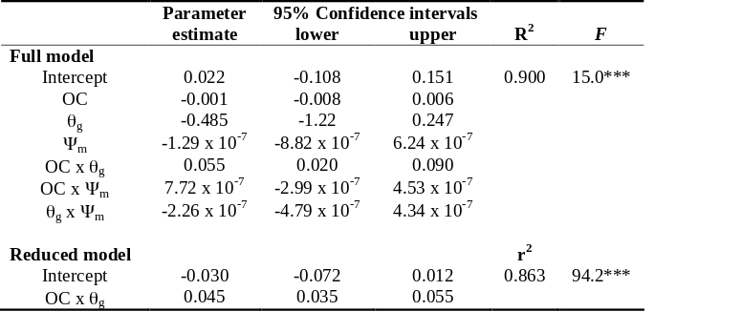
Transport of pesticide to groundwater is governed in part by sorption of the pesticide to soil particles. Sorption may be dependent on soil moisture conditions, but limited data are available from which to elucidate the effect. Our objective was to determine the effect of soil water content on the sorption coefficient of a hydrophilic pesticide. Sorption of dicamba was measured in three soils, each at two initial water contents (Table 1). At low water contents (~0.05 kg kg⁻¹), sorption coefficients were similar for all three soils, ranging from 0.01 L kg⁻¹ for the loamy sand to 0.07 L kg⁻¹ for the silty clay loam. At higher water contents (0.19 to 0.24 kg kg⁻¹), the sorption coefficient for the loamy sand was unchanged, for the silt loam was doubled, and for the silty clay loam was increased by almost sixfold. Multiple regression analysis revealed a strong linear relationship between the sorption coefficient and the product of soil water content and organic C content (r² = 0.86, Table 2). The number of dicamba sorption sites likely increases with soil organic C content, while the accessibility of these sites appears to increase with soil water content. This may be caused by the decreasing hydrophobicity of soil organic matter with increasing water content. The effects of water content on pesticide sorption require further research and may ultimately have implications for the methods used to determine sorption and for managing pesticide application.

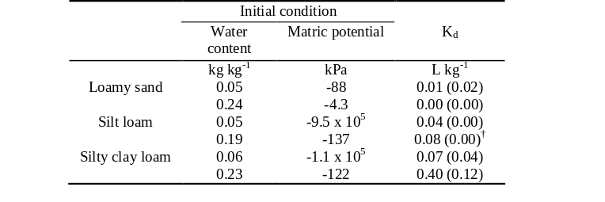
Table 1. Dicamba sorption coefficients (K_{d}) determined by the unsaturated transient flow method for three soils each at two different initial water contents and matric potentials. Shown are mean and (standard deviation) of three replicates.

Table 2. Parameter estimates, 95% confidence intervals, coefficients of determination (R², r²), and F statistics for the full and reduced regression models. The independent variables are organic carbon content (OC, g kg⁻¹), initial water content (θ_{g}, kg kg⁻¹), matric potential (Ψ_{m}, kPa), and their cross-products. The dependent variable is the dicamba sorption coefficient (L kg⁻¹).

USDA-ARS USSL, Riverside, CA

Collaborators: Scott Bradford, Peter Shouse, Todd Skaggs, Rien van Genuchten, Scott Yates

Transport of Pathogenic Microorganisms in Soils:
Computer models for predicting the transport and retention of pathogenic microorganisms in soils and aquifers are typically based on filtration theory. This theory assumes that the amount of microbes retained in the soil is controlled by chemical interactions between the microbes and the soil surfaces. Over the past decade considerable research suggests that this theory does not provide an adequate description of microbe retention in many soil systems, because it does not include the potential influence of physical factors such as soil pore size and surface roughness. New work this year highlighted experimental evidence that indicates that these physical factors can play an important role in microbe retention. The implications of microbe straining in soil pores was discussed, and areas for future research were identified.

Additionally, the transport and retention of a disease causing bacteria (Escherichia coli O157:H7) was studied in several sandy soils. The amount and location of bacteria retained in the soil was strongly dependent on the size of the soil particles and on the velocity of the flowing water through this system. The bacteria were transported in greater numbers when the water flow rate was higher and the sand grains were larger in size. Microscopic observations of E. coli retention in these sandy soils indicated that large numbers of bacteria could were retained in small soil pores. Results from this study strongly indicate that retention of bacteria in soil pores can be strongly influenced by chemical interactions between bacteria and the water flow rate. A computer model was adapted and successfully used to describe the observed bacteria transport behavior.

Simulating Herbicide Volatilization from Bare Soil:
A numerical model that simulates pesticide fate was developed to predict the behavior of triallate after application to a field soil. The model has options that allow water and/or heat transport, and can limit simulated aqueous phase concentrations to triallate solubility in water. Several methods for describing the volatilization boundary condition were tested to assess the accuracy in predicting the volatilization rate, including an approach that requires no atmospheric information and an approach that couples soil and atmospheric processes. Four scenarios were constructed and simulated, to compare with measured volatilization rates. The peak measured volatilization rate (168 g ha–1 hr–1) was most accurately predicted with the scenario that included the most complex model (100 g ha–1 hr–1). The simplest model over predicted the peak rate (251 g ha–1 hr–1) and the others under predicted the peak rate (16 – 67 g ha–1 hr–1). The simulations that limited aqueous solubility provided relatively similar values for the total emissions (21% – 36% of applied triallate), indicating that simplified models may compare well with measurements (31% of applied). A prospective simulation over a period of 100 days showed that applying triallate to the soil surface would ultimately lead to atmospheric emissions of 80% of the applied material with 6% remaining in soil. Incorporating triallate to depth of 10 cm would reduce emissions to less than 5% and lead to 41% remaining in soil.

Gaseous Diffusion in Soils:
Gaseous diffusion controls many transport phenomena in soils, such as soil aeration, fumigant emissions, volatilization of volatile organic chemicals from contaminated sites, and the sequestration or emission of greenhouse gases such as methane into or from soils. Knowledge of diffusion is critical to developing accurate predictive models for gas flow in porous media, and to improving our understanding of the basic transport processes involved. The gasous diffusion coefficient (D) in soils, which determines the overall rate of diffusion, has long been correlated empirically with porosity or the soil air content. Unfortunately, D is known to be affected also by other parameters including especially pore structure and soil type. To investigate the effects of pore morphology on D, we carried out a large number of numerical simulations of diffusion in idealized soil pore systems estimated from digitized images of soil thin sections. Results of the pore-scale simulations confirm that the diffusion coefficient is not a unique function of porosity, but depends also on pore structure (especially macroporosity) as well as the direction of the concentration gradient leading to gaseous diffusion, especialy for very heterogeneous (macroporous or fractured) media . The calculations furthermore indicate that accurate measurements of the diffusion coefficient in the laboratory requires careful packing of soil cores, and that relatively large samples should be used (this to minimize boundary and heterogeneity effects). If small cores are to be used, the diffusion experiments may need to be carried out with concentration gradients in different directions. Results of this study are important for improved predictive modeling of gasous transport in soils.

Conversion of Metam Sodium and Emission of Fumigant from Soil Columns:
Metam sodium is the most widely used soil fumigant in the United States. The primary breakdown product of metam sodium in soil is methyl isothiocyanate (MITC), an active pesticidal agent with a high toxicity and a great potential for volatilization. Reducing atmospheric emissions of MITC is therefore critical to maintain air quality. The objective of this study was to examine the rate and efficiency of conversion of metam sodium to MITC in soil and to investigate the potential of using surface water sealing to reduce MITC emissions. The conversion of metam sodium to MITC was a rapid abiotic decomposition process. At typical field application rates, the conversion efficiency depended on the initial content of metam sodium in soil, but was independent of soil moisture, soil type, and soil atmospheric conditions. A soil column system was used to measure the emission and distribution of MITC after subsurface and surface application of metam sodium. Volatilization flux and cumulative emission loss of MITC was substantially reduced with surface water sealing compared to uncovered soil columns after subsurface application of metam sodium. When metam sodium was surface applied in simulated chemigation, surface water sealing was ineffective, suggesting the need for additional emissions reduction practices when metam sodium is broadcast. Results of the column experiment indicate that surface water sealing with subsurface application of metam sodium may be an effective and economical strategy to reduce MITC emissions while maintaining pest control efficacy.

Utah State University (USU)

Collaborator: Scott B. Jones

Optimizing a Root Zone Soil System:
Rigorous management of restricted root zones utilizing coarse-textured porous media greatly benefits from optimizing the gas-water phase balance within plant-growth media. Geophysical techniques can help to quantify root-zone parameters like water content, air-filled porosity, temperature and nutrient concentration to better address the root systems performance. Due to the high root densities and limited volumes of restricted root zones the efficiency of plant growth is critically linked to maintaining favorable water content/air-filled porosity balance while considering adequate fluxes to replenish water at decreasing hydraulic conductivities during uptake. The supply of nutrients to the volumes adjacent to roots also needs to be optimized to provide adequate supplies during each period of the plant’s life cycle avoiding build-up of excessive nutrient concentrations. Our objectives were to (1) design and model an optimized root zone system using optimized porous media layers, (2) verify our design by monitoring the water content distribution and tracking nutrient release and transport within the porous medium. We developed a unique root zone system using layered Ottawa sands promoting more uniform water content (and air-filled porosity) within the column profile. Watering was achieved by maintaining a shallow saturated layer at the bottom of the column and allowing capillarity to draw water upward, first through coarser particle sizes in the bottom layer with finer particles sizes forming the layers above. The depth of each layer was designed to optimize water content based on measurements and modeling of the wetting water retention curves. Layer boundaries were chosen to maintain saturation between 50 and 85 percent. The vertical water content distribution was verified by dual-probe heat-pulse water content sensors and finally by destructive sampling. The nutrient experiment involved embedding slow release fertilizer in the porous media in order to detect variations in electrical resistivity versus time during the release, diffusion and uptake of nutrients. The experiment required a specific geometry for the acquisition of ERT data using the heat-pulse water-content sensor’s steel needles as electrodes. ERT data were analyzed using the sensed water contents and deriving pore-water resistivities using Archie’s law. The proposed plant-growth media’s design and monitoring capabilities offers an efficient means to describe the effects of the root system’s performance on plant growth and links porous media physics with in-situ monitoring.
Impact: Our optimized design for plant rooting media is being considered for a 500 day Mars Mission Chamber test to be carried out by the Russian Space Agency. The benefit of our design is that it provides water content levels more closely related to the expected microgravity root zone environment expected in space. This approach has potential benefit for water and fertilizer savings in greenhouse and horticultural industries.

Washington State University (WSU)
Collaborators: Markus Flury and Joan Wu
Our activities focused on (1) elucidating mechanisms of colloid mobilization in unsaturated porous media, (2) sorption of Eu on mineral surfaces and Eu pseudo-colloid formation, and (3) on determining the mineral transformation pathways when sediments are subject to highly alkaline conditions.
We have completed the experiments on mineral transformations when Hanford sediments are reacted with caustic Hanford tank waste. We have also completed the work on silicate mineral resistance to alkaline Hanford waste solutions. The results show that the stable end products of mineral transformation depends on the presence of certain anions and cations, but will always lead to zeolite, cancrinite, or sodalite (Deng et al. 2006a, 2006b). These minerals are porous, and the radionuclide Cs can diffuse into or be incorporated in these minerals upon mineral formation (Mon et al., 2006a). Selective dissolution of the minerals influenced the solution chemistry and the precipitation of new solid phases, and altered the sorption and transport of contaminants present in the wastes. The mineral resistance to caustic solutions was predicted based on solution compositions and solubility product constants.
We have initiated experimental work on in-situ colloid mobilization under transient flow conditions using columns repacked with Hanford sediments. Five series of unsaturated column experiments were performed with initial infiltration rates of 0.018, 0.036, 0.072, 0.144 and 0.288 cm/min. The cumulative amount of colloids released was linearly proportional to the column water content established after steady-state flow rates were achieved. The colloid release rate coefficient increased nearly linearly with the increase of water content. The results suggest that under the low flow rates at Hanford, colloid transport should not be significant unless the water flow occurs in preferential flow channels or is funneled by textural layering.
We studied precipitation and adsorption of europium on smectite and calcite. Smectite and calcite were mixed with Eu solutions for up to one year in either capped or open centrifuge tubes. When an amount of Eu that was equivalent to twice the CEC of smectite was added, about 50% of the added Eu was adsorbed in pH range 3–5.5, and the adsorption did not vary significantly with pH in this range, implying that smectite was nearly saturated with Eu and that the affinity of Eu to smectite was strong.
Impact: Colloid stability studies indicate that Hanford sediment form stable colloidal suspensions when suspended in Hanford sediment pore waters. Colloid stability was assessed by determination of the critical coagulation concentration, i.e., the chemical electrolyte concentration at which colloidal suspensions flocculate and settle out (become unstable). Although in the stable mode, Hanford colloids will settle out of solution after extended periods of time (months to years). The results of this project have also led to improvements of our fundamental understanding of colloid transport and mobilization under unsaturated flow conditions in porous media. We have found that colloid attachment to the liquid-gas interface is not relevant and that colloids rather attached near the triple phase interface where air, water, and solid phases meet. We have also found that capillary forces are the most dominant forces governing colloid release in unsaturated porous media. These results help to advance our understanding of colloid fate and transport in unsaturated porous media.

University of Wyoming

Collaborator: Thijs Kelleners

Freezing and Melting of Soil Water in Small Watersheds:
An algorithm was developed to describe freezing and melting of soil water for incorporation in a distributed water and energy balance model for small mountainous catchments. Phase change between solid ice and liquid water will take place under the following conditions:

where T is the temperature (K) and θ is the volumetric soil water content. The rate of the phase change depends on the magnitude of the net incoming (melting) or net outgoing (freezing) energy flux. The effect of total soil water potential on the potential for soil water freezing is incorporated through an additional criterion that reads:

where h is the soil water potential in head units (negative value in m). Matric head is calculated from the soil liquid water content using the Brooks-Corey soil water retention function. Osmotic head is estimated using:

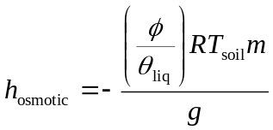

where φ is the porosity, R is the gas constant (8.3 J mol⁻¹ K⁻¹), m is the molality (mol of solute per kg of liquid soil water), and g is the gravitational acceleration (9.81 m s⁻²). The threshold head value is calculated from an integrated form of the Clapeyron equation that describes liquid water potential as a function of temperature when ice is present in the soil:

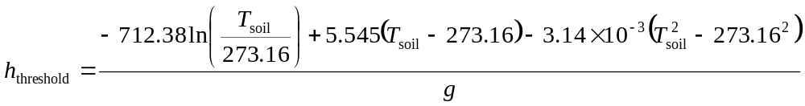
where an empirical function is incorporated to describe the temperature dependence of the latent heat of fusion h_{f} of water and where the ice potential is assumed to be zero. For details see Spaans and Baker, SSSAJ 60: 13-19 (1996).

OBJECTIVE 2: To develop and evaluate instrumentation and methods of analysis for characterizing mass and energy transport in soils at different scales

California State University Fresno

Collaborator: Zhi Wang

Performance of ridge and furrow planting for rain harvesting in Northwest China:
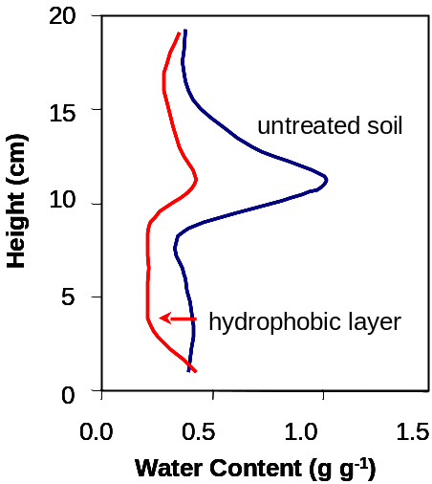
Ridge and furrow planting system (RFPS) for rain harvesting agriculture has been commonly practiced for decades in the Loess Plateau of northwest China resulting in significant improvements in soil and water conservation and economic returns. In the conventional RFPS, the ridge serves for planting and the furrow serves for water conservation. This study was focused on the reversed RFPS where the ridge serves for rain harvesting and the furrow for planting and water conservation (Yu et al., 2006). The relationships between the amount of harvested water versus ridge surface treatment and ridge-to-furrow ratio were quantified. Two types of ridge surface treatment (bare and plastic covered) and three ridge-to-furrow ratios (i.e., 30:60, 45:60 and 60:60 by width in cm) were studied experimentally. The results showed that the plastic covered ridges could harvest about 60% of precipitation compared to about 6% for the uncovered bare ridges in the study area with an annual precipitation of 263 mm (or 10.4 inches) varying between 150 mm (5.9 inches) and 400 mm (15.7 inches). Because of raindrop splashing from the plastic surfaces, the narrower ridges lost more water than the wide ridges. The wider ridges gained about 5% more runoff per 15-cm increase in the ridge width ranging from 30 cm to 60 cm (1 to 2 ft). Visual examination of the crop growth status indicated that the 60-cm wide, plastic-covered ridges produced the best promise for higher crop yield. Therefore, the plastic-covered ridges with the highest ridge-to-furrow ratio (60-cm to 60-cm) were recommended for applications in this region.
Fig 1. Water content distributions for soil with and without a hydrophobic layer after 30 d freezing conditions at the upper boundary.

Iowa State University and USDA-ARS National Soil Tilth Laboratory

Collaborators: Toby Ewing, Dan Jaynes, and Bob Horton

The effect of a hydrophobic layer on the upward movement of water during freezing:
Accomplishments: Laboratory experiments were performed to compare upward water movement from a fixed water table during freezing for soils with and without a hydrophobic layer. A 20-cm length soil column was developed to enable one-dimensional vertical heat flow by including a column-within-a-column design that minimizes radial heat transfer. Upper-boundary temperature was maintained at -6 °C with a heat exchanger; transient temperature distributions and water uptake were measured for 30 d. Ice and water distributions were determined by sampling at the conclusion of the experiment. Outcome. The hydrophobic layer had a significant effect on liquid water movement during freezing (Fig. 4). Some water redistribution occurred above the hydrophobic layer, but little water was drawn upward from the water table. The reduced water movement resulted in deeper freezing but less frost heave. Impact. Chemically treating soil in a similar approach may have beneficial applications in agriculture and engineering.

Montana State University

Collaborators: Jon M. Wraith and Paolo Castiglione

Ability to obtain accurate and detailed measurements is critical to characterization of flow and transport processes. We are continuing our work to advance measurement techniques and associated capabilities, particularly with respect to time domain reflectometry (TDR).

Time Domain Spectroscopy in Soils:
The soil apparent dielectric constant (ε_{a}) obtained from travel time analysis of TDR waveforms can be related to the soil volumetric water content (θ). However, the permittivity of soils is determined not only by the , but is also affected by factors such as the pore water conductivity, specific surface area, particle arrangement, and tortuosity of flow paths. An improved understanding of the dependence of the soil permittivity on the above factors that influence the soil complex permittivity spectrum 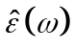would facilitate a more robust and accurate inference of the water content, and perhaps also other quantities of interest in soil physics.

Although Time Domain Spectroscopy (TDS) measurements are routinely performed in disciplines including physical chemistry, material science, medical diagnostics, the technique has largely not been used for soil science applications. The primary reason for this is that the experimental setup used in soil science differs considerably from that used in other disciplines where the fundamentals of TDS have been developed and applications brought to maturity. For example, the conventional probes used in soil science differ substantially in geometry and dimension from those in other disciplines. As a consequence, the working equations and theoretical results valid for other fields are in many cases not directly applicable in soil science.

TDS measurement can be regarded as an inverse problem, where the sample permittivity spectrum is inferred from analysis of the reflected voltage 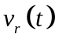. However, the relation between and is not invertible analytically, so is obtained either through numerical inversion (e.g., Newton-Raphson), or through parametric description of the function and subsequent optimization of the relevant parameters. An alternative to these procedures is the development of a simplified impedance model, valid only for short probes, which can be inverted analytically. This strategy was first introduced by Cole et al. (1989), and was adapted to the specific features of our conventional TDR instrumentation and transmission lines. Outcome: Montana developed an equivalent TDS model describing the transmission line and probe combinations typically used in soil physics applications. We derived a closed-form equation for the input impedance of the 3-rod probe. Impact: Our analyses led to significant improvements in the modeling of time domain systems, and to a substantial simplification of the TDS method that should facilitate its use by others. Based on impedance spectroscopy analysis of TDR signals we were able to measure for the first time the permittivity spectrum of materials with very good accuracy over a wide frequency range using conventional TDR instruments (e.g., Fig. 1).

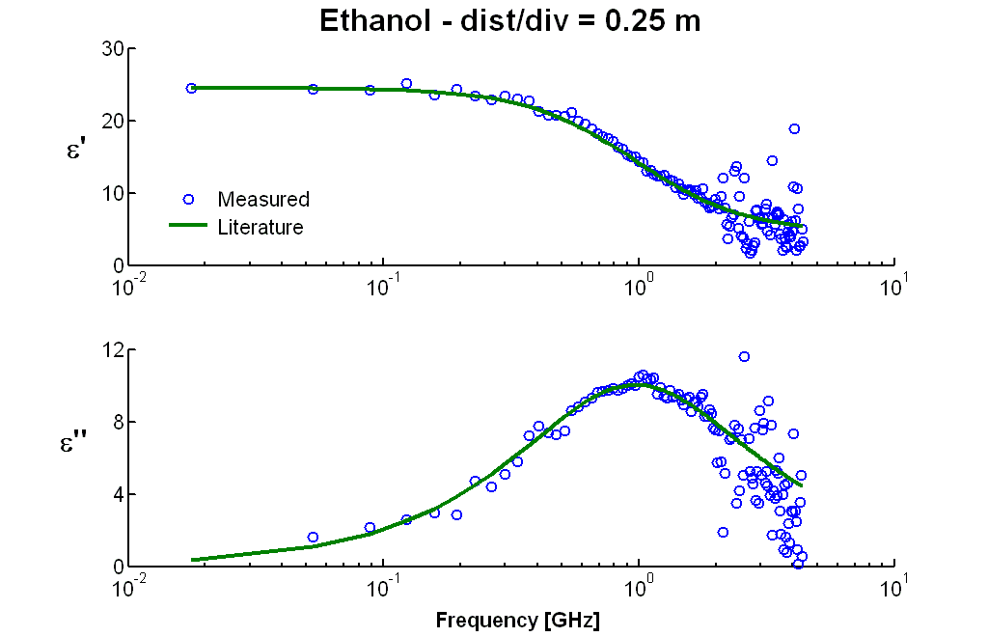

TDR Electrical Conductivity Measurements:
Time Domain Reflectometry (TDR) is commonly used for bulk soil electrical conductivity (σ_{a}) measurement, and is often preferred over other methods including four electrode probes, electromagnetic induction, capacitance sensors, etc. In spite of the substantial research efforts undertaken to improve the technique, TDR measurements remain subject to inaccuracy, particularly in the conductivity range of interest for agricultural soils. Errors arise mainly because of our inability to characterize the probe (i.e., to determine the cell constant), and from the behavior of the feeding line at low frequency (i.e., to account for cable losses). While the two problems are fundamentally distinct, in practice the cell constant is generally obtained through calibration in standard solutions of known conductivity, thus including (and masking) the errors due to energy dissipation through the feeding line (cable losses). This not only prevents us from developing a correct model for the cable losses, but also compels us to characterize the measurement setup through laborious calibration procedures. Outcome: Montana carried out combined theoretical and experimental investigations aimed at separately characterizing the probe and the feeding line in TDR electrical conductivity measurement. The first step was the development of an exact model for the feeding line, using standard network theory. The model was verified through measurements of sample resistance (R_{S}) using multiple different cable configurations. Subsequently, we related the cell constant to the sample capacitance, which can be easily obtained from analysis of the probe’s electrical field. Once the effects of the probe geometry and cable losses are properly taken into account, TDR provided very accurate measurements of electrical conductivity throughout the range of interest, as shown in Fig. 2.
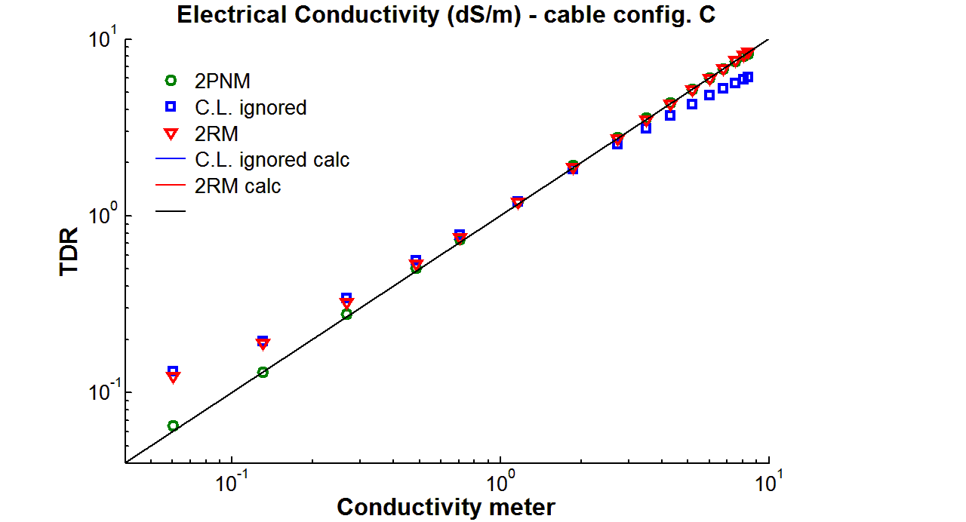

Impact: We developed a comprehensive and effective model to account for resistive losses along the feeding line, including cables, connectors, multiplexers, and the probe head. The feeding line is modeled as a generic two-port network, and its behavior at low frequency analyzed using standard network theory. We found that the line is characterized by two parameters, effectively corresponding to longitudinal and transverse losses, and which can be easily obtained from the reflection coefficient values observed with the empty and short-circuited probe. The model does not require prior knowledge of the probe cell constant. Results confirm the efficacy of our approach, and show that the commonly-used two-resistor model fails in the conductivity range of interest for practical soils applications. Once the feeding line is properly characterized, the new model can be used to compensate for errors resulting from (prior) use of incorrect cable loss models. We also found that the incident voltage (V_{i}) needed to calculate the reflection coefficients in TDR electrical conductivity measurement should be obtained from the waveform immediately following the incident step (as opposed to the common practice where V_{i} is obtained from the signal just before the probe handle). Through electromagnetic field analysis of the probe we were also able to derive analytical expressions predicting the cell constant for different probe geometries, including the 3-rod configuration commonly used for soils applications. These expressions return the cell constant from the geometry of the probe, and spare us from having to calibrate the probe-transmission line system using standard solutions of known conductivity.

Software for Numerical Convolution of Time Domain Signals
In time domain reflectometry the measured waveform (WF) results from the convolution of the incident voltage, 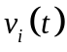, with a response function characterizing the TDR setup. Once the characteristics of the feeding line - probe system and the permittivity of the sampled material are known, the convolution process allows us to predict the resulting waveform. On the other hand, can be obtained from and the WF through a deconvolution process (i.e., through spectroscopy methods). This latter ability to predict the WFs for different sample permittivities and experimental setups allows us to investigate and identify the effects of different individual factors on the TDR response. Most commonly, the convolution is performed in the frequency domain (in virtue of the convolution theorem) through numerical methods. Numerical convolution, however, inevitably involves aliasing and truncation errors, so that the calculated WFs may differ considerably from the measured ones. Outcome: Montana conducted a theoretical investigation of the numerical convolution process, and reviewed different strategies for correcting the associated truncation errors. We found that the commonly used Nicolson ramp method (known to reduce truncation errors in Fourier transformations) performs badly for convolution processes. In this case, the errors derive from the product of the transfer and input functions in the frequency domain, a phenomenon known as circular convolution. We were able to virtually eliminate such effect through the zero-padding technique. We also developed a user-friendly software application to predict TDR waveforms, which is based on the improved numerical algorithm. The software features a Graphical User Interface (GUI), and will be soon available on our web site. Impact: The software that incorporates the improved numerical convolution concepts is able to accurately reproduce TDR waveforms due to its more sophisticated modeling of the TDR transmission line and probe. For example, frequency dependent losses in the coaxial cable and the probe (such as those resulting from the skin effect) are taken into account, as are the effects of the sample conductivity. Users can reproduce WFs for any cable length and type, for probes of different geometries (coaxial, 2-rod, 3-rod, etc.), and for materials with any number of relaxation frequencies. An initial and useful application of the software is in the design of TDR probes. For example, we analyzed the WFs obtained (calculated by the software) in high salinity media using different probe configurations, and identified the optimal probe geometry for permittivity measurements based on travel time analysis of the simulated waveforms.

TDR Waveform Analysis in Dispersive and Conductive Media:
Time domain reflectometry (TDR) measurement of soil volumetric water content relies on estimation of the soil apparent dielectric permittivity (ε_{a}) deduced from travel-time analysis (TTA) of measured waveforms. Travel time analysis returns the dielectric constant of the sampled medium for non-dispersive and non-conductive systems, but in agricultural soils (which are known to be conductive and dispersive), the TTA-determined ε_{a} represents a single permittivity value integrated over an uncertain frequency range. This range depends on the properties of the medium under investigation, as well as on the characteristics of the TDR instrument. The effective frequency range of TDR must be determined in order to compare the permittivity values estimated through TDR with those obtained using other techniques, such as remote sensing, ground penetrating radar, and capacitance sensors. addressed the uncertainty in determination of the apparent permittivity through generation of synthetic waveforms and application of TTA. Synthetic TDR waveforms are obtained through the convolution procedure described in the previous section. Waveforms were generated for various cable-probe configurations embedded in media with different dielectric properties. A primary advantage of this method is that individual factors contributing to signal distortion, such as relaxation phenomena and electrical conductivity, as well as the cable losses, can be systematically isolated. Outcome: Montana examined the different algorithms commonly used to perform travel time analysis of TDR waveforms, namely the dual tangent (DT), flat tangent (FT), and inflection point (IP) methods. We found that DT and FT gave similar results, while the IP method consistently overestimated the permittivity values and is therefore not recommended. We also determined that the electrical conductivity of the sample medium had little impact on the measured permittivity except at very high values where severe attenuation of the signal prevented the travel time analysis altogether. Conversely, the measured values strongly depend on the cable length, as shown in Figure 3. This is due to the dispersive effects that cables have on TDR signals. Finally, we suggested a procedure to identify the frequency range characteristic of the TDR setup based on perturbation analysis of the waveforms (Figure 4). Our results indicate that this range depends on the cable-probe configuration (with the cable losses having the greatest impact), as well as on the sample permittivity. For example, for a 5 m-long RG58 cable and 20 cm length 3-rod probe (typical values in practical applications), we found that the effective frequency range is 0.9 < f < 5 GHz, in accordance with other estimates reported in the literature. Research is ongoing in our laboratory to confirm the conceptual results with experimental evidence. Impact: Improved understanding of the most appropriate TDR travel time analysis algorithms will contribute to more accurate measurements in research and practical applications. Our evaluation of the effective measurement frequency range for TDR will facilitate comparison with other dielectric measurement approaches including remote sensing, ground penetrating radar, capacitance sensors, and others.
Conductivity Effects
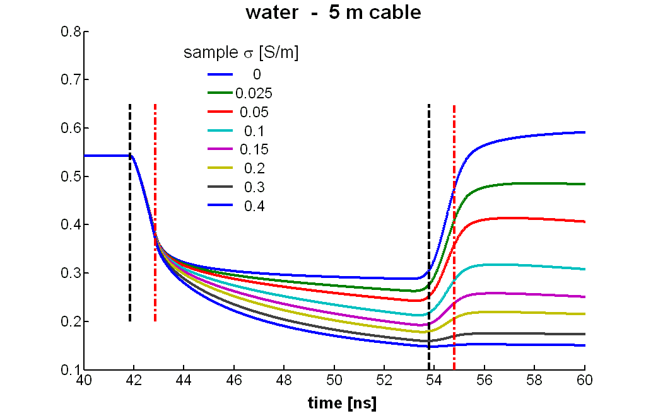

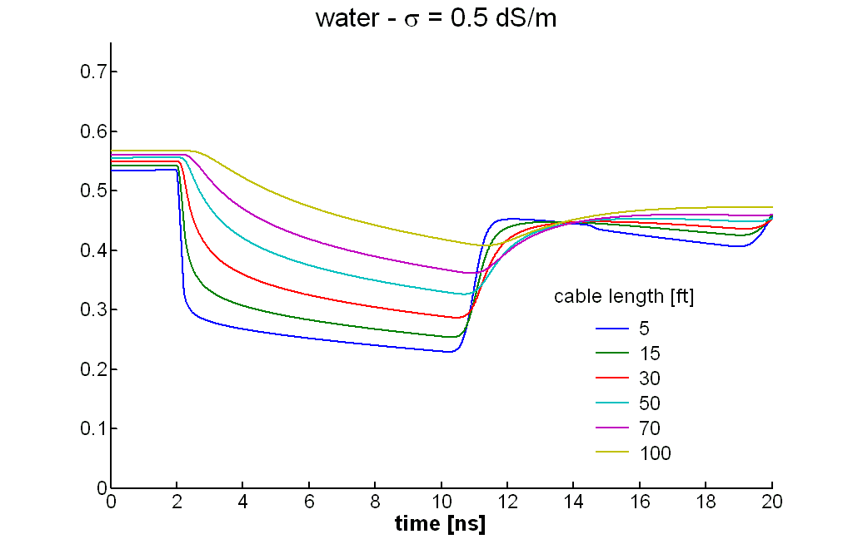
Cable Effects
Figure 3
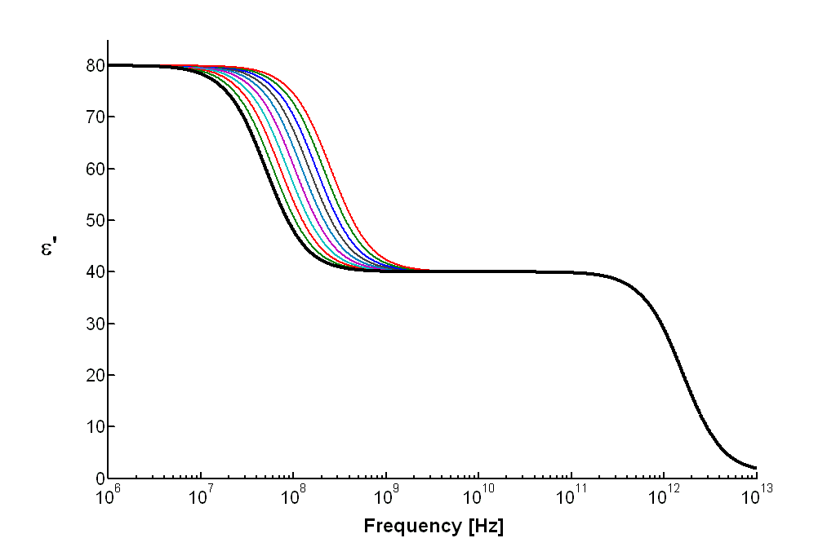
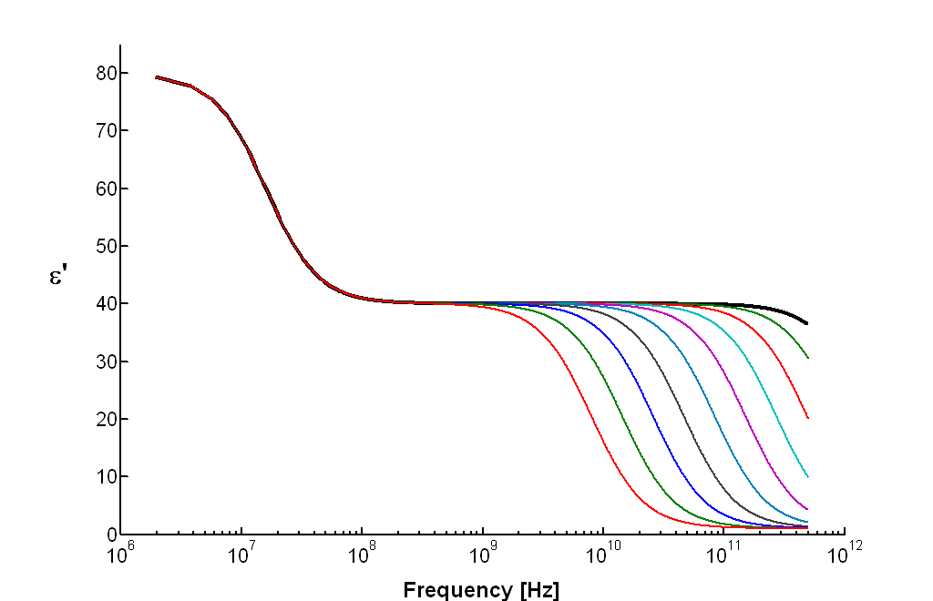
Lower TTA frequency bound
Upper TTA frequency bound
Figure 4

A Small Probe for TDR Tensiometry:
The measurement of the soil matric potential (h) is critical to characterize mass and energy transport in soils. In spite of many years of sensor development, there remains a need for matric sensors with a broad range of operation, including zero to -1.5 MPa or greater. Further, it would be desirable that a matric sensor was compatible with existing methods to measure soil water content, to facilitate in situ estimation of the soil water retention relationship (h). Outcome: Montana designed a small soil matric potential sensor by embedding a miniature time-domain reflectometry (TDR) probe within a porous fritted clay pellet. The matric potential of the pellet equilibrates with that of surrounding soil, and the soil matric potential is estimated through measurement of the pellet’s water content, using the known (h) of the pellet medium. The (h) for the fritted clay pellets was determined using a combination of hanging water column and pressure plate methods, and displays a relatively broad relationship between volume water content and matric potential for tensions to -1.5 MPa, making it well suited for tensiometric measurements. The reduced dimensions of the probe relative to alternative designs will facilitate rapid equilibration with the surrounding soil as well as provide opportunities for applications having smaller spatial scales. The embedded TDR probe is a 3-rod design with 3-mm length, 0.8-mm diameter rods spaced 3-mm apart. Measurements of the permittivity spectrum in the range 0.05 to 3 GHz are obtained using a standard TDR instrument via time-domain spectroscopy. Analyses of the sensor’s permittivity spectrum combined with a calibration procedure facilitates correlation of the pellet’s volume water content to the permittivity values displayed at high frequencies. Impact: The innovative new probe design offers a potential to obtain automated, in-situ measurements over a wide range of matric potential, for which no single sensor design currently performs well. It may be easily paired with miniature ‘conventional’ TDR probes to obtain the in situ water retention relationship of undisturbed soils.

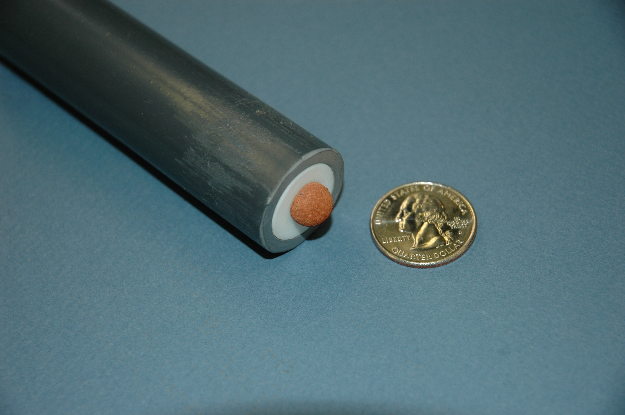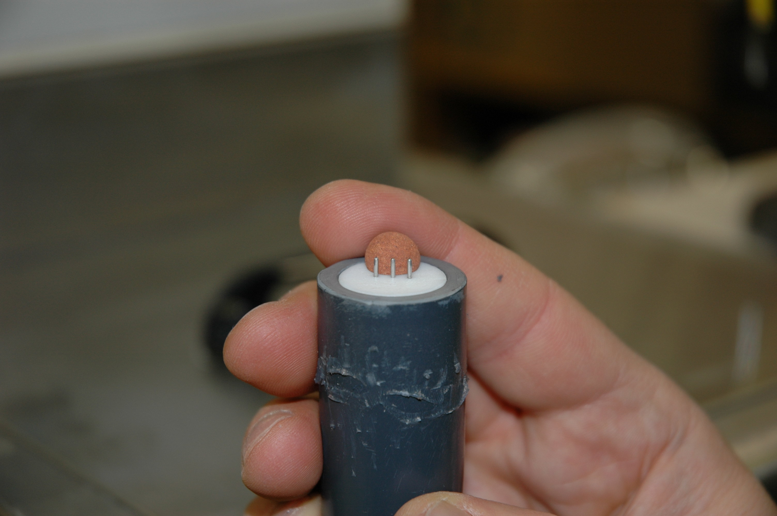

University of Arizona

Collaborators: T.P.A. Ferré, A.W. Warrick

Infiltration Relationships for Furrows:
Last year we reported new work on infiltration from two (x,z) and three-dimensional axially symmetric sources (r,z). In review, we used a generalization of results by Haverkamp, Ross, Smettem and Parlange (1994, WRR, p. 2931). They worked with a relationship for a tension disc infiltrometer for which the three-dimensional cumulative infiltration per unit source area I_{3D} [L] is the simple sum
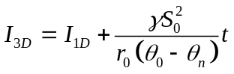
where I_{1D} [L] is the one-dimensional cumulative infiltration, γ a dimensionless “constant”, S₀ [LT^{-0.5}] the sorptivity, θ₀ [-] the volumetric water content at the disc source, θ_{n} [-] the
initial water content in the profile and t [T] is time. The last term in (1) is based on linear diffusion from an edge of a one-dimensional semi-infinite strip. Using alternate lines of reasoning, they established a“reasonable bounds” on γ of 0.6-0.8.

We the same general form for two dimensional infiltration from strips and from irrigation furrows. In each case, we generated results from HYDRUS for a range of soils, disc radii, initial water contents and source pressures and compared them to a relationship of the form
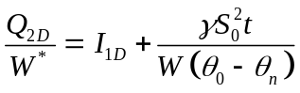
where Q_{2D} [L²] is the cumulative intake per unit length of the furrow, W [L] is the wetted perimeter, W* [L] an adjusted wetted perimeter (not to be confused with the SCS adjusted perimeter ). An approximate value of W* is W and an approximate value of γ is 0.7.

Figure 1 shows the time dependent two-dimensional cumulative infiltration (A), one-dimensional cumulative infiltration (B) and “edge effect” (C) for the three furrow shapes and for the loamy soil (soil properties are the default values from HYDRUS). Note for each furrow shape the straight line relationship for the “edge effect” consistent with (2). Figure 3 shows only the edge effect for the three shapes and three soils, all showing the straight line relationship. The overall ranges of γ and W*/W are 0.5-1.4 and 0.8-1.3, respectively. Table 1 shows general affects of hydraulic and geometric factors on their values.

Describing subsurface water patterns by moments:
Multi-dimensional spatial moments for a water plume, M_{ijk}, are defined following Ye et al. (2005), Yeh et al. (2005) and Ward et al. (2005):

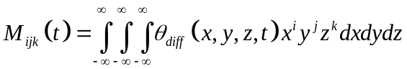
with θ_{diff} (x, y, z, t) = θ ( x, y, z, t) - θ_{init} (x, y, z, t). The center of mass is at x_{C}, y_{C}, z_{C} given by
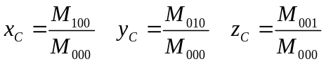

and the spread of the plume about its center is described by the spatial variance in the x, y, and z directions (σ_{x}², σ_{y}², σ_{z}²):
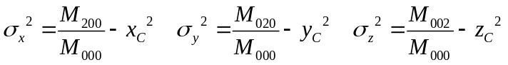
Figure 3 shows the wetting patterns and ellipses for 1 and 2 standard deviations for three representative soils under a surface line source. Figure 4 shows the vertical center of gravity, horizontal and vertical standard deviations for the same case. Figure 5 shows a probability distribution which is the fraction of added water as a function of the number of standard deviations for ellipses (in 2D) and spheroids (in 3D) on the abcissa. For practical considerations, the curves are functions of dimensions only and are independent of time, soils or input flow rates! Plots for furrows also fall on the same 2D curve.

For both the infiltration and for the moment analyses, neural networks offer a way of finding the needed parameters. In the case of infiltration from a furrow, there are 2 factors the γ and the effective wetted perimeter; in the case of moment analysis, values of the vertical center of gravity and the standard deviations are needed. We have had success with respect to the moment analysis but have not yet worked with finding the 2 factors for the infiltration.

IMPACT: The infiltration results for the furrow are a significant advance over previously existing results. They are useful for predicting flow rates from various shapes of furrows and potentially can be used to compute using a simple spread sheet. The moment analyses leads to a simple quantifying the distribution of added water in the subsurface, particularly for point and line drip sources, but potentially also for flow from furrows.
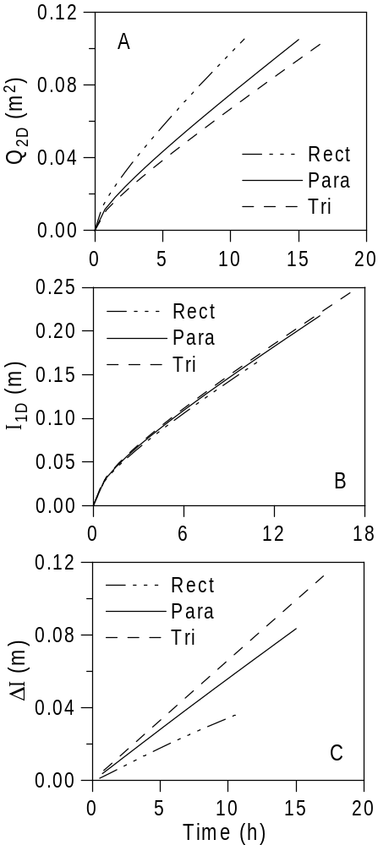
Figure 1. Time dependent two-dimensional cumulative infiltration (A), one-dimensional cumulative infiltration (B) and “edge effect” (C) for the three furrow shapes and for the loamy soil.

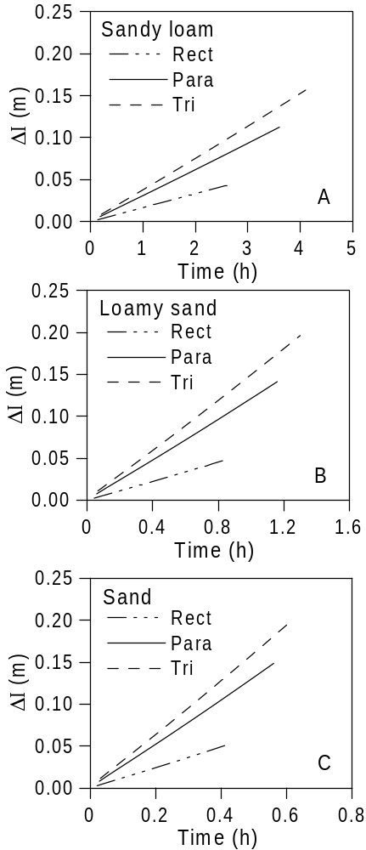
Figure 2. The “edge effect” for three furrows shapes (rectangular, parabolic and triangular) and for a Sandy loam (A), Loamy sand (B) and Sand (C) as a function of time.
Table 1. General relationship of empirical factors with soil etc.

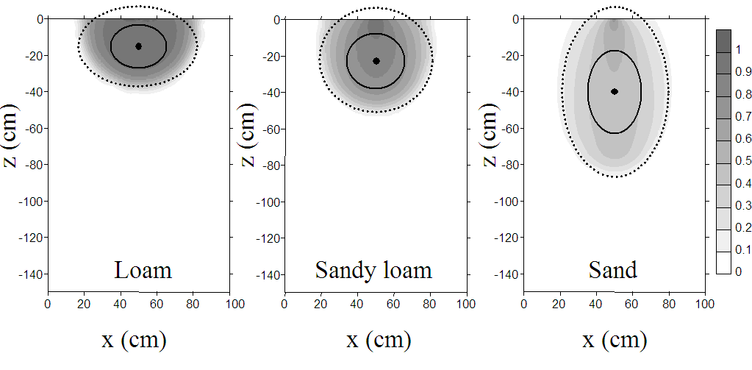
Factor | γ | W*/W
VanGenuchten m (0.35 to 0.65) | Directly proportional | Inversely proportional
Shape | Triangular > parabola > rectangular | Triangular < parabola < rectangular
Relative water  depth D/Z > 2 | No effect | No effect
Furrow depth  Z | Increases with bigger Z | Decreases with bigger Z
θ_{n} (0.01 to 0.14) | Increases with wetter initial condition | Decreases with wetter initial condition

Figure 3. Wetting patterns and ellipses for 1(solid line) and 2 (dashed line) standard deviations about center of gravity for three representative soils under surface line source.

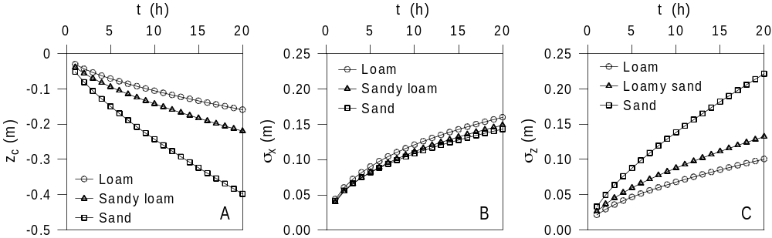

Figure 4. Vertical center of gravity, horizontal standard deviation and vertical standard deviation for surface line source in 2-D plane as a function of time.

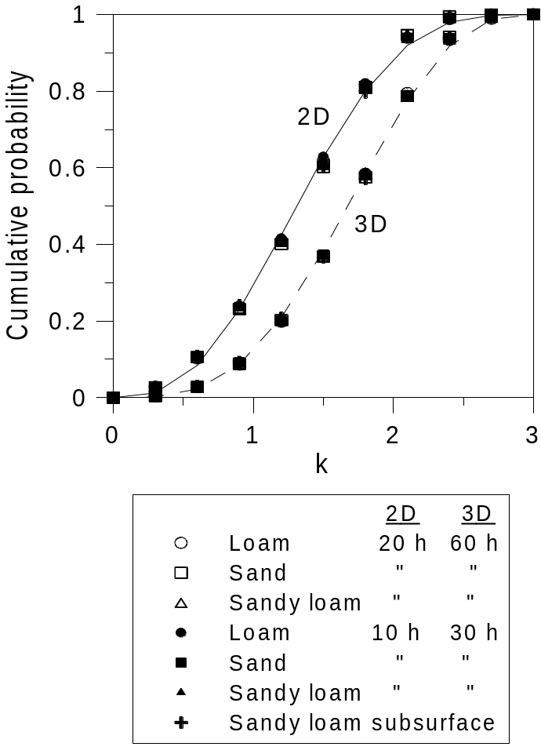

Figure 5. Cumulative probability as function of the number of standard deviations, k, in various soils times and source locations and dimensions.

University of California Davis

Develop and Evaluate Instrumentation and Methods of Analysis for Characterizing Mass and Energy Transport in Soils at Different Scales:
The overall motivation for the development of these multi-functional techniques is to achieve an improved characterization of flow and transport processes. Several benefits are achieved by combining measurements. First, by measuring several parameters at the same time and place, the coupling of related transport properties are determined in concert, thereby allowing examination of the nature of their interdependency, such as for the coupled transport of water and solute, and water and heat. Second, by using the same instrument for various measurements within approximately the same measurement volume at about the same time, the need to interpolate different measurement types in space and time is largely eliminated. Thirdly, simultaneous analysis of flow and transport using combined soil measurements of water content, temperature, and solute concentration, decreases parameter uncertainty. Thus, using multi-functional measurement techniques allows determination of inter-dependent soil properties and processes, providing an improved understanding of coupled flow and transport.

MFHPP:
Simultaneous measurement of coupled water, heat, and solute transport in unsaturated porous media is made possible with the multi-functional heat pulse probe (MFHPP). The probe combines a heat pulse technique for estimating soil heat properties, water flux, and water content, and uses a Wenner array to measure bulk soil electrical conductivity. The heat pulse probe (HPP) has increasingly received attention recently as it allows in-situ, direct, simultaneous, and automated measurements of soil hydraulic and thermal properties, as well as soil water fluxes. Although the currently used design allows many applications, changes in HPP design and operation are needed to increase the sensitivity to smaller water fluxes. Numerical studies were conducted to evaluate the effects of 1) sensor locations and thermal properties of the HPP body material, 2) the heater diameter and heat pulse intensity, and 3) vapor flow on HPP performance. We concluded that the larger heat pulses can be applied to measure low water fluxes, provided vapor transport is considered.

The MFHPP is adapted for field use with wireless communications. Alternative designs incorporate reduced power consumption with new low-voltage electronic design techniques and miniature circuitry. Current developments will include an ad-hoc multi-hop wireless network to study in situ process of coupled water, nitrate and heat transport in plant root zone of both natural and agricultural ecosystems. The proposed system includes signal processing circuits, a microcontroller, and a RF transceiver with ZigBee™ protocol. Prototype measurements showed that it is possible to implement the multi-functional probe in a small-scale microsystem.

Dialysis Membrane Sampler:
Passive solution samplers are an important alternative to active sampling, pumping, or purging of monitoring wells in saturated soils and in groundwater. We developed and tested a low-cost passive solution sampler using readily available dialysis membrane tubes made of regenerated cellulose membrane, hardware supplies, and Teflon string.

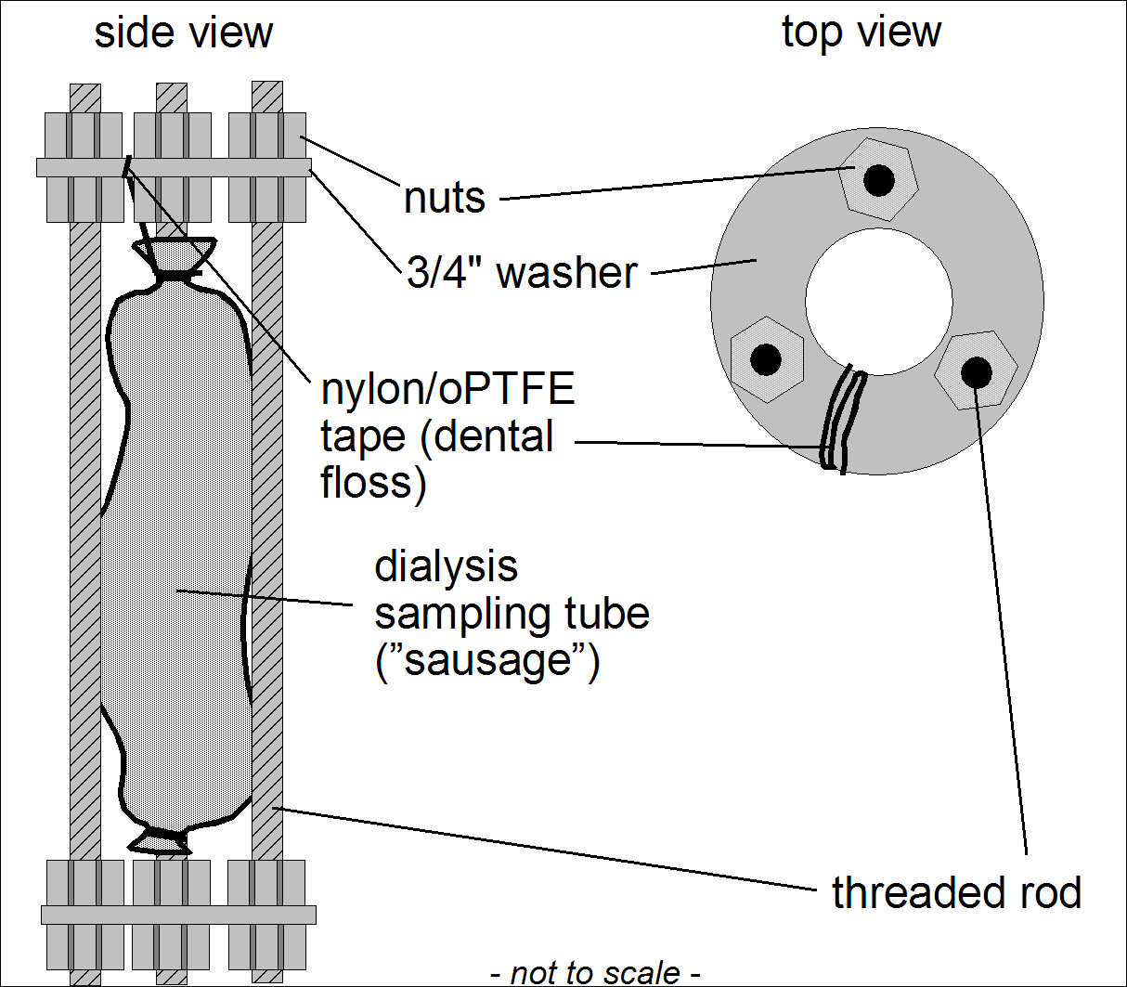

The time needed for the solution sampler content to equilibrate with the surrounding water quality is determined by the shape of the solution sampler and by the diffusion through the membrane. We developed an effective equation from which the membrane diffusion coefficient can be computed for arbitrary ions based on their aqueous diffusion coefficient. We demonstrated the utility of this sampler to construct an open multi-level sampling (oMLS) system in monitoring wells that effectively captures profiles and average concentrations of nitrate and salinity in shallow groundwaters affected by recharge from animal farming systems (Harter and Talozi, 2004).

University of California Riverside

Collaborator: Laosheng Wu

An Integrated Model for Evaluating the Effects of Reclaimed Wastewater Irrigation:
Water reclamation and reuse are becoming essential components of integrated water resources management worldwide since the treated wastewater can serve as an alternative water resource to help satisfy increasing demands for water. One common use for reclaimed wastewater is for agricultural irrigation. While wastewater reuse for agriculture has many benefits, it should be properly managed in order to maximize productivity and reduce negative environmental impacts such as salinity buildup, nitrate leaching, and crop uptake or transport to groundwater of toxic metals. In this research, a user friendly (Windows based) model is being specifically developed to evaluate the effects of wastewater irrigation on crop growth, salt distribution and movement, nitrogen balance, and the fate of toxic metals in the root zone. The model allows simulation of the water, salt, nitrogen, and toxic element movements in soil and their effect on relative crop yield. The later is influenced by water pressure, salinity, and nitrogen stresses. Model outputs include relative crop yield, mass balance tables about water flow, nitrogen and selected elements, the temporal as well as profile distributions of salts, nitrogen and selected elements. It can be used as a planning tool to assess the risks related to reclaimed water application. Specifically, the model will help to select appropriate management practices to sustain crop production and environmental quality in soils irrigated with reclaimed wastewaters.

University of Nevada and Desert Research Institute

Collaborators: Markus Berli, Todd Caldwell, Scott Tyler, Wally Miller, Michael Young, Jianting Zhu

Nevada has been working to develop methodologies to characterize vadose zone heterogeneity and variability in soil hydraulic properties and processes by (1) incorporating “hard”-to-measure data and readily available “soft” data, such as soil moisture measurements and topographic attributes and remotely-sensed land cover information, (2) developing new methodologies that incorporate temporal and spatial variability of mass and energy transport, and (3) developing a new research facility specifically designed for high resolution measurements of mass and energy transport.
Using cokriging and artificial neural network (ANN), Nevada developed a new method to generate heterogeneous soil hydraulic parameters based on a variety of data. The method is applied at the S&L site of the U.S. Department of Energy’s Hanford Site. The generated hydraulic parameters are used to simulate the 2000 field injection experiment within the imperfectly stratified media at the S&L site. The soil hydraulic properties data include laboratory measurements of saturated hydraulic conductivity and van Genuchten moisture retention parameters obtained from 70 core samples. Another type of data used, also referred to as pedotransfer variables, are bulk density and percentages of gravel, coarse sand, fine sand, silt, and clay measured for the same 70 core samples. The data set also includes 1,376 observations of initial moisture content (θ_{i}) before the 2000 injection experiment started as secondary variable [Ye et al., 2006].
At another field site, based on the soil deposition and vegetation growth patterns across a topographically heterogeneous landscape, Nevada also explored the use of topographic and vegetation attributes – in addition to pedologic attributes – to develop pedology-topography-vegetation-transfer functions (PTVTFs) for estimating soil hydraulic properties in the Southern Great Plains of USA [Sharma et al., 2006; Mohanty et al., 2006]. We specifically explored the usefulness of topographic attributes from Digital Elevation Model (DEM) and remotely-sensed Normalized Difference Vegetation Index (NDVI) in addition to soil physical attributes for developing and improving catchment- or regional-scale pedo-transfer functions.
Nevada is also developing Raman spectra optical time domain reflectrometry for the measurement of temperature along long (1-4 km) fiber optic cables. Resolution of temperature at 1-2 meter scales with an accuracy of 0.1 °C with 5-10 minute integration time appears feasible. Current plans call for cable installations 1-2 cm below the land surface on agricultural fields to determine seed bed temperatures in a much more dense spatial array than previously developed.
Nevada also incorporated Monte Carlo simulations and a combination of site-specific data (e.g., soil properties, climatic conditions, and native vegetation) to design alternative (evapotranspiration) landfill covers at Edwards Air Force Base, located near Lancaster, CA [Young et al., 2006]. Laboratory analyses of site soils indicated the presence of three distinct surface soils, from which statistical distributions were generated. A 10-yr climate sequence (precipitation and potential evapotranspiration) was used for the upper boundary. Potential evapotranspiration was partitioned into potential evaporation and potential transpiration using the phenology of a Mojave Desert plant community. Nearly 1000 realizations were run for each of 72 different combinations of soil type, cover thickness, and plant cover percentage. The results indicate that threshold design parameters, needed to limit deep flux to <0.5 cm yr⁻¹, differ based on the relationship between the Ks (saturated hydraulic conductivity) of the surface soil, cover thickness, and plant cover percentage. In the lower conductivity soils (mean Ks = 20 cm d⁻¹), deep flux was ≤0.2 cm yr⁻¹ for a cover thickness >80 cm with a plant cover >10%. Higher conductivity soils (Ks=250 cm d⁻¹) required thicker soils covers (>100 cm) and greater plant cover (>20%) to achieve similar fluxes. In all cases, variations in both cover thickness and plant cover percentage indicated threshold values, above which incremental additions added little to cover performance. The methods developed here could be implemented at other sites where conditions are known. Designs can account for uncertainties in site parameters and contribute to improved decision making.
During 2006, Nevada completed its first full year of a three-year NSF grant to create a new research facility. The theme of this NSF EPSCoR Infrastructure grant is: Scaling Environmental Processes in Heterogeneous Arid Soils (SEPHAS). This research program focuses on scaling of subsurface and landscape-interface environmental processes in arid settings. The SEPHAS project seeks to add infrastructure for scientists inside and outside of Nevada, and address scaling issues by focusing on constructing large outdoor weighing lysimeter systems that contain intact and disturbed soil blocks. The current plan calls for up to seven weighing lysimeters, each independently instrumented depending on the needs of the research community. Depth of the lysimeters is 3 m. Data collected through automated systems will be archived and available to facility researchers through the Internet. Groundbreaking is planned for early 2007. Funds are also available for indoor instrumentation for soil/water analyses and high resolution imaging. When completed, the SEPHAS project will allow researchers to investigate mass and energy budgets, carbon sequestration, nitrogen fixation, soils development and soil/plant interactions, specifically related to arid soils. Nevada is seeking partners for future research that could use these lysimeters.
Impact: Our new method of generating heterogeneous soil hydraulic parameters has significant potential implications. The proposed method is generic and can be extended to include other site measurements of varying types through cokriging. For example, if more measurements of pedotransfer variables are available, they can be incorporated in the cokriging to generate more realistic fields. If the dense initial moisture content data set is not available at other sites, other easily obtained geophysical measurements (e.g., electrical resistance tomography and ground-penetrating radar etc.) may be used as the secondary variable for cokriging. Findings of our studies will also be useful for estimating pixel-scale soil hydraulic parameters in Soil Vegetation Atmosphere Transfer (SVAT) schemes in regional-scale hydro-climatic models. The numerical implementation of soil/plant/climate variability was effective in helping to understand the complex interactions between environmental parameters. The method could be used in a variety of different environmental applications, including land restoration, and water budget and ecosystem studies.

USDA-ARS, Bushland, TX

Collaborators: Robert Schwartz and Steve Everett

Sensor comparison of soil profile water content determinations in a wheat field:
Electromagnetic (EM) soil water sensing systems are rapidly gaining acceptance for soil water sensing. Common systems use sensors based on capacitance or time domain reflectometry (TDR) principles. For three capacitance soil water sensing systems (Sentek EnviroSCAN, Sentek Diviner 2000, and Delta-T PR1/6), the Trime T3 quasi-TDR soil water sensing system, and the neutron moisture meter (NMM), we developed soil-specific calibrations for the A, Bt, and calcic Bt horizons of the Pullman soil at Bushland, TX (Evett et al., 2006). We applied these calibrations to data acquired in a wheat field in 2003 in order to investigate the variability of soil water estimates without the confounding factor of inaccurate factory calibrations. There were ten access tubes for each system, arranged in linear transects. After the first three measurement cycles, half of the winter wheat field (containing five access tubes) was irrigated to see how the five systems were able to sense the differences in water content. Access tubes were spaced 10-m apart. In addition to the five soil water sensing methods, gravimetric samples were taken with a hydraulic push probe in transects on some of the sampling dates. Sampling points were spaced 10-m apart; and samples were 10-cm in height and had a volume of 75.5 cm³.

Profile water contents reported by the six methods differed considerably (Fig. 1), particularly in the degree of water content variability and the shape of the profile, including over and under estimation of water content at different depths. The smallest variability of water content was reported by the NMM; variability of gravimetric measurements was only slightly larger; and variability of Trime T3 results was somewhat more variable but still representative of the profile water content in much the same way as the NMM and gravimetric methods. While all of the EM sensors exhibited more variability than the NMM, the three capacitance sensors exhibited the most variability as well as a tendency to severely underestimate water content above 0.5-m depth. Because of the consistency of this underestimation, we believe it is a result of the dependency of the calibration coefficients on soil clay content that increases with soil depth.

The NMM exhibited the smallest SD of water content for either the dry or irrigated sides of the field, with values approximately one half of those from gravimetric samples. By contrast, the EM methods exhibited SD values usually larger than those from gravimetric sampling, particularly for the dry side of the field in the 20 to 60-cm depth range. As a consequence, determination of the profile water content to within 1-cm precision would require two NMM access tubes, two gravimetric cores, four Trime T3 access tubes, 20 access tubes for the EnviroSCAN and Diviner 2000, and 130 access tubes for the PR 1/6. The greater variability exhibited by the EM methods in the dry side of the field, particularly in the zone of active root water uptake (depths <150 cm), is probably related to the relatively smaller measurement volumes of these sensors compared with that of the NMM or even the gravimetric samples.

Ranking of the mean relative difference of estimated water contents was used to evaluate if the five locations in the irrigated side of the field were consistently wetter than the five locations in the un-irrigated side of the field (Fig. 2). The most reliable relative differences were computed from the NMM data, which also showed the least variability over time, and the next most reliable were from the gravimetric data. Data from the Trime T3 probe, which was read in the same access tubes as the NMM, showed a trend in the data, particularly on the dry side, which was not evident in the gravimetric or NMM data. Similar trends were apparent in data from the three capacitance sensors, with location six being sometimes not clearly different from the irrigated side of the field. Although the EnviroSCAN and Diviner 2000 were read in the same access tubes, the Diviner 2000 showed less inherent variability, but also a less clear distinction between irrigated and dry sides of the field than did the EnviroSCAN. Data from the PR1/6 did not clearly differentiate between irrigated and non-irrigated sides of the field.

The capacitance-based soil water sensing systems were so sensitive to small-scale variability in soil water content (or, more likely, bulk electrical conductivity) that many more access tubes would be needed to obtain a plot mean profile water content to a given precision than would be required for the NMM or gravimetric methods. Despite soil-specific calibrations, the capacitance-based systems were more inaccurate than the NMM in detecting differences in soil water content. The Trime T3 quasi-TDR system is much less sensitive to variability in soil properties, probably because it employs a waveguide that forces the EM pulse to pass soil moieties that are both wet and dry. Problems with access tube installation and sensitivity to temperature changes, not reported on here, make the Trime T3 system a poor choice for profile water content determinations for crop water use studies. There is currently no substitute for the neutron moisture meter for scientific studies of profile water content changes and determinations of crop water use in water use efficiency studies.

Temperature correction of apparent permittivity measurements in soils using time-domain reflectometry:
High frequency dielectric measurements of soil water content can exhibit temperature sensitivities inconsistent with that expected for bulk water, θ (m³ m⁻³). In fine-textured soils, diel oscillations of soil water content of up to 0.03 m³ m⁻³ are commonly estimated using time-domain reflectometry (TDR). Water content oscillations near the soil surface are uncharacteristically in phase with soil temperature. Based on previous studies, these temperature responses are thought to be principally controlled by the interplay among the temperature dependencies of the static permittivity of bulk water, the volumetric fraction of bound water (θ_{bw}), and the bulk electrical conductivity of soils, σ_{dc}. The objective of this study was to develop and evaluate physically-based and empirical expressions to estimate temperature, T, effects on apparent permittivity and soil water content.

The apparent permittivity K_{a} of a bulk soil inferred from the propagation velocity of a transverse electromagnetic signal can be described by the Debye Equation (von Hippel, 1954; Robinson et al., 2003)
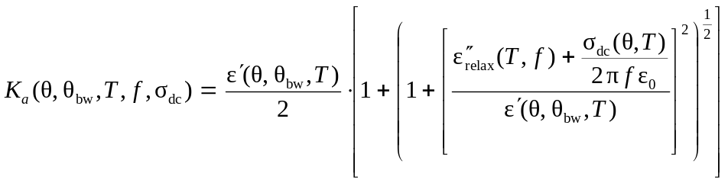
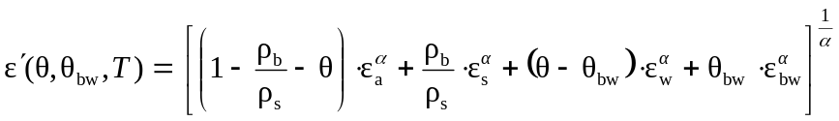where f is an effective frequency. Secondly, we assume that the real part of permittivity ε΄ can be evaluated using a dielectric mixing model
where ε_{w} is the static permittivity of water, ρ_{b} is the soil bulk density, ρ_{s} is the particle density. And we assume that conductive losses can be evaluated using measured or predicted bulk electrical conductivity with negligible relaxation losses. Appropriate expressions for describing the temperature dependencies of σ_{dc}, θ_{bw}, and ε_{w} permit a closed form solution of apparent permittivity as a function of soil water content. We also developed and evaluated an empirical equation to describe temperature dependent soil water content of the form
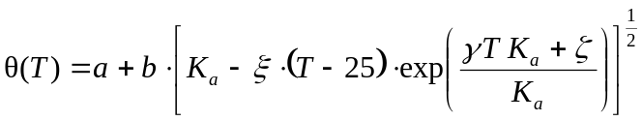

where a, b, ξ, γ, and ζ are fitting parameters. Ottawa silica sand (1 replicate) and the Ap and Bt horizons (3 replicates) of a Pullman clay loam (fine, mixed, superactive, thermic Torrertic Paleustolls) were packed in 0.2 m dia. × 0.21 m PVC columns. Volumetric water content in the sand column was adjusted by repacking with a range of water to soil mixtures. Water content in soil columns were adjusted by applying tension at the base of the column, evacuating air through the base of the column, and slow evaporative drying at the top of the column combined with long equilibration times between short periods of drying. Travel time and attenuation of the signal were measured using a Tektronix 1502C cable tester in conjunction with the TACQ Software. Triplicate permittivity measurements were taken at room temperature (20-23 ˚C), in a refrigerator (6-8 ˚C) and in an incubator (40-42 ˚C).

Using the Debye Equation in conjunction with the dielectric mixing model permitted an adequate representation of the temperature and soil water effects on apparent permittivity (Fig. 3). Inclusion of bound water in the mixing model was a necessary assumption for the Pullman soil to describe the measured temperature dependence at low soil water contents and also to avoid underestimation of water contents. Moreover, a nonzero bulk EC was required to explain observed temperature dependencies for the Pullman soil at high water contents. Nonetheless, the fitted bulk EC at 25 ˚C and saturation (0.10 – 0.25 S m⁻¹) overestimated the measured bulk EC unless effective frequency was reduced to values less than 100 MHz. The empirical model was also able to correctly describe temperature dependencies in soil water content measurements in the Pullman soils and the silica sand. However, use of this model under field conditions requires duplicating the cabling and multiplexer setup in the field whereas use of the Debye-Mixing Model could permit the accounting of losses and high-frequency filtering in the estimation of apparent permittivity. Application of temperature corrections under field conditions improved the accuracy of soil water content measurements and reduced or eliminated diel oscillations. (Schwartz, Evett, and Bell; in preparation).

USDA-ARS, St. Paul, MN

Collaborator: Tyson Ochsner

Table 3. Results of partial cylindrical T-TDR sensor validation where ρc is volumetric heat capacity, λ is thermal conductivity, and K is the dielectric permittivity. †denotes value measured by independent laboratory methods.

Medium | Parameter | Reference value | Sensor Estimate | Difference % | Coefficient of Variation %
Water | ρc (MJ m⁻³ K⁻¹) | 4.174 | 4.217 | 1.0 | 0.17
 | λ (W m⁻¹ K⁻¹) | 0.614 † | 0.615 | 0.2 | 0.35
Acetone | 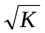 | 4.58 | 4.65 | 1.4 | 0.75

A New Partial Cylindrical Thermo-time Domain Reflectometry Sensor Capable of Accurately Measuring Soil Water Content and Thermal Properties:
Thermo-time domain reflectometry (T-TDR) sensors can be used to measure soil thermal properties and water content (θ), and to obtain indirect estimates of bulk density and air-filled porosity. However, the small size and sensitivity to needle deflection of the conventional T-TDR sensor limit its accuracy, precision, and durability. In this study we changed the size and geometry of this sensor to improve accuracy and precision and to better withstand the stress of field use. The new partial cylindrical design features opposing curved heaters with a central temperature sensing needle and is more than double the size of conventional T-TDR sensors (Fig. 1). The new design drastically reduced sensitivity to needle deflection. Laboratory testing indicated that the new sensor was capable of accurately measuring dielectric permittivity and thermal properties (Table 3). In soil the new sensor performed as well as, or better than, conventional T-TDR sensors in all areas except volumetric heat capacity (ρc) estimates. Qualitative assessment indicated that the partial cylindrical sensor should be less prone to distortion.

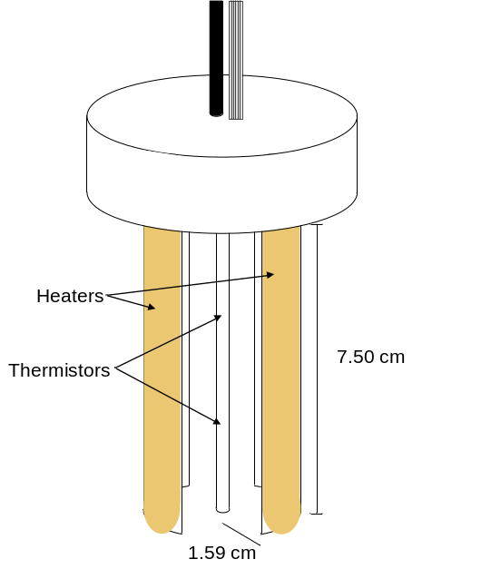
USDA-ARS USSL, Riverside, CA

Collaborators: Scott Bradford, Peter Shouse, Todd Skaggs, Rien van Genuchten, Scott Yates

Measuring Herbicide Volatilization from Bare Soil:
A field experiment was conducted to measure surface dissipation and volatilization of the herbicide triallate after application to bare soil using micrometeorological, chamber, and soil-loss methods. The volatilization rate was measured continuously for 6.5 days and the range in the daily peak values for the integrated horizontal flux method were from 32.4 (day 5) and 235.2 g ha-1 d-1 (day 1), for the theoretical profile shape method were from 31.5 and 213.0 g ha-1 d-1, and for the flux chamber were from 15.7 to 47.8 g ha-1 d-1. Soil samples were taken within 30 min after application and the measured mass of triallate was 8.75 kg ha-1. The measured triallate mass in the soil at the end of the experiment was approximately 6 kg ha-1. The triallate dissipation rate, obtained by soil sampling, was approximately 334 g ha-1 d-1 (98 g d-1) and the average rate of volatilization was 361 g ha-1 d-1. Soil sampling at the end of the experiment showed that approximately 31% (0.803kg/2.56kg) of the triallate mass was lost from the soil. Significant volatilization of triallate is possible when applied directly to the soil surface without incorporation.
Figure 1. The partial cylindrical thermo-TDR sensor.

Estimation of Soil Hydraulic Properties from Tension Disk Infiltrometer Data:
Many applications involving variably saturated flow and transport require estimates of the unsaturated soil hydraulic properties. Numerical inversion of cumulative infiltration data during transient flow, complemented with initial or final soil water content data, is an increasingly popular approach for estimating the hydraulic curves. In this study, we compared Mualem–van Genuchten (MVG) soil hydraulic parameters obtained from direct laboratory and in situ unsaturated hydraulic conductivity measurements with estimates using numerical inversion of tension infiltration data of four coarse- to medium-textured soils in Alentejo (Portugal). The laboratory methods used were suction tables, pressure plates, and the evaporation method as applied to undisturbed soil samples collected from the surface horizons of four different soil profiles. Field measurements were taken with a tension disk infiltrometer using consecutive supply pressure heads of -15, -6, -3, and 0 cm. Six MVG parameters (the residual soil water content, the saturated soil water content, three empirical shape factors, and the saturated hydraulic conductivity) were estimated from the field data by numerical inversion using the HYDRUS-2D software package, and compared with values estimated from the laboratory data. Macroporosity was also determined. The laboratory- and field-measured water retention curves were found to agree closely for most experiments as reflected by relatively high values of the coefficient of determination, the modified coefficient of efficiency, and the modified index of agreement (always >0.9949, 0.8412, and 0.8931, respectively). The unsaturated hydraulic conductivity curves were predicted less accurately, although good estimates of the saturated conducivity were obtained. This study confirms that numerical inversion of tension infiltrometer data provides a relatively simple and reliable method for determining the water retention and conductivity curves of unsaturated soils. Results are important for scientists and engineers trying to estimate the unsaturated soil hydraulic properties for subsequent use in models predicting water flow and solute transport processes at the field scale.

Utah State University (USU)
Collaborator: Scott B. Jones

The fate of precipitation and snowmelt are important inputs to hydrological modeling. Higher soil moisture often results in increased runoff due to the limited storage capacity and to a limited infiltration rate (i.e., near long term rates) of the soil. While soil moisture sensors are widely used in monitoring of weather station sites, a more widely distributed set of moisture measurements is desirable for obtaining spatial information across a watershed. Recent work using heat-pulse measurements to assess water flux in soil have shown promise for determinations of flux ranging from 1 to 1000 mm h⁻¹. While these flow rates exclude many finer textured and unsaturated soil transport rates, they can capture the higher rates associated with significant rainfall and snowmelt events where the soil matrix is satiated. A single sensor can provide estimates of soil moisture and temperature in addition to flux estimates. Preliminary results in soil columns demonstrated a range of flux rates for near-saturated conditions. Infiltration rate comparisons between infiltrometer and flux probes showed reasonable agreement even without soil specific calibration. A forest test site has been instrumented under 4 native vegetation regimes to evaluate both water flux sensors and CO2 concentration sensors. The goal is to monitor snow melt infiltration as inputs to hydrologic modeling and carbon dynamics in common Forest ecosystems.

Impact: Our gradient-based flux approach (Turcu, Jones and Or, 2005) is being adopted in many ecological studies where long-term measurements of soil CO₂ concentration and flux estimates are needed. This measurement technique is being applied in the T.W. Daniel Experimental Forest and will provide important information on soil carbon dynamics in Utah’s Forest Ecosystems.
Washington State University (WSU)
Collaborators: Markus Flury and Joan Wu
The suitability of Passive Capillary Samplers (PCAPS) for collection of representative colloid samples under partially saturated conditions was evaluated by investigating the transport of negatively and positively charged colloids in fiberglass wicks. A synthetic pore water solution was used to suspend silica microspheres (330 nm in diameter) and ferrihydrite (172 nm in diameter) for transport experiments on fiberglass wicks. Breakthrough curves were collected for three unsaturated flow rates with silica microspheres and one unsaturated flow rate with ferrihydrite colloids. For silica microspheres, 90% of the colloids were transmitted through the wicks. For ferrihydrite, 80% of the colloids were transmitted. The mechanisms responsible for the retention of the colloids on the fiberglass wicks appeared to be physico-chemical attachment and not thin-film, triple-phase entrapment, or mechanical straining. Visualization of pathways by iron staining indicates that flow is preferential at the center of twisted bundles of filaments (Shira et al., 2006).
We investigated the feasibility to produce porous media with similar hydrodynamic properties, but different surface characteristics. Four minerals (ferrihydrite, kaolinite, illite, and smectite) and a humic acid were coated on silica sand grains (Jerez et al., 2006). Coated grains were packed into columns and the hydrodynamic properties of the media were determined with anionic tracers. The hydrodynamic properties of the various coated silica sands were similar, suggesting that porous media with similar spatial structure, but different surface characteristics, could be produced (Jerez and Flury, 2006).
Dye tracers are important hydrological tracers. Only a few commercially available dyes have been systematically evaluated for their suitability as hydrological tracers. Sorption is one of the limiting factors for the suitability of a dye tracer. We examined the sorption of four dyes to a sandy soil using batch and column techniques. The four dyes, C.I. Food Blue 2 (Brilliant Blue FCF), C.I. Food Green 3, C.I. Acid Blue 7, and C.I. Acid Green 9, were all from the class of triarylmethnane dyes. Adsorption isotherms were determined and analyzed with the Langmuir equation. The four dyes showed two different sorption behaviors: C.I. Food Green 3 and C.I. Food Blue 2 sorbed considerably less than C.I. Acid Green 9 and Acid Blue 7. The former two dyes contain three sulfonic acid groups while the latter only contain two sulfonic acid groups (Mon et al., 2006b,c).
Impact: Colloid sampling in the vadose zone is a challenging task. Several studies on colloid sampling in the vadose zone have been reported, and our work is the first to systematically investigate this topic. Our results show that colloid sampling in the vadose zone is possible, but has limitations on quantitative interpretations. Our studies on coating of clay minerals on silica grains have important implications for the use of clay minerals for sorption and transport studies. Our method for coating of different materials onto silica sand grains allows studying of interactions of chemicals and colloids with dynamic flow experiments in a porous medium with defined structure. We have further advanced our understanding and the application of dyes as vadose zone tracers. C.I. Food Green 3 was found a good hydrological tracer, and is an alternative to C.I. Food Blue 2, which is frequently used as a vadose zone tracer.

OBJECTIVE 3: To develop and evaluate scale-appropriate methodologies for the management of soil and water resources

California State University Fresno

Collaborator: Zhi Wang

Performance of ridge and furrow planting for rain harvesting in Northwest China:
Ridge and furrow planting system (RFPS) for rain harvesting agriculture has been commonly practiced for decades in the Loess Plateau of northwest China resulting in significant improvements in soil and water conservation and economic returns. In the conventional RFPS, the ridge serves for planting and the furrow serves for water conservation. This study was focused on the reversed RFPS where the ridge serves for rain harvesting and the furrow for planting and water conservation (Yu et al., 2006). The relationships between the amount of harvested water versus ridge surface treatment and ridge-to-furrow ratio were quantified. Two types of ridge surface treatment (bare and plastic covered) and three ridge-to-furrow ratios (i.e., 30:60, 45:60 and 60:60 by width in cm) were studied experimentally. The results showed that the plastic covered ridges could harvest about 60% of precipitation compared to about 6% for the uncovered bare ridges in the study area with an annual precipitation of 263 mm (or 10.4 inches) varying between 150 mm (5.9 inches) and 400 mm (15.7 inches). Because of raindrop splashing from the plastic surfaces, the narrower ridges lost more water than the wide ridges. The wider ridges gained about 5% more runoff per 15-cm increase in the ridge width ranging from 30 cm to 60 cm (1 to 2 ft). Visual examination of the crop growth status indicated that the 60-cm wide, plastic-covered ridges produced the best promise for higher crop yield. Therefore, the plastic-covered ridges with the highest ridge-to-furrow ratio (60-cm to 60-cm) were recommended for applications in this region.

Development of Sequentially Activated Micro-Flood Irrigation System (SAMFIS) to increase irrigation efficiencies:
A preliminary study was carried out to develop a Sequentially Activated Micro-Flood Irrigation System (SAMFIS). The practical purpose is to reduce agricultural runoff and deep percolation for ecosystem restoration in Central Valley and the Bay-Delta area of California. Irrigation efficiency can be significantly improved if control of water flow is engineered into the system and not left to human control, such as in the center pivot sprinkler systems. Flood irrigation mechanization has met with limited success, partly due to the complex physics involved in predicting the simultaneous surface sheet flow and unsteady infiltration in the soil, and balancing hydraulic parameters and the volume of runoff and deep percolation. We try to incorporate a computer program for surface irrigation simulation and design with innovative water delivery system that results in an automated surface irrigation system in which a low cost Sequential Irrigation Valve (SIV) will be used as the critical water-flow control device. The new concept of surface irrigation will result in a scientifically designed and technically programmed system that can be achieved without changing the existing field layouts and without arbitrary human intervention.
Development of geodatabase models for water management in the San Joaquin Valley:
We have also started building geodatabase models for assessment of watersheds in east Sierra Nevada and groundwater banks in the San Joaquin Valley. This includes the collection of digital elevation models (DEM), land and water use data, meteorological and geological datasets, etc., for regional assessment of water resources, water supply and water quality conditions. A GIS-aided watershed model (BASINS) was used to simulate hydrographs and water quality in streams along the foothill areas of east Sierra Nevada. We started with the Fresno River Watershed. The model produced reasonable hydrographs when compared with historical and our own monitoring data. However, it’s difficult to obtain the water quality predictions due to limited history of monitoring data and complicated parameterization of various pollutant sources and sinks in the watershed.
We used ArcHydro, ArcGIS, BASINS and HYDRUS software programs to simulate the capacities of surface and groundwater banks in San Joaquin Valley. Results were consistent with those obtained separately by Geomatrix company. We also started student projects to estimate snow water resources in the upper Fresno River and San Joaquin River watersheds using GIS and NOAA data. This will be linked to studies on global climate changes indicated by snowpack retreat.

Iowa State University and USDA-ARS National Soil Tilth Laboratory

Collaborators: Toby Ewing, Dan Jaynes, and Bob Horton

Surface and subsurface solute transport properties at row and inter-row positions:
Accomplishments. Although numerous studies have investigated the effects of crop production practices on soil water dynamics, not much information is available on the impact of row position on solute transport. A field experiment was carried out to evaluate surface and subsurface solute transport properties in plant-row, non-trafficked inter-row, and trafficked inter-row positions. For this purpose, a plot of 14- by 14-m in a strip-cropped field with soybean (Glycine max L. Merr ), corn (Zea mays L.), and oat (Avena L.) was selected. After harvesting the crops, surface (top 2 cm) electrical conductivity measurements were made by time domain reflectometry (TDR) at 45 locations during a chloride pulse leaching experiment. At the conclusion of the pulse leaching experiment, 120-cm deep soil cores were collected at the 45 locations in order to measure the soil profile chemical distributions. Outcome. No crop or row position effects were observed for surface determined pore water velocities (v), while profile determined v was greater in plant row vs. inter-row positions when averaged over all crops. Overall, the profile determined v was slightly greater than the surface determined v, probably because of lower effective or mobile water contents. The profile determined dispersion coefficient (D), was smaller in row positions than inter-row positions in soybean and corn, perhaps because of surface ponding in the inter-row positions of the crops resulting in macropore flow. Profile determined D was greater in the inter-row positions of soybean than oat, again reflecting possible macropore flow. Overall, the mean soil profile dispersivity (γ = 2.97 cm) was larger than the surface soil γ (1.02 cm). Impact. The local surface solute transport varied by row positions while profile solute transport was affected by both row position and crop perhaps due to surface ponding producing macropore flow in the trafficked and non-trafficked inter-rows of soybean and the trafficked inter-rows of corn. Thus, a one-dimensional solute transport model with a spatially distributed flux or potential controlled upper boundary condition must be used to model this system.

Potential methods for reducing nitrate losses in artificially drained fields:
Accomplishments. Nitrate in water leaving subsurface drain (‘tile’) systems often exceeds the 10 mg N L^{–1} maximum contaminant level (MCL) set by the USEPA for drinking water and has been implicated in contributing to the hypoxia problem within the northern Gulf of Mexico. Because previous research shows that N fertilizer management alone is not sufficient for reducing NO₃ concentrations in subsurface drainage below the MCL, additional approaches need to be devised. In this field study, we compared the NO₃ losses in tile drainage from a conventional drainage system (CN) consisting of a free-flowing pipe installed 1.2 m below the soil surface to losses in tile drainage from two alternative drainage designs. The alternative treatments were a deep tile (DT), where the tile drain was installed 0.6 m deeper than the conventional tile depth, but with the outlet maintained at 1.2 m, and a denitrification wall (DW), where trenches excavated parallel to the tile and filled with woodchips serve as additional carbon sources to increase denitrification. Four replicate 30.5 x 42.7-m field plots were installed for each treatment in 1999 and a corn/soybean rotation initiated in 2000. Outcome. For 2001 - 2005, the tile flow from the DW treatment had annual average NO₃ concentrations significantly lower than the CN treatment. The DT treatment did not significantly lower the NO₃ concentration, nor reduce the annual NO₃ mass loss in drainage. The DT treatment did have lower NO₃ concentrations in tile drainage than the CN treatment during late summer when tile flow rates were minimal. The average NO₃ concentration in tile drainage from the CN treatment was about 25 mg N L^{–1} compared with less than 10 mg N L^{–1} for the DW treatment. This represented an annual reduction in NO₃ mass loss of 33 kg N ha^{–1} or a 57% reduction in nitrate mass lost in tile drainage for the DW treatment. Impact. Results from this 5-yr field study illustrated that denitrification walls can be effective in reducing NO₃ concentrations and mass losses by ~60% without reducing grain yields or taking land our of production. Thus, denitrification walls may be a viable management practice for substantially reducing NO₃ losses in tile drainage.

Sustaining soil resources while managing nutrients:
Accomplishments. The effects of nutrient management practices need to be evaluated against not only economics and water quality, but also against long-term soil productivity to ensure a profitable and environmentally sustainable agricultural production system within the Corn and Soybean Belt. Soil organic matter (SOM) is an important indicator of soil productivity and soil tilth as many of the biological, chemical, and physical properties of a soil that are important for crop production in the Corn and Soybean Belt are strongly influenced by SOM levels. We reviewed three field studies in the Midwest that measured nearly complete mass balances for N in the soil. Outcome. The mass balance computations showed negative N balances in almost every case indicating that N was being mineralized from the soil in each system. The negative N mass balances for a deficit fertilizer treatment and where liquid manure was applied to corn grown in rotation with soybean were equivalent to ~0.2% yr⁻¹ loss in SOM from the top 20 cm of the soil profile. Conversely, positive N balances were found when a cover crop was planted after corn and soybean and where liquid manure was applied to continuous corn. These positive N balances represented increases in SOM of ~0.2% and ~0.9 % yr⁻¹, respectively. These changes represent about a 5% loss in SOM over 30 yr for the first two systems, and a gain of 5% and 26% in 30 yr for the latter two. Compared to the 10-20% minimum difference in SOM typically required for detection of significant differences in soil carbon studies, it is of little wonder that losses in SOM due to organic matter decomposition has been difficult to quantify with direct SOM measurements. Impact. Nutrient management practices need to be assessed for their ability to enhance or maintain SOM content in addition to their impact on yield and profit. Just as nutrient management studies are incomplete if they consider only yield and ignore water quality, water quality studies evaluating nutrient practices that neglect the long-term effects on the soil resource are also incomplete. Future nutrient management studies must be designed to measure impacts on soil and water resources as well the economics of various practices.

Rye cover crop and gamagrass strip effects on NO₃ concentration and load in tile drainage:
Accomplishments. A significant portion of the NO₃ from agricultural fields that contaminates surface waters in the Midwest Corn Belt is transported to streams or rivers by subsurface drainage systems or “tiles”. Previous research has shown that N fertilizer management alone is not sufficient for reducing NO₃ concentrations in subsurface drainage to acceptable levels, therefore additional approaches need to be devised. We compared two cropping system modifications for NO₃ concentration and load in subsurface drainage water for a no-till corn (Zea mays L.)-soybean (Glycine max [L.] Merr.) management system. In one treatment, eastern gamagrass (Tripsacum dactyloides L.) was grown in permanent 3.05-m-wide strips above the tiles. For the second treatment, a rye (Secale cereale L.) winter cover crop was seeded over the entire plot area each year near harvest and then chemically killed before planting the following spring. Twelve 30.5 x 42.7-m subsurface-drained field plots were established in 1999 with an automated system for measuring tile flow and collecting flow-weighted samples. Both treatments and a control were initiated in 2000 and replicated four times. Outcome. Full establishment of both treatments did not occur until fall 2001 because of dry conditions and treatment comparisons were conducted from 2002 through 2005. The rye cover crop treatment significantly reduced subsurface drainage water flow-weighted NO₃ concentrations in all 4 yr and NO₃ loads in 3 of 4 yr. The rye cover crop treatment, however, did not significantly reduce cumulative annual drainage. Averaged over 4 yr, the rye cover crop reduced flow-weighted NO₃ concentrations by 59% and loads by 62%. The gamagrass strips did not significantly lower flow-weighted NO₃ concentrations, but significantly lowered cumulative annual drainage by 26% and NO₃ loads by 24% averaged over the 4 yr. Impact. A rye winter cover crop grown after both corn and soybean have the potential to reduce the NO₃ loads delivered to surface waters by subsurface drainage systems. Covercrop adoption across the Midwest cornbelt could substantially reduce NO₃ in streams.
North Dakota State University

Evaluation and Effectiveness of Nutrient Management Zone Determination Methods in the Northern Plains:
It is important for today’s farmer to manage his fields in the most efficient manner possible to maximize economic return and minimize environmental impacts. Managing agricultural inputs based on spatial variability in a field may help to achieve these goals. The objective of this study was to develop and compare different nitrogen (N) management zone delineation methods and investigate the effect that variable nitrogen fertilization directed by these zones had on corn (Zea mays L.) grain yield over four years. The zone delineation methods were based on (i) bare soil color (all four years); (ii) cluster analysis of soil N, apparent electrical conductivity (ECa), and a single year of yield (one year); or (iii) a summation of standardized ECa, elevation, and five years of yield data (last two years). The different delineation methods resulted in relatively similar zones with some differences in patterns and order of zone rank. Differences in applied N rate were mostly affected by varying yield goals as the soil test N varied little between zones. The effect of zone method on yield was inconsistent over the study period except for the first year. Yield was affected by adverse weather conditions in two years, which likely exacerbated the inconsistencies. The uniform treatment yields were not significantly different than yields from most of the treatment zones, making it difficult to recommend any zone delineation method/N treatment over uniform application or any other zone treatment in this field (Casey et al., 2006a; Derby et al., 2006).

Field-scale spatial relations between surface topography, electrical conductivity, and surficial aquifer ion concentrations:
Eighty monitoring wells were installed on a 100-m grid to sample the upper 60 cm of the shallow unconfinded aquifer under a 64-ha field in southeastern North Dakota. Hydrochemistry was characterized spatially and compared to soil properties and topography via multivariate statistical analysis (e.g., clustering and principal component analysis). The majority of the field was characterized by Ca-Mg-HCO₃ type water and was associated with topographic high areas with net groundwater recharge. It was found that topographic depressions were areas of net groundwater discharge and were characterized by Na-HCO₃ type water. Salts precipitated in the discharge areas via ET were dissolved and leached to the groundwater during depression-focused recharge. A number of small depressions showed indications of denitrification by pryrite and organic carbon as well as transport of surface applied fertilizers. High resolution topography and apparent electrical conductivity measurements can aid in characterization of hydrochemistry on the field-scale and delineate areas where the shallow groundwater is most susceptible to contamination (Derby and Casey, 2006).
Project Outputs to Stakeholders:
- One manuscript accepted and in press at Agronomy Journal
- One abstracts at the 18th World Congress of Soil Science July 9-15, 2006 - Philadelphia, Pennsylvania, USA
- Taught class session on developing nutrient management zones using yield data.
Project Outcomes to Stakeholders:
- Zonal management of nutrient inputs can result in optimized yields based on the soils local capacity to produce.
- Demonstrate that precision agriculture has can minimize subsurface water quality impact compared to conventional uniform nutrient management methods.
- Made this zone delineation technology more accessible to producers.

Texas A&M University
Soil hydraulic properties (hydraulic conductivity, water retention) are by far the most important land surface parameters to govern the partitioning of soil moisture between infiltration and evaporation fluxes at a range of spatial scales. However, an obstacle to their practical application in the field, catchment, watershed, or regional scale is the difficulty of quantifying the “effective” soil hydraulic functions theta(h) and K(h), where theta is the soil water content, h is the pressure head and K is unsaturated hydraulic conductivity. Proper evaluation of the water balance near the land-atmosphere boundary depends strongly on appropriate characterization of soil hydraulic parameters under field conditions and at the appropriate process scale. In recent years we have adopted a multi-facet approach to this problem including: (1) a bottom-up approach, where larger-scale effective parameters are calculated by aggregating point-scale insitu hydraulic property measurements, (2) a top-down approach, where effective soil hydraulic parameters are estimated by inverse modeling using remotely sensed soil moisture measurements, and (3) an artificial neural network approach, where effective soil hydraulic parameters were estimated by exploiting the correlations with soil texture, topographic attributes, and vegetation characteristics at multiple spatial resolutions. Numerical and experimental results using these various effective soil hydraulic parameter estimation approaches including some comparisons between the approaches are presented in various publications for the SGP and SMEX remote sensing experimental regions well as for the Rio Grande river basin. Results show great promise for the use of remote sensing platforms for better understanding and characterization of the scale relationships in soil moisture and vadose zone hydraulic properties.

University of Arizona

Ye et al. (2006) present a modeling study that successfully tries to simulate an artificial contaminant plume at the “Sisson and Lu” infiltration site at the Hanford nuclear research facility in WA. This is accomplished by co-kriging initial saturations (neutron logs) and point measurements of texture. A Hanford-specific pedotransfer function then enabled use to estimate the Mualem-van Genuchten parameters for the ~ 10⁵ grid cells in the simulation domain. Forward modeling with a 3D simulation model (MMOC) resulted in a moisture plume that mimicked the observed plume very well; the strong effects of layering was captured adequately.

University of California Davis

The sustainability of irrigated agriculture in many arid and semi-arid areas of the world is at risk because of a combination of several interrelated factors, including lack of fresh water, lack of drainage, the presence of high water tables, and salinization of soil and groundwater resources. A solid understanding of salinization processes at regional spatial and decadal time scales is required to evaluate the sustainability of irrigated agriculture. Prediction of large-scale water flow and salt transport is affected by errors due to uncertainties in model structure, i.e. complexity of representation of hydrologic processes and model input uncertainties such as parameter values, boundary conditions and initial conditions. Selection of an appropriate level of model complexity must consider these two sources of uncertainty. Numerical studies were conducted for the prediction of field-scale crop transpiration and salt drainage in irrigated agriculture given a limited number of point-scale measurements. Various levels of model input uncertainty in hydraulic properties and infiltration rates were considered, representative of a range of spatial heterogeneities. Model complexity is defined relative to a “true” model, in terms of the level of spatial and temporal averaging used in the approximate model. This set-up allowed for the separation of the total model error into different terms representing the model input error and the structural model error. Results show that the relative contribution of structural model error to the total model error decreases as spatial heterogeneity or uncertainty in the model input increases. Model input uncertainty may be reduced by taking a larger number of point-scale measurements. The sensitivity analysis further illustrated the existence of an optimal trade-off between model complexity and model input uncertainty. It suggests that complex models may be replaced by simpler ones as long as the resulting structural model error is smaller than the prediction errors due to input uncertainty. The methodology provides a straightforward and objective approach to identifying an optimal level of model complexity as a function of the degree of field-scale heterogeneity and data availability.

A key driver in the uncertainty about salinization (and other groundwater contamination) is the highly heterogeneous nature of the alluvial aquifers underlying many of the productive agricultural basins in semi-arid regions of the world. Over the past twenty years, Gaussian-based stochastic methods have been developed to provide a conceptual framework for representing aquifer heterogeneity. However, the Gaussian random field is only one possible representation of aquifer heterogeneity. Markov-chain based representations of heterogeneous aquifers (and soils) have recently been developed and are, by many geologists and soil physicists, considered a more realistic, and easier to apply geostatistical framework. With our work we show that a regional assessment of groundwater pollution from nonpoint sources (e.g., by salinization, nitrate sources) is critically dependent on the geostatistical framework chosen to represent aquifer heterogeneity (e.g., Gaussian versus Markov-chain representation). We further investigate how sensitive a regional-scale assessment of aquifer pollution from nonpoint sources is to the specific geostatistical parameters used for the assessment. While model sensitivity to aquifer parameters controlling flow and transport has been investigated in the past, stochastic model sensitivity to the geostatistical parameters controlling the stochastic output has not been addressed. We derive an extensive set of solutions to demonstrate the effect of geostatistical parameter uncertainty on the large-scale salinity (and nitrification) of groundwater aquifers (Zhang et al., 2006). Specifically, this work finds significant acceleration of downward salt movement in the Western San Joaquin Valley due to the heterogeneity of the alluvial aquifer, which has major implications for groundwater management. This pioneering work contributes fundamentally to our understanding of nonpoint source pollutant transport in alluvial aquifers with deep groundwater production. Solute transport behavior in these systems is much different from that postulated by stochastic methods that assume log-normal distribution of (anisotropic) hydraulic conductivities. Based on these results, we developed a new fractal analysis method to apply to this type of groundwater transport problems. The method is considered a potential approach to evaluating contaminant breakthrough histories as a means of characterizing the structure of the aquifer (Sivakumar et al., 2006).

Collaborative arrangements: Collaboration within the Regional Project has occurred with the US Salinity Laboratory (Simunek, van Genuchten) and with KSU (Kluitenberg), continuing the development of alternative laboratory and field methods for the estimation of soil physical properties using inverse modeling and parameter optimization across spatial scales. In addition, recent BARD funding made possible the collaboration between USDA Salinity Laboratory (Simunek) and UCD (Hopmans) on development of innovative approaches to model the compensated and active uptake of water and nutrients by plant roots. USDA NRI funding provided the support for collaborations with Northwestern University (Packman) on measuring and modeling Cryptosporidium parvum transport in the stream-streambed continuum.

Impact statement: Both measurement and modeling methodologies were developed that allow for hydrological characterization of the vadose zone across spatial scales, using inverse modeling and scaling techniques.

University of California Riverside - Simunek

We have continued working in similar research areas as before, except that our research focus has shifted from issues associated with water quantity towards water quality. We have been active in the following research areas: (i) development and application of geochemical transport models, including HYDRUS, CW2D, and HP1, (ii) development and application of models capable to simulate colloid and colloid-facilitated solute transport, (iii) model abstraction techniques, (iv) development and application of models capable to consider preferential/nonequilibrium flow and transport, (v) application of numerical models to evaluate various micro-irrigation and fertigation schemes, (vi) transport of various contaminants, (vii) developing and applying models for coupled transport of water, vapor and energy, (viii) development of HYDRUS (2D/3D), and (ix) miscellaneous work.

Geochemical Modeling:
In the past three numerical models that have capabilities to consider simultaneously both physical (flow and transport) and biogeochemical (reactions) processes have been developed in our group. During the last year we applied these models to various scenarios (both real and hypothetical) and thus verified and validated the underlying assumptions and numerical implementation.
a) The HP1 model resulted from coupling of the flow and transport code HYDRUS with a geochemical model PHREEQC developed by USGS. The program can simulate a broad range of low-temperature biogeochemical reactions in water, soil and ground water systems including interactions with minerals, gases, exchangers, and sorption surfaces, based on thermodynamic equilibrium, kinetics, or mixed equilibrium-kinetic reactions. After releasing this program to the public in 2005 we have worked mostly on applications. We have been able to simulate transient flow simulations involving heavy metals and/or radionuclides involved in cation exchange, surface complexation, and aqueous complexation. We have compared Uranium fluxes under transient and steady-state flow conditions, and demonstrated that U migrated considerably faster under transient flow conditions, mainly due to changing geochemical conditions in the soil profile.
b) In 2005 the UNSATCHEM module was incorporated in the HYDRUS-1D software package. UNSATCHEM simulates the transport of carbon dioxide and major chemical ions. We have validated this new module by applying it to water flow and solute transport in three soil lysimeters irrigated with waters of different quality that were used to evaluate salinization and alkalization hazards. Application of the UNSATCHEM model expanded to simulate the arsenic transport in gold mine heap-leach facilities was reported in the peer-reviewed journal articles.
c) A new module CW2D (part of HYDRUS-2D) that models the biochemical transformation and degradation processes in subsurface flow constructed wetlands have been released to the public. The components defined in CW2D include: dissolved oxygen, organic matter (3 fractions of chemical oxygen demand: readily- and slowly-biodegradable, and inert), 4 nitrogen compounds (NH₄⁺, NO₂⁻, NO₃⁻, and N₂O), inorganic P, and heterotrophic and autotrophic microorganisms.

Colloid, Virus, and Bacteria Transport Models and Colloid-Facilitated Solute Transport Models:
Models simulating the transport of colloids were further expanded by considering new processes, such as attachment to the air water interface and different blocking mechanisms and applied them to new data sets involving the transport of both colloids and bacteria. A model that can consider transport of solutes facilitated by the presence of colloids has also been developed. This model was applied to experimental data involving saturated column experiments, conducted to investigate the transport of cadmium (Cd) in the presence of Bacillus subtilis spores in alluvial gravel aquifer media.

Model Abstraction:
A relatively new research area that we have been involved in was the question of model abstraction, i.e., techniques that can be used to describe soil water flow and solute transport in subsurface. Model abstraction (MA) is a methodology for reducing the complexity of a simulation model while maintaining the validity of the simulation results with respect to the question that the simulation is being used to address.

Preferential/Nonequilibrium Flow and Transport:
Previously developed models capable of simulating preferential flow and transport using various dual-porosity and dual-permeability models were applied at both laboratory and field scales. A lot of new information is being obtained from these various applications at different spatial and temporal scales.

Applying Numerical Models to Evaluate Various Micro-Irrigation and Fertigation Schemes.
We have been working on applications of numerical models to analyze various micro-irrigation schemes involving fertigation. We managed to simulate the distribution of soil nitrogen, phosphorus, potassium, and nitrate for the subsurface drip irrigation system after applying a urea-ammonium-nitrate-phosphorus-potassium (NPK) fertilizer, commonly used for fertigation under drip irrigation.

Transport of Various Contaminants:
Subsurface transport of various contaminants (not reported in other sections above) has been studied using my numerical models. For example, the HYDRUS-1D model was applied to simulate the transport of copper, TNT, RDX, and Composition B, antibiotics sulfadiazine, and NDMA. The HYDRUS-2D model was used to simulate the transport of nitrogen and herbicide bentazone (This paper was featured in CSA News, 51(8), page 11, 2006). Mechanisms and pathways of trace element mobility in soils were reviewed in the peer-reviewed journal article.

Models for Coupled Transport of Water, Vapor and Energy:
We have recently developed and applied to field data models that can consider simultaneous movement and transport of water, vapor, and energy, including the mass and energy balance at the soil surface. HYDRUS (2D/3D): We have released a major upgrade and extension of the popularly used HYDRUS-2D/MESHGEN-2D software package called HYDRUS (2D/3D). The new version has a completely new graphical environment for both two- and three-dimensional applications, and as such should provide users with much more flexibility and ease of use than the original HYDRUS-2D. The software also includes many new features in the computational modules. This new program is documented in two research reports.

Miscellaneous Work:
Additional work that does not fit into any category above includes a) modeling water flow patterns in flexible pavements, b) modeling the impact of clustered septic tank systems on groundwater quality (this paper was featured in CSA News), c) estimation of the unsaturated hydraulic conductivity of peat soils, d) effects of canopy shading and irrigation on soil water content and temperature, e) numerical analysis of soil limiting flow from subsurface sources, f) modelling the effects of soil tillage on water and solute transport, g) multi-functional heat pulse probe measurements, h) characterization of hydraulic properties in the vadose zone using inter-borehole radar.

University of California Riverside

Collaborator: Laosheng Wu

Cadmium Uptake by Lettuce in Fields Treated with Cd-Spiked Phosphorus Fertilizers:
The rate of Cd uptake by lettuce over an entire growing season was investigated in a field treated with P-fertilizers spiked to different Cd levels. Romaine lettuce was planted flowing the standard cultivation practices. Over the growing period, soil and plant samples were taken to determine the total soil Cd content, Cd concentration of 1:0.5 (soil to water) extracts, and Cd content of plant tissue. Results indicated that lettuce can accumulate rather high levels of Cd without observing adverse effects on growth. Plant uptake over the growing period can be simulated by a sigmoid pattern model. The fitted plant uptake coefficient (α, L solution kg biomass⁻¹ day⁻¹) decreases as the Cd treatment level increases, but for the same treatment it decreases with time, indicating a dilution factor existing along with the plant growth. At any of the sampling dates, Cd plant uptake follows a one-site saturation model, namely the plant uptake increases as Cd concentration in soil solution increases until it reaches a plateau. However, the fitted Michaelis-Menton kinetic parameters are not constant for different sampling time. These results indicates the plant uptake at field conditions can by simulated using the Michaelis-Menton kinetics and a sigmoid pattern model, but the parameters need to be carefully evaluated for risk assessment purposes.

University of Kentucky
This report describes the progress of two projects related to “Characterizing Mass and Energy Transport at Different Scales” that were initiated in 2006.

1. Space-time variance propagation of biophysical processes.
2. Vadose zone solute transport through a soil profile within a Karst landscape.

Space-time variance propagation of biophysical processes:
Prediction of crop yield, associated soil state variables and their spatial variation remain complex problems and are relevant for appropriate nutrient supply, soil and crop management. Estimation of above-ground biomass spatial distribution during the vegetation season is associated with errors. These errors depend on the spatial representation of the process, observation uncertainty, and the model yielding a range of confidence of the estimation, which is manifested in e.g., a kriging or cokriging standard deviation or a standard error in autoregressive state-space models. In a similar manner, when temporal biomass development and associated processes are described with physically-based equations and boundary conditions, estimation uncertainty is based on the model error, the temporal representation of the process, and measurement error. These errors are represented in the state variance of the temporal process.
Or and Hanks (1992) showed that simultaneous consideration of spatial and temporal processes and their associated variance could help to reduce the magnitude of estimation uncertainty for soil water storage. The objective of this study was to quantify the variance behavior of biomass development and soil water storage in a space-time Kalman Filtering scheme.
Profile soil water storage data were obtained from a calibrated simulation model applied to a thoroughly investigated 16-ha field. A spatial grid of 64 points and weekly soil water storage data were investigated.
The spatial series were estimated with an autoregressive model consisting of the state equation,
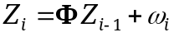

with state vector Z_{i}, a matrix of transition coefficients Φ and model error ω. The observation equation relates the observation Y_{i} to the state of the system through an observation matrix M
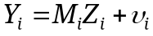

yielding the system
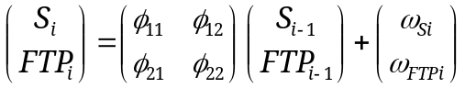

where S_{i} denotes the local profile water storage, FTP_{i} the local average fine textural particles. Both are spatially related through the matrix of transition coefficients φ. Deep drainage and surface runoff are neglected.
In the Kalman filter, the predicted state of the system is updated through
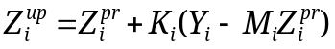

Where the Kalman gain K_{i} weighs the prediction against the observation based on the observation uncertainty.
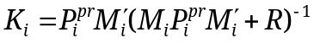

For further details of the methodology, see Shumway (1988), Or and Hanks (1992), and Nielsen and Wendroth (2003).
The temporal estimation part is

with a standardized normalized evapotranspiration term ESN_{t}, precipitation Pr_{t} and evapotranpiration ET_{t}. The state covariance (variance of model error) obtained in the temporal domain is incorporated in the gain matrix as measurement variance. This reduces the state covariance in the spatial domain.
In a similar way, spatial process of biomass development B_{i} is estimated with
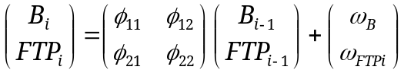

and the temporal process with

where T_{t} denotes daily average temperature.

The benefit of combining the spatial and temporal estimation is based on the fact that the prediction variance obtained in the temporal domain is included in the local observation error in the spatial domain. As a result, both soil water storage (Fig. 1) and biomass estimation (Fig. 2) could be improved substantially if both spatial and temporal domains were combined in the estimation, compared to pure spatial estimation.
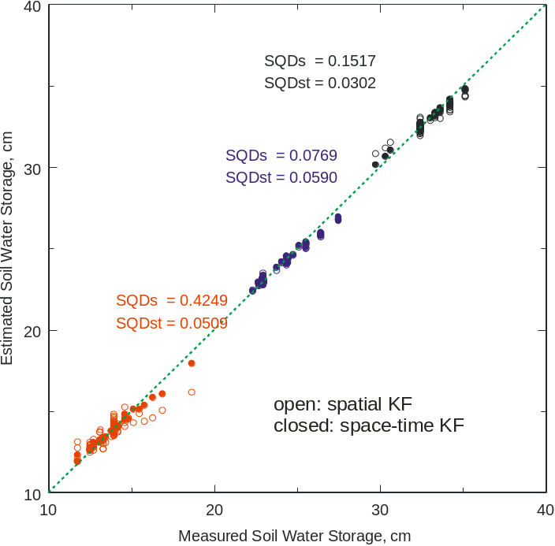

Figure 1. Measured soil water storage compared to water storage based on purely spatial and both time-space estimation.

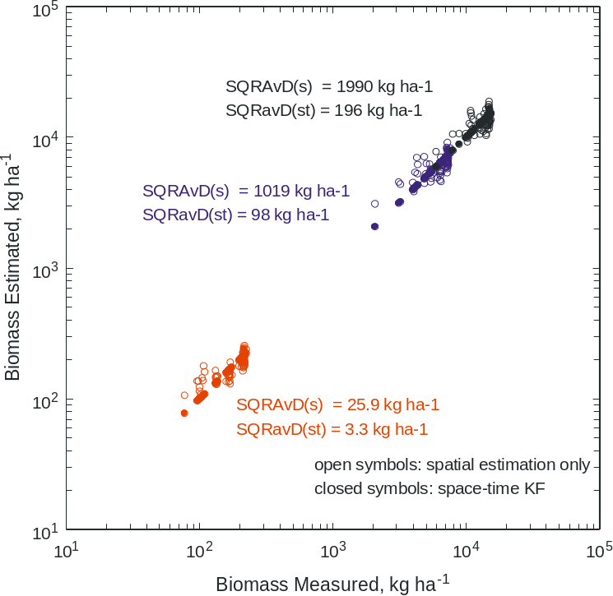

Figure 2. Measured biomass compared to biomass based on purely spatial and both time-space estimation.
The next step in this project will be to combine space-time estimations in a common scheme and improve the computation algorithm, and to apply this concept in a farmer’s field with input of nutrients varied in a sinusoidal pattern.

Vadose zone solute transport through a soil profile within a Karst landscape:
Vadose zone transport properties in the well-drained soils of Kentucky mainly associated to Karst topography are relevant for soil management, and determine the transport of surface applied chemicals and nutrients. The main objective of this study is to determine transport properties from observations of salt movement in pulse input of salt to the soil surface, and corresponding output response at different soil depths.

For large-scale hydrologic systems, input-output response can be analysed and described with time series techniques (Panagopoulos and Lambrakis, 2006). The shape of the autocorrelation function indicates whether a system is quickly responding, has low memory and is strongly developed, or on the other hand if a system is less developed and shows a strong memory effect. In the first case, the autocorrelation quickly decreases, i.e., has a short decorrelation lag time, in the second case, it decays slowly. Hydrologically this implies, that the system has a larger storage capacity. The autocorrelation is converted from the time mode to the frequency mode through Fast Fourier Transformation, and the spectral density function associates the variance to periodic components appearing at different frequencies.

Output response to some input, e.g., precipitation or a solute pulse, can be observed at some soil depth and depends on the soil properties. The temporal pattern of input at the soil surface is changed during the passage through the soil layer, and it can be discovered with some time delay at a certain depth. Besides the delay, an attenuation of the amplitude can be observed in many cases. The time delay between input and output is quantified with the lag of the maximum crosscorrelation coefficient. This lag is different from zero. Changing from time to frequency mode, the cross and the quad spectra allow to identify frequencies at which both input and output series have cyclic variation components. Depending on the phase shift, the cross and the quad spectrum behave differently. The coherency spectrum indicates if there is a linear relation between input and output at the same frequency. And the phase spectrum indicates the time delay for different cyclic components.

The objective of this study is to use a system of cyclic solute input pulses in a soil profile at different water contents to identify solute transport parameters from statistical time series analysis.

So far, the first experiment was performed under soil water saturation with applying a rainfall rate of 100 mm day-1 and add pulses of salt to the soil surface (Fig. 3). Electrical conductivity EC was measured using TDR probes at 10, 30 50, and 70 cm soil depth.

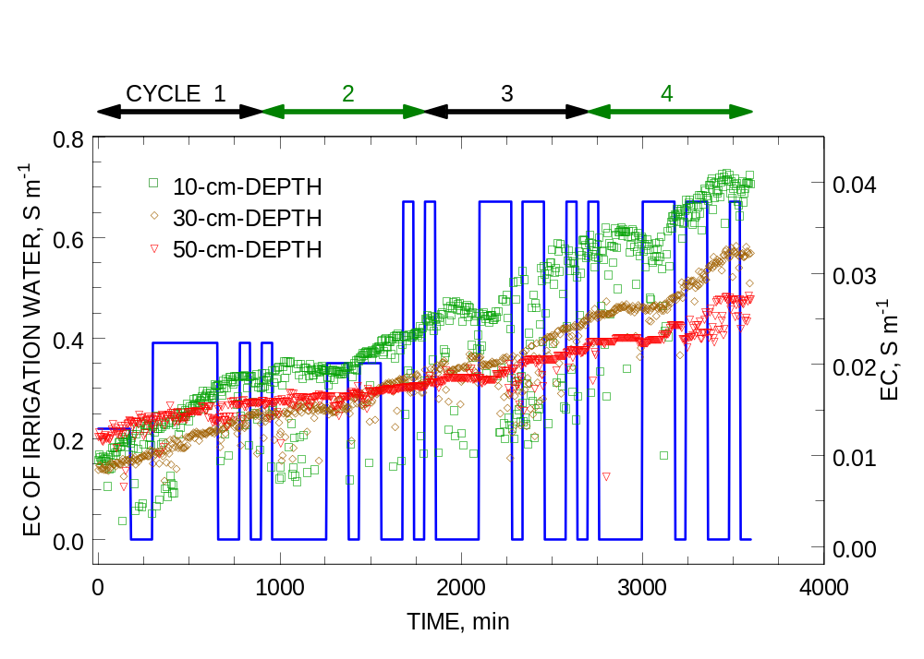
Figure 3. Solute pulses added in four cycles to the soil surface and temporal process of electrical conductivity at soil depths of 10, 30 and 50 cm.

Analysis of cycles 3 and 4: Crosscorrelation and Crossspectral analysis show that with increasing soil depth, the solute pulse arrives slightly delayed. If the EC at 10-cm-depth is used as the input concentration and the response in the layers below is considered, there is hardly any delay in the signal observable, obvious from crosscorrelation behavior and the quadspectrum which turns out to be zero.

The next steps will be to derive transport parameters from the statistical analysis (Jury and Roth, 1990) and to conduct similar experiments at lower water application rates.

University of Nevada and Desert Research Institute

Collaborators: Markus Berli, Todd Caldwell, Scott Tyler, Wally Miller, Michael Young, Jianting Zhu

Develop and Evaluate Scale-Appropriate Methodologies for the Management of Soil and Water Resources:
Nevada’s researchers focused on several scale-related issues pertinent to management of land and water resources. Their work included (1) a new method of representing infiltration using the Green-Ampt approach on sloping lands and its application on runoff modeling, (2) use of geophysical tools for rapid estimation of hydraulic conductivity at different scales, and (3) a new way to define effective hydraulic parameters for various large-scale hydrologic processes in heterogeneous fields.
Nevada continued its effort at improving the representation of alluvial fan hydrology in rainfall runoff modeling [Chen and Young, 2006]. An important aspect of this effort is the characterization of infiltration in these models. This work quantifies and explains the direct physical effects of slope angle on infiltration and runoff generation by extending the Green-Ampt equation onto sloping surfaces. A new extended solution using identical precipitation hydrographs was compared to the original formulation and then used to calculate the infiltration and runoff generation for different slope angles but for identical horizontal projection lengths. Homogeneous and isotropic soil is assumed, and two different boundary conditions for vertical rainfall are studied: ponded infiltration and infiltration under steady rainfall. Infiltration under unsteady rainfall was found to be similar to cases with steady rainfall. Both theoretical and numerical results show that infiltration increases with increasing slope angle. For cases with ponded infiltration the slope effect was generally not significant for mild to moderate slopes, but the slope effect became more important for low-intensity and short-duration rainfall events, especially as it delayed the time for ponding. It was also found that the cumulative vertical infiltration depth (I_{hp}) at ponding (or the initial loss) increases with increasing slope angle. The model was compared to Richards’ equation on horizontal and sloping surfaces and found to perform well. The model’s applicability for nonuniform slopes was discussed, and it was found that the model is generally applicable for isotropic and mildly anisotropic soils except for some small-scale topographic elements. Finally, the occurrence of nonvertical rainfall could increase runoff with increasing slope angle when rainfall deflects a large angle to upslope.
Nevada demonstrated [Meadows et al., 2006] the use of surface geophysical measurement tools for the clay content and saturated hydraulic conductivity (Ks) of well-developed desert pavements. Nevada examined the use of surface-based ground penetrating radar (GPR) to rapidly approximate these properties on six, 100-m-long transects for two different aged (~100 000 vs. 4000 yr) desert pavement surfaces. We determined early-time amplitudes from GPR transects, ground electrical conductivity, hydraulic properties, clay content, water content, and soil salinity at regular intervals along each transect. Both surfaces were low in water content and salinity; however, the older pavement contained substantial amounts of silt and clay in the surficial soil horizon. Using multivariate linear regression, which included GPR amplitude and a nominal measure of soil structure ascertained by visual field inspection, we show significant correlations between measured and predicted values of both silt plus clay content (r = 0.84, P < 0.0001) and Ks (r = 0.73, P < 0.0001) for the older surface. No significant correlations were found on the younger surface. This is probably due to the low concentrations of clays in the young soil. Including the metric of soil structure improved the predictive capabilities on the older surface. The GPR method provides higher spatial resolution than electromagnetic measurements. The results suggest that, at this location, the approach is not influenced by heterogeneities in lower soil horizons. The method can be used for reconnaissance surveys as a means of estimating the clay content, and in some cases Ks, of surficial soils on certain well developed desert pavements.
The study of Zhu and Mohanty [2006] investigated the effective scaling factors for transient infiltration in terms of the optimal averaging schemes for the input hydraulic and environmental parameter fields. The derived optimal effective p-norm for the random (input) parameters defines an optimal averaging scheme for the random input fields. Zhu et al. [2006a; 2006c] examined the impact of the skewness (third-order moment) of hydraulic parameter distributions on the effective soil hydraulic parameter averaging schemes for heterogeneous soils. Using three widely used unsaturated hydraulic conductivity functions and various types of probability distribution functions to represent spatial variability for the nonlinear shape factor in the hydraulic conductivity function, we derived the effective parameter values. Mohanty and Zhu [2006] studied effective soil hydraulic parameter averaging schemes in horizontally and vertically heterogeneous soils. Assuming one-dimensional vertical moisture movement in the unsaturated soils, both scenarios of horizontal (across the land surface) and vertical (across the soil profile) heterogeneities were investigated. The effects of hydraulic parameter statistics, surface boundary conditions, domain scales and fractal dimensions in case of nested soil hydraulic property structure were addressed.
In a series of studies [Zhu et al., 2006b; Zhu et al., 2006d; Sun and Zhu, 2006; Sun et al., 2006], we develop a methodology for upscaling hydraulic property functions using a p-norm approach, examine how p-norm values differ for two commonly used soil hydraulic property models (the Gardner, and van Genuchten functions), and investigate the relative sensitivities of p-norms and the effective hydraulic parameters to the degree of soil heterogeneity (expressed in terms of variances and auto-correlation lengths of the hydraulic parameters) and other environmental conditions. The upscaling schemes are obtained as results of two new criteria proposed to upscale soil hydraulic properties in this study. One criterion preserves the ensemble vertical moisture flux across the land-atmosphere boundary, and a second criterion the ensemble soil surface moisture content.
Our work also tries to evaluate how the coupled effects of the leakage and the spatial variability of the hydraulic conductivity influence subsurface flow and transport in heterogeneous formations. To explore the effects of the leakage factor and the variability of the hydraulic conductivity field, the spectrally based stochastic continuum approach is used in which the random functions such as the hydraulic conductivity and the hydraulic head are expressed using the spectral representation technique. Perturbed forms of the flow equation can be solved for the spectrum of flow and contaminant transport in terms of the spectrum of the hydraulic conductivity field [Zhu and Satish, 2006; Koehne and Zhu, 2006; Satish and Zhu, 2006].

Impact: Our work demonstrates how limited field data can be used in a relatively large-scale upscaling context and determines if limited field characterization is sufficient for upscaling considerations in a wide range of hydrologic processes ranging from infiltration and evaporation. Our results show that the upscaling schemes are in general better defined, and have less variability, in terms of p-norms than when effective parameter values are used. The findings also reveal that distribution skewness is important in determining the upscaled effective parameters in addition to the mean and variance and the optimal averaging schemes for different hydraulic property models can be quite different.

USDA-ARS, Bushland, TX

Collaborators: Robert Schwartz and Steve Everett

Estimation of Soil Water Balance Components Using an Iterative Plane of Zero Flux Procedure:
Quantification of the hydrologic balance at high temporal resolution is necessary to evaluate field scale management effects on infiltration and soil water storage. Meteorological methods are typically not suitable for small field or plot-scale studies whereas weighing lysimeters may restrict or compromise the application of large scale treatments such as tillage. High frequency sampling of soil water contents within the profile using time-domain reflectometry (TDR) has the potential to accurately resolve the hydrologic balance within a control volume provided it is coupled with estimates of drainage and runoff. Our objective was to develop and evaluate a hybrid procedure to estimate drainage, infiltration, and evaporation based on changes in plot-scale soil water storage on a Pullman clay loam (fine, mixed, superactive, thermic Torrertic Paleustolls). Soil water contents were monitored at 0.5 h intervals on twelve plots instrumented with time-domain reflectometery probes at 0.05, 0.1, 0.15, 0.2, and 0.3 m depths, and weekly using a neutron moisture meter to a depth of 2.3 m in 0.2-m increments. During periods in August 2005 when either a plane of zero flux existed or when a wetting front penetrated into an upper boundary, changes in soil water storage were used to iteratively fit effective hydraulic parameters to estimate soil water fluxes into and out of the control volume. Predicted hydraulic conductivities were not significantly different (p=0.409) from hydraulic conductivities calculated using the iterative method during three other months in 2005 and yielded drainage rates that differed by less than 0.0049 mm d⁻¹ as compared to calculated changes in storage below the plane of zero flux. The strategies used to partition changes in soil water storage led to reasonable estimates of infiltration and evaporation throughout a month with 103 mm precipitation. The proposed procedure permits the indirect estimation of soil water balance components useful for comparing plot-scale treatments and overcomes some of the difficulties associated with traditional approaches. (Schwartz, Baumhardt, and Howell; submitted).

USDA-ARS USSL, Riverside, CA

Collaborators: Scott Bradford, Peter Shouse, Todd Skaggs, Rien van Genuchten, Scott Yates

Irrigation of Forage Crops with Saline Drainage Waters:
In regions lacking outlets for agricultural drainage disposal, the recycling of drainage waters for irrigation is increasingly seen as a viable management option. Modeling could potentially assist in the design of management practices for drainage reuse operations, but data are lacking about the accuracy of simulations of root water uptake under the dynamic, saline field conditions that are encountered in reuse systems. We conducted a lysimeter study to examine, within the context of drainage reuse management systems, relationships between irrigation water salinity, irrigation depth, forage crop biomass production (alfalfa and tall wheatgrass), evapotranspiration (ET), drainage depth, and drainage water quality. Additionally, we compared the collected data with HYDRUS-1D simulations of root water uptake and drainage. A trial-and-error fitting procedure was used to determine uptake reduction parameters for each crop. Good agreement between the model simulations and data was achieved, a noteworthy result given the broad range of experimental conditions considered: irrigation waters with salinities ranging from 2.5 to 28 dS/m and irrigation rates ranging from deficit to luxurious. It does not seem possible at this time to derive uptake reduction parameters from published salt tolerance data, meaning the near term prospects for using this model in a purely predictive capacity (i.e., without crop- and site-specific calibration) are limited. Nevertheless, it is clear the modeling approach captures many essential features of root water uptake under stressed conditions and it may be useful in designing and analyzing reuse operations.

Utah State University (USU)

Collaborators: Scott B. Jones, David Johnson, and Shmulik Friedman

Reliable and rapid measurement of soil water content at the field-scale could greatly enhance many agronomic as well as environmental activities such as development of reclamation strategies, reducing fertilizer application and characterizing hydrologic and geophysical properties. This capability suggests the need for improvements in sensor design, signal analysis and novel application of the technology before real-time field-scale measurements for precision agriculture are readily available. With the long term goal to develop a system that provides depth-dependent soil characteristics such as water content, electrical conductivity and temperature, we have designed and tested a flange-type open-ended TDR probe. We considered different geometrical configurations of the open-ended probe design compatible with either a single-sided near-surface probe or double-sided probes embedded within a subsurface blade. The fringing field associated with the sensing volume was modeled and a network analyzer was used to measure and compare attenuation among different open-ended probes, with a dielectric probe as reference. The use of multiple sensing heads for multi-depth measurements required a dedicated TDR for each head to obtain waveforms at a sufficient rate for mapping purposes using existing technology. Waveforms were collected in static and on-the-go field conditions and compared to determine the influence of travel speed on the resulting waveform. Deviations from the mean of 9 consecutive waveforms collected in moist soil traveling at 5 kmph were only double the RMSE of the same probes at rest in water, demonstrating the stability and accuracy of on-the-go measurements. At the maximum waveform collection rate of 3 seconds, 4 m grid spacings were achievable at a travel speed of 5 kmph. Faster waveform collection (and future analysis) will provide higher resolution water content maps. waveform analysis approaches are being considered for inclusion into analysis software providing field-scale mapped water content with the ultimate goal of real-time measurements.

Impact: Our electromagnetic induction (EMI) work on mapping soil properties for small watershed hydrology is expanding and will likely be employed in one of CUAHSI’s 11 test beds here in the Little Bear Watershed in the spring of 2007. This method is providing ecology and environment sciences with detailed soil properties at scales that were previously unavailable.
Washington State University (WSU)

Collaborators: Markus Flury and Joan Wu

A study was conducted to improve the knowledge of winter hydrology and erosion in the Pacific Northwest (PNW) through combined field experimentation and mathematical modeling (Greer et al, 2006). Surface runoff and sediment were collected for three paired field plots under conventional tillage and no-till, respectively. Additionally, transient soil water content and temperature at various depths were continuously monitored for two selected plots. These data were used to assess the suitability and performance of the USDA’s WEPP (Water Erosion Prediction Project), a physically-based erosion model, under the PNW winter conditions. Field observations revealed that minimal erosion was generated on the no-till plots, whereas erosion from the conventionally tilled plots largely exceeded the tolerable rates recommended by the Natural Resources Conservation Service. The WEPP model could reasonably reproduce certain winter processes (e.g., snow and thaw depths and runoff) after code modification and parameter adjustment. Yet it is not able to represent all the complicated processes of winter erosion as observed in the field. Continued field and laboratory investigation of dynamic winter runoff and erosion mechanisms are necessary so that these processes can be properly represented by physically-based erosion models.
The WEPP model was tested using data from a detailed study conducted on experimental plots in the Apennines Mountain Range, northern Italy (Pieri et al., 2006). Runoff, soil water and sediment data, together with weather information, were collected on an hourly basis at the study site. WEPP was first applied to simulate transient surface runoff, soil water and erosion. Two important input parameters, the biomass energy ratio for crop and the effective hydraulic conductivity of surface soil, were calibrated using field-observed runoff, soil water, erosion and plant biomass data. The calibrated model was then used to simulate the hydrologic and erosion impacts of three typical crop rotations, thereby to evaluate their abilities in reducing surface runoff and sediment yield. Results indicated that, with the definition of a restrictive layer at the bottom of the soil profile and the calibration of the two crucial model parameters, WEPP could adequately account for the water balance for the modeled experimental plot. For the study area, continuous corn with a conservation practice that delayed primary and secondary tillages produced low surface runoff and soil erosion, from both field observation and WEPP modeling. However, this mono-cultural practice may lead to accelerated soil-quality degradation. On the other hand, a four-years rotation, corn-wheat-alfalfa-alfalfa, was predicted to substantially reduce soil erosion and has potential to become a sustainable cropping system under the pedo-climatic settings of the study area.

Wetlands are dynamic habitats with many unique, important functions including filtering sediments and providing diverse habitats for fish and wildlife. Livestock grazing has historically altered wetland and riparian area form and function by facilitating exotic species invasions, altering spatial heterogeneity of vegetation, and increasing erosion. In a recent study, we examined vegetation structure and the erosion potential in a wetland meadow exposed to unregulated grazing along Deer Creek in the Salmon River Sub-basin, Idaho (Hopfensperger et al., 2006). We characterized the vegetation composition and structure within the study area and attempted assessing potential erosion conditions of the area using the Revised Universal Soil Loss Equation (RUSLE), an empirical model developed by the USDA ARS. We found no significant spatial variability in species richness, and noted a moderate amount of exotic species in the total plant composition. Plant cover was higher near slightly entrenched banks, indicating that uncontrolled livestock were primarily occupying gentle sloped stream banks and the interior of the meadow. Based on current vegetation composition and RUSLE results, we inferred that uncontrolled grazing may be negatively impacting the study area. If uncontrolled grazing were to be excluded or carefully managed in the wetland meadows of the upper portion of the Deer Creek watershed, a reduction in excess sediments to Deer Creek may occur.

Impact: Soil erosion is a serious and continuous environmental problem in the Pacific Northwest and many other areas nationwide and worldwide. Our studies on continuous development and application of erosion models, in particular, the WEPP model, have substantially contributed to the advancement of our knowledge in water erosion and its mathematical modeling.

University of Wyoming

Collaborator: Thijs Kelleners

Work continued on a distributed water and energy balance model for small mountainous catchments that are subject to snow accumulation and snow melt. The model calculates separate energy balances for the vegetation canopy and the land surface (soil or snow). Snow is described by a single layer in the model. Lateral sub-surface flow along the soil-bedrock interface is calculated using an adapted version of the Boussinesq equation. Saturation-excess surface runoff is calculated assuming instantaneous redistribution.

A new feature in the model is the ability to describe multiple soil layers. Vertical soil water redistribution between the layers is limited to downward flow assuming a unit hydraulic gradient (i.e. dh/dz=0; q=-K(θ)). The soil hydraulic conductivity K is calculated using the Brooks-Corey relationship. Another new feature is the incorporation of a soil water freezing/melting routine as described under objective 1. The effect of ice induced pore blocking on hydraulic conductivity is incorporated by multiplying the Brooks-Corey K with an impedance factor: 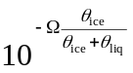, where Ω is an empirical impedance factor (see Hansson et al. VZJ 3:693-704 [2004]).

A comparison between measured and calculated snow-melt induced outflow from a 1.41 ha zero-order catchment near Boise, ID is shown in the figures below. The first figure includes the effect of soil freezing/melting, while the second figure disregards this process. It is clear that the sudden peaks of up to 232 l/min (value not shown) in the outflow for the first figure are unrealistic. It appears that either the extent of soil freezing is overestimated or that the effect of soil freezing on the hydraulic conductivity and therefore the vertical soil infiltrability is overestimated. We hope to resolve this issue in the coming year.

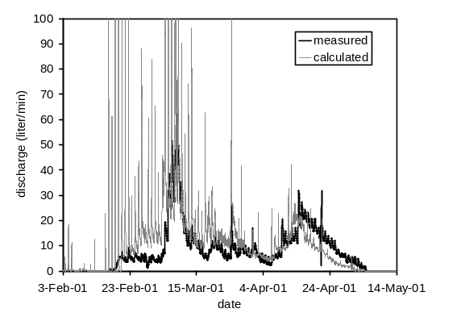 |  | 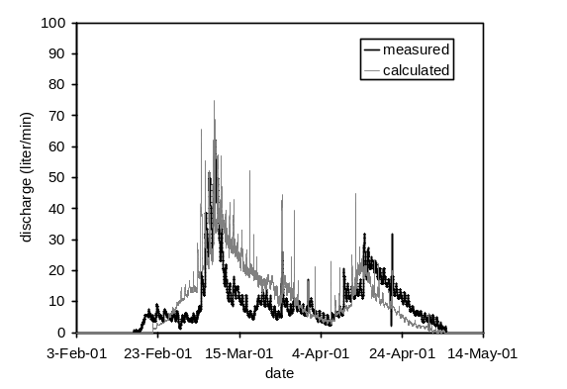
Snow-melt induced outflow with frozen soils |  | Snow-melt induced outflow without frozen soils

4. PUBLICATIONS DURING 2006:

Abdu, H. D.A. Robinson and S. B. Jones. 2006. Comparing Bulk Soil Electrical Conductivity Determination Using the DUALEM 1-S and EM-38DD EMI Instruments. Accepted in Soil Sci. Soc. Am. J.
Albright, W.H., C. H. Benson, G. W. Gee, T. Abichou, E. V. McDonald, S. W. Tyler, and S. A. Rock. 2006. Field Performance of a Compacted Clay Landfill Final Cover at a Humid Site, J. Geotech. and Geoenvir. Engineering. 132:1393-1399
Albright, W.H., C. H. Benson, G. W. Gee, T. Abichou, S. W. Tyler, and S. A. Rock. 2006.
Al-Jabri, S.A., J. Lee, A. Gaur, R. Horton and D.B. Jaynes. 2006. A dripper-TDR method for in situ determination of hydraulic conductivity and chemical transport properties of surface soils. Adv. Water Resour. 29: 239-249.
Bachmann, J., G. Arye, M. Deuer, S. K. Woche, R. Horton, K. H. Hartge, and Y. Chen. 2006. Universality of a surface tension – contact angle relation for hydrophobic soils of different texture. J. Plant Nutr. Soil Sci. 169: 745-753.
Bahaminyakamwe, L., J. Šimůnek, J. Dane, J. F. Adams, and J. W. Odom, Copper mobility in soils as affected by sewage sludge and low molecular weight organic acids, Soil Sci., 171(1), 29-38, 2006.
Bakhsh, A., R. Kanwar, D.B. Jaynes, T.S. Colvin, and L.R. Ahuja. 2005. Modeling precision agriculture for better crop productivity and environmental quality. Asian Assoc. Agricult. Eng. 14:235-243.
Berli, M and Or, D., 2006. Deformation of spheroidal pores in viscoplastic soil material. International Journal of Geomechanics, 6(2), 108-118.
Berli, M. Eggers, C.G., Accorsi, M. and Or, D., 2006. Theoretical analysis of mechanical behavior of fluid inclusions for in-situ measurements of soil stress and deformation. Soil Science Society of America Journal, (in press).
Berli, M., Accorsi, M.L. and Or, D., 2006. Size and shape evolution of pores in viscoplastic matrix under compression. International Journal for Numerical and Analytical Methods in Geomechanics, (in press).
Blonquist, J.M. Jr., S.B. Jones and D.A. Robinson. 2006. Water Conservation from Precise Irrigation Scheduling Using a Subsurface Electromagnetic Soil Moisture Sensor. Ag. Water Management 84:153-165.
Blonquist, J.M. Jr., S.B. Jones, I. Lebron and D.A. Robinson. 2006. Micro-structural and phase configuration effects determining water content: Dielectric relationships of aggregated porous media. Water Resour. Res. 42(5), W05424, doi:10.1029/2005WR004418.
Boivin, A., J. Šimůnek, M. Schiavon and M. Th. van Genuchten, A comparison of pesticides transport processes in three contrasting field soils using Hydrus-2D, Vadose Zone Journal, 5, 838–849, 2006.
Boivin, A., J. Šimůnek, M. Schiavon, and M. Th. van Genuchten. 2006. Comparison of pesticide transport processes in three tile-drained field soils using HYDRUS-2D. Vadose Zone J. 5(3): 838-849.
Bondarenko, S., Zheng, W., Yates, S.R., and Gan, J. 2006. Dehalogenation of halogenated fumigants by polysulfide salts. Journal of Agricultural & Food Chemistry. 54:5503-5508.
Bradford, S. A., and M. Bettahar. 2006. Concentration dependent colloid transport in saturated porous media. J. Contaminant Hydrology, 82:99-117.
Bradford, S. A., J. Šimůnek, and S. L. Walker, Transport and straining of E. coli O157:H7 in saturated porous media, Water Resour. Res., 42, W12S12, doi:10.1029/2005WR004805, 12 pp., 2006.
Bradford, S. A., J. Simunek, and S. L. Walker. 2006. Transport and deposition of E. coli O157:H7 in saturated porous media. Water Resources Research, 42, W12S12, doi:10.1029/2005WR004805.
Bradford, S. A., J. Simunek, M. Bettahar, M. Th. van Genuchten, and S. R. Yates. 2006. Significance of straining in colloid deposition: Evidence and implications. Water Resources Research, 42, W12S15, doi:10.1029/2005WR004791.
Bradford, S. A., J. Šimůnek, M. Bettahar, M. Th. van Genuchten, and S. R. Yates, Significance of straining in colloid deposition: evidence and implications, Water Resour. Res., 42, W12S15, doi:10.1029/2005WR004791, 16 pp., 2006.
Bradford, S. A., Y. F. Tadassa, and Y. Jin. 2006. Transport of coliphage in the presence and absence of manure suspension. Journal of Environmental Quality, 35, 1692-1701.
Bradford, S. A., Y. F. Tadassa, and Y. Pachepsky. 2006. Transport of Giardia and manure suspensions in saturated porous media. Journal of Environmental Quality, 35, 749-757.
Bradford, S.A., Simunek, J., Bettahar, M., van Genuchten, M.Th., S.R. Yates. 2006. Significance of straining in colloid deposition: Evidence and implications. Water Resources Research. 42 (12): Art. No. W12S15
Cable-Rains, M., G. E. Fogg, T. Harter, R. A. Dahlgren, and R. J. Williamson, 2006. The role of perched aquifers in hydrological connectivity and biogeochemical processes in vernal pool landscapes, Central Valley, California. Hydrol. Process. 20, 1157–1175.
Caldwell, T.G. E.V. McDonald, M.H. Young. 2006. Soil disturbance and unsaturated hydraulic response at the National Training Center, Ft. Irwin, California. J. Arid Env. 67:456-472.
Caldwell, T.G., E.V. McDonald, and M.H. Young. Soil water balance, seedbed microclimate, and the revegetation of disturbed lands in the Mojave Desert, In R. H. Webb, et al., eds. The Mojave Desert: Ecosystem Processes and Sustainability. University of Nevada Press, Reno, NV. In Press
Carrillo-González, R., J. Šimůnek, S. Sauve, and D. Adriano, Mechanisms and pathways of trace element mobility in soils, Advances in Agronomy, 91, 111-178, 2006.
Casey, F.X.M., G.L. Larsen, H. Hakk, and Z. Fan. 2006b. The Fate of Manure-Borne, Land-Applied Hormone. In Annual Meetings Abstracts, Division S11 Symposium [CD-ROM]. ASA, CSSA, and SSSA, Madison, WI.
Casey, F.X.M., N.E. Derby, and D.W. Franzen. 2006a. Comparison of nitrogen management zone delineation methods for corn grain yield 8th International Conference on Precision Agriculture and Other Precision Resources Management. July 2006, Minneapolis, MN.
Castiglione, P., P.J. Shouse, and J.M. Wraith. 2006. Multiplexer-induced interference in TDR measurements of electrical conductivity. Soil Sci. Soc. Am. J. 70:1453-1458.
Chen, L. M.H. Young. 2006. Green-Ampt model for sloping surfaces. Water Resour. Res., Vol. 42, No. 7, W07420.
Chuoke, R. L., P. van Meurs, and C. van der Poel, The instability of slow, immiscible, viscous liquid-liquid displacements in permeable media, Trans. Am. Inst. Min. Metall. Pet. Eng., 216, 188-194, 1959.
Colaizzi, P.D., Evett, S.R., Howell, T.A. 2006. Cotton production with SDI, LEPA, and spray irrigation in a thermally-limited climate. International Water & Irrigation. 26(1):10-12, 14.
Colaizzi, P.D., Evett, S.R., Howell, T.A. 2006. Crop emergence and near-surface soil temperature for SDI, LEPA, and spray irrigation. In: Proceedings of the ASABE Annual International Meeting, July 9-12, 2006, Portland, Oregon. 2006 CDROM. Paper No. 062278.
Colaizzi, P.D., Evett, S.R., Howell, T.A. 2006. Near-surface soil water and temperature for SDI, LEPA, and spray irrigation. In: Irrigation Association Conference Proceedings, November 5-7, 2006, San Antonio, Texas. 2006 CDROM.
Colaizzi, P.D., Evett, S.R., Howell, T.A. 2006. SDI bed design comparison for soybean emergence and yield. In: Proceedings of the ASABE Annual International Meeting, July 9-12, 2006, Portland, Oregon. 2006 CDROM.
Colaizzi, P.D., Evett, S.R., Howell, T.A., Tolk, J.A. 2006. Comparison of five models to scale daily evapotranspiration from one-time-of-day measurements. Transactions of the ASABE. 49(5):1409-1417.
Colaizzi, P.D., Evett, S.R., Howell, T.A., Tolk, J.A., Li, F. 2006. Evaluation of a two-source energy balance model in an advective environment. In: Proceedings of the World Water and Environmental Resources Congress. Examining the Confluence of Environmental and Water Concerns, May 21-25, 2006, Omaha, Nebraska. 2006 CDROM.
Colaizzi, P.D., Lamm, F.R., Howell, T.A., Evett, S.R. 2006. Crop production comparison under various irrigation systems. Proceedings of the Central Plains Irrigation Conference, February 21-22, 2006, Colby, Kansas. p. 189-207.
Cortis, A., T. Harter, L. L. Hou, E. R. Atwill, A. I. Packman, and P. G. Green, 2006. Transport of Cryptosporidium parvum in porous media: Long-term elution experiments and continuous time random walk filtration modeling. Water Resour. Res. 42, W12S13 (12 pages), doi:10.1029/2006WR004897.
Corwin, D.L., J.W. Hopmans, and G. de Rooij. 2006. From Field- to landscape scale vadose zone processes: scale issues, modeling and monitoring. Vadose Zone Journal 5:129-139.
Decker, D. L., Ch. Papelis, S. W. Tyler, M. Logsdon, and J. Šimůnek, Arsenate and arsenite sorption on carbonate hosted precious metals ore, Vadose Zone Journal, 5, 419-429, 2006.
Decker, D. L., J. Šimůnek, S. W. Tyler, Ch. Papelis, and M. Logsdon, Variably saturated reactive transport of arsenic in heap leach facilities, Vadose Zone Journal, 5, 430-444, 2006.
Decker, D.L, J. Simunek, S. W. Tyler, C. Papelis, and M. J. Logsdon. 2006. Variably Saturated Reactive Transport of Arsenic in Heap-Leach Facilities. Vadose Zone J. 5:430-444.
Decker, D.L., C. Papelis, S.W. Tyler, M. Logsdon and J. Simunek. 2006. Arsenate and Arsenite Sorption on Carbonate Hosted Precious Metals Ore. Vadose Zone J. 5:419-429
Deng, Y., Flury, M., Harsh, J.B., Felmy, A.R. and Qafoku, O., 2006a. Cancrinite and sodalite formation in the presence of cesium, potassium, magnesium, calcium, and strontium in Hanford tank waste simulants. Appl. Geochem., 21: 2049–2063.
Deng, Y., Harsh, J.B., Flury, M., Young, J. and Boyle, J.S., 2006b. Mineral formation during simulated leaks of Hanford waste tanks. Appl. Geochem., 21: 1392–1409.
Derby, N.E., and F.X.M. Casey. 2006. Field-scale spatial relations between surface topography, electrical conductivity, and surficial aquifer ion concentrations. 18th World Congress of Soil Science July 9-15, 2006 - Philadelphia, Pennsylvania, USA.
Derby, N.E., F.X.M. Casey, and D.W. Franzen. 2006. Comparison of nitrogen management zone delineation methods for corn grain yield. Agron. J. (In press).
Dontsova, K. M., S. L. Yost, J. Šimůnek, J. C. Pennington, C. Williford, Dissolution and transport of TNT, RDX, and Composition B in saturated soil columns, J. of Environ. Quality, 35, 2043-2054, 2006.
Dragila, M. I. 2005a. “Evaporation and Salt Redistribution Caused by Soil Cracks: I. Conceptual Model,” Presentation at W-1188 Soil Physics Regional Meeting, Las Vegas, January 3-5, 2005.
Dragila, M. I. 2005b. Improved Characterization and Quantification of Flow and Transport Processes in Soils. W-1188 Regional Project Annual Report, Jan 2005 (W-1188)
Dragila, M. I. 2006a. “Evaporation and Salt Redistribution Caused by Soil Cracks: II. Numerical Model,” Presentation at W-1188 Soil Physics Regional Meeting, Las Vegas, January 3-5, 2006.
Dragila, M. I. 2006b. Improved Characterization and Quantification of Flow and Transport Processes in Soils. W-1188 Regional Project Annual Report, Jan 2006 (W-1188)
Dragila, M. I. 2007a. “Evaporation and Salt Redistribution Caused by Soil Cracks: III. Field Observations of Thermal Convection,” Presentation at W-1188 Soil Physics Regional Meeting, Las Vegas, January 3-5, 2007.
Dragila, M.I., N. Weisbrod, T. Kamai and C. Graham. 2006. Experimental observation and quantification of convective flux of water vapor from surface-exposed fractures. Gordon conference on Flow and Transport in Permeable Media, New Hampshire, USA.
Du, B., A. Saleh, D.B. Jaynes, and J.G. Arnold. 2006. Evaluation of SWAT in simulating nitrate nitrogen and atrazine fates in a watershed with tiles and potholes. Trans. ASAE 49:949-959.
Eggers, C.G., Berli, M., Accorsi, M. and Or, D., 2006. Deformation and permeability of aggregated soft earth materials. Journal of Geophysical Research – Solid Earth, (in press).
Eggers, C.G., Berli, M., Accorsi, M. and Or, D., 2006. Permeability of deformable soft aggregated earth materials: From single pore to sample cross-section. Water Resources Research, (in press).
Evett, S.R. 2007. Chapter 4: Soil Water and Monitoring Technology. In press. American Society of Agronomy, Crop Science Society of America, Soil Science Society of America, Madison, WI.
Evett, S.R., B.B. Ruthardt, and K.S. Copeland. 2006. External full-time vacuum lysimeter drainage system. Appl. Engr. Agric. 22(6): 875-880.
Evett, S.R., Parkin, G.W. 2005. Advances in soil water content sensing: The continuing maturation of technology and theory. Vadose Zone Journal. 4:986-991.
Evett, S.R., Tolk, J.A., Howell, T.A. 2006. Soil profile water content determination: Sensor accuracy, axial response, calibration, temperature dependence, and precision. Vadose Zone Journal. 5:894-907.
Ewing, R.P. and A.G. Hunt. 2006. Dependence of the electrical conductivity on saturation in real porous media, Vadose Zone J. 5: 731-741.
Fan, Z., and F.X.M. Casey. 2006. Estimating solute transport parameters using stochastic ranking evolutionary strategy. Water Resour. Res. (In review).
Fan, Z., F.X.M. Casey, G.L. Larsen, and H. Hakk. 2006a. Fate and transport of 1278-TCDD, 1378-TCDD, and 1478-TCDD in soil-water systems. Science of The Total Environment 371:323-333.
Fan, Z., F.X.M. Casey, G.L. Larsen, and H. Hakk. 2006b. Persistence and fate of 17β-estradiol and testosterone in agricultural soils. Chemosphere (In press).
Fan, Z., F.X.M. Casey, H. Hakk, and G.L. Larsen. 2006c. Discerning the fate and transport of testosterone in undisturbed soil: model development and experimental evaluation. J. Environ. Qual. (In review).
Field Performance of Three Compacted Clay Landfill Covers .Vadose Zone J. 2006 5: 1157-1171
Frankenberger, J., E. Kladivko, G. Sands, D.B. Jaynes, N.R. Fausey, M. Helmers, R. Cooke, J. Strock, K. Nelson, and L. Brown. Drainage water management for the Midwest. Purdue Ext., Knowledge to Go. WQ-44, p. 1-8.
French, C., L. Wu, T. Meixner, D. Haver, J. Kabashima and W. A. Jury. 2006. Modeling nitrogen transport in the Newport Bay/San Diego Creek watershed of Southern California. Agricultural Water Management. 81: 199-215.
Friedman, S.P., D.A. Robinson and S.B. Jones. 2006. Review of geometrical and interfacial factors determining the effective permittivity-volumetric water content relationships of soil and rocks. Proceedings of the 3rd International Symposium and Workshop on Time Domain Reflectometry for Innovative Soils Applications. September 17-20, 2006, Purdue University.
Fuentes, J.-P., Bezdicek, D., Flury, M., Albrecht, S. and Smith, J.L., 2006. Microbial activity affected by lime in a long term no-till soil. Soil Till. Res., 88: 123–131.
Furman, A., A. W. Warrick, D. Zerihun and C. A. Sanchez. Modified Kostiakov infiltration function: Accounting for initial and boundary conditions. J. Irrig & Dr. Eng. 132:587-596, doi: 10.1061/(ASCE)0733-9437(2006)132:6(577). (accepted)
Gärdenäs, A. I, J. Šimůnek, N. Jarvis, and M. Th. van Genuchten. 2006. Two-dimensional modeling of preferential water flow and pesticide transport from a tile-drained field. J. Hydrol. 329: 647-660.
Gärdenäs, A., J. Šimunek, N. Jarvis, and M. Th. van Genuchten, Two-dimensional modelling of preferential water flow and pesticide transport from a tile-drained field, J. Hydrology, 329, 647-660, 2006.
Gaur, A., R. Horton, D. B. Jaynes, and J.L. Baker. 2006. Measured and predicted solute transport in a tile drained field. Soil Sci. Soc. Am. J. 70: 872-881.
Gebrenegus, T., M. Tuller, and B. Muhunthan, 2006. The Application of X-ray Computed Tomography for Characterization of Surface Crack Networks in Bentonite-Sand Mixtures. In: J. Desrues, G. Viggiani, and P. Besuelle (Eds.), Advances in X-Ray Tomography for Geomaterials, pp. 207-212, ISTE Publishing Company, ISBN:1905209606.
Gonçalves, M. C., J. Šimůnek, T. B. Ramos, J. C. Martins, M. J. Neves, and F. P. Pires, Multicomponent solute transport in soil lysimeters irrigated with waters of different quality, Water Resour. Res., 42, W08401, doi:10.1029/2006WR004802, 17 pp., 2006.
Greenan, C.M., T.B. Moorman, T.C. Kaspar, T.B. Parkin, and D.B. Jaynes. 2006. Comparing carbon substrates for denitrification of subsurface drainage water. J. Environ Qual. 35:824-829.
Greer, R.C., Wu, J.Q., Singh, P., and McCool, D.K., 2006. WEPP simulation of observed winter runoff and erosion in the Pacific Northwest, USA, Vadose Zone J., 5: 261–272.
Guber, A. K., Ya. A. Pachepsky, M. Th. van Genuchten, W. J. Rawls, J. Šimůnek, D. Jacques, T. J. Nicholson, and R. E. Cady, Field-Scale Water Flow Simulations Using Ensembles of Pedotransfer Functions for Soil Water Retention, Vadose Zone Journal, 5, 234–247, 2006.
Guber, A. K., Ya. A. Pachepsky, M. Th. van Genuchten, W. J. Rawls, J. Simunek, D. Jacques, T. J. Nicholson, and R. E. Cady. 2006. Field-scale water flow simulations using ensembles of pedotransfer functions for soil water retention. Vadose Zone J. 5:234-247.
Hanson, B. R., J. Šimůnek, and J. W. Hopmans, Numerical modeling of urea-ammonium-nitrate fertigation under microirrigation, Agric. Water Management, 86, 102-113, 2006.
Hanson, B.R. J. Simunek, and J.W. Hopmans. 2006. Evaluation of Urea-Ammonium-Nitrate Fertigation with drip irrigation using numerical modeling. Agricultural Water Management 86102-113.
Hanson, B.R., N. O’Connell, J.W. Hopmans, J. Simunek, and R. Beede, 2006. Fertigation with Microirrigation. DANR Special Publication. University of California, Agriculture and Natural Resources. Publication 21620. 60 pages.
Harter, T. and S. Talozi, 2004. A simple, inexpensive dialysis sampler for small diameter monitoring wells, Ground Water Monitoring & Remediation, Fall 2004, 97-105.
Harter, T., 2005. Finite-size scaling analysis of percolation in 3-D correlated binary Markov chain random fields, Physical Review E 72(2), 26120 (8 pages), DOI: 10.1103/PhysRevE.72.026120.
Harter, T., S. Wagner, E. R. Atwill, 2000. Colloid transport and filtration of Cryptosporidium parvum in sandy soils and aquifer sediments, Env. Science and Technology, 34(1), pp. 62-70.
Heinse, R., K.S. Lewis, S.B. Jones, G. Kluitenberg, R.S. Austin, P. Shouse and G.E. Bingham. 2006. Integration of heat capacity and electrical conductivity sensors for root module water and nutrient assessment. SAE Technical Paper no. 2006-01-2211.
Heinse, R., S.B. Jones, S. Steinberg, M. Tuller, and D. Or. 2007. Effects of Variable Gravity on Liquid Behavior in Particulate Porous Media: Measurements and Modeling. Submitted July 2006 to Vadose Zone J.
Heitman, J.L., A. Gaur, R. Horton, D.B. Jaynes, and T.C. Kaspar. 2007. Field measurement of soil surface chemical transport properties for comparison of management zones. Soil Sci. Soc. Am. J. (in press).
Henry, A., J. Norton, S.B. Jones, J. Chard and B. Bugbee. 2006. Design and maintenance of an axenic plant culture system to facilitate optimal growth in long-term studies. J. Environ. Qual. 35:590-598.
Hill, Judson P., Matthew J. Germino, Jon M. Wraith, Bret E. Olson, and Megan B. Swan. 2006. Superior carbon assimilation and water relations in an invasive forb, Centaurea maculosa, compared to established flora in semiarid steppe. Int. J. Plant Sci. 167: 269-277.
Hinnell A. C., T. P. A. Ferré, A. W. Warrick (2006). The influence of time domain reflectometry rod induced flow disruption on measured water content during steady state unit gradient flow, Water Resour. Res., 42, W08420, doi:10.1029/2005WR004604.
Hopfensperger, K.N., Wu, J.Q., and Gill, R., 2006. Plant composition and erosion potential of a grazed wetland in the Salmon River Subbasin, Idaho, J. West. N. Am. Naturalist, 66: 354–364.
Hopmans, J. W., Tissa Illangasekare, D. Or, and R. van Genuchten. 2006. Editorial: The future of Vadose Zone Journal. Vadose Zone J. 2006 5:125
Hopmans, J.W. 2006. Modeling multidimensional water and nutrient uptake. Handbook of Methods in Rhizosphere Research. In Press.
Hopmans, J.W. 2006. Review of ‘Principles of Soil and Plant Water Relations’ by M.B. Kirkham. Vadose Zone J. 5:506.
Hopmans, J.W. 2006. Soil properties, processes and associated root-soil interactions. IN: Ecohydrology of arid and semiarid ecosystems: An introduction. (Eds. A. Porporato and P. D’Odorico). Springer, Pages 13-29
Hopmans, J.W. and G.Pasternack. 2006. Experimental Hydrology: A bright future. Adv. In Water Resources 29:1-3.
Hopmans, J.W., D. Or, T. Ilangsekare, and M. Th. Van Genuchten. 2006. Editorial: The future of vadose zone journal. Vadose Zone Journal:5:125.
Hopmans, J.W., J.-Y Parlange, and S. Assouline. 2006. Infiltration. Pages 7-1 to 7-18. The Handbook of Groundwater Engineering. (J. W. Delleur, Ed.), CRC Press Taylor & Francis Group, Boca Raton, FL.
Howell, T.A., Evett, S.R., Tolk, J.A., Copeland, K.S., Dusek, D.A., Colaizzi, P.D. 2006. Crop coefficients developed at Bushland, Texas for corn, wheat, sorghum, soybean, cotton, and alfalfa. In: Proceedings of the World Water and Environmental Resources Congress. Examining the Confluence of Environmental and Water Concerns, May 21-25, 2006, Omaha, Nebraska. 2006 CDROM.
Illangasekare, T., S. W. Tyler, P. Clement, K. G. Villholth, A. P. G. R. L. Perera, J. Obeysekera, A. Gunatilaka, C.R Panabokke, D. W. Hyndman, K. J. Cunningham, W. W-G. Yeh, M. Th. van Genuchten, and K. H. Jensen. 2006. Impacts of the 2004 tsunami on groundwater resources in Sri Lanka. Water Resour. Res. 42, W05201, doi:10.1029/2006WR004876.
Ilsemann, J., R.R. van der Ploeg, R. Horton, and D. Hermsmeyer. 2006. A semi-analytical model for solute transport in layered dual-porosity media. J. Plant Nutr. Soil Sci. 169: 754-761.
Jacques, D., J. Šimůnek, D. Mallants, and M. Th. van Genuchten, HP1: Operator-splitting errors in reactive coupled transport codes for flow and transport under atmospheric boundary conditions or layered soil profiles, J. Contam. Hydrology, (submitted June 15, 2005, minor revision May 2006, in press).
Jacques, D., J. Simunek, D. Mallants, and M. Th. van Genuchten. 2006. Operator-splitting errors in coupled reactive transport codes for flow and transport under atmospheric boundary conditions or layered soil profiles. J. Contam. Hydrol. 88:197-218.
Javaux, M., Z. Wang, J. Feyen, D. Elrick, and M. Vanclooster. Correction to ‘‘Prediction of fingering in porous media,’’ Water Resour. Res., 41, W04005, doi:10.1029/2004WR003831, 2005.
Jaynes, D.B. and T. Colvin. 2006. Corn yield and nitrate loss in subsurface drainage from mid-season N fertilizer application. Agron. J. 98:1479-1487.
Jerez, J. and Flury, M., 2006. Humic acid, ferrihydrite, and aluminosilicate coated sands for column transport experiments. Colloids Surf. Physicochem. Eng. Aspects, 273: 90–96.
Jerez, J., Flury, M., Shang, J. and Deng, Y., 2006. Coating of silica sand with aluminosilicate clays. J. Colloid Interface Sci., 294: 155–164.
Jianhang Lu*, Laosheng Wu, Julie Newman, Ben Faber, Donald J. Merhaut, and Jianying Gan. 2006. Sorption and Degradation of Pesticides in Nursery Recycling Ponds. J. Environ. Qual. 35:1795-1802.
Jianhang Lu, Laosheng Wu, Julie Newman, Ben Faber, and Jianying Gan. 2006. Degradation of Pesticides in Nursery Recycling Pond Waters. J. Agri. & Food Chemistry. 54(7): 2658 – 2663.
Jones, S.B., D.A. Robinson and S.P. Friedman. 2006. A subsurface open-ended TDR probe for on-the-go mapping of water content. Proceedings of the 3rd International Symposium and Workshop on Time Domain Reflectometry for Innovative Soils Applications. September 17-20, 2006, Purdue University.
Jury, W.A., and K. Roth. 1990. Transfer functions and solute movement through soil. Birkhäuser Verlag, Basel, Switzerland.
Kamai, T., N. Weisbrod and M. I. Dragila. 2006. Quantifying evaporation from surface-exposed fractures: mechanism and implications for groundwater salinization and contamination. Israel Geological Society Annual Meeting, Beit Shean, Israel.
Kampf, S.K. and S. W. Tyler, 2006 Spatial characterization of evaporation and land surface energy budgets at the Salar de Atacama using ASTER image classification. Advances in Water Resources. Vol. 29(2):336-354
Kaspar, T.C., T.B. Parkin, D.B. Jaynes, C.A. Cambardella, D.W. Meek, and Y.S. Jung. 2006. Examining changes in soil organic carbon with oat and rye cover crops using terrain covariates. Soil Sci. Soc. Am J. 70:1168-1177.
KAWAMOTO, K., P. MOLDRUP, T.P.A. FERRÉ, M. TULLER, O.H. JACOBSEN, and T. KOMATSU, 2006. Linking the Gardner and Campbell Models for Water Retention and Hydraulic Conductivity in Near-Saturated Soils, Soil Science, Vol. 171, No. 8, 573-584.
Kluitenberg, G. J., T. E. Ochsner, and R. Horton. 2007. Improved analysis of heat pulse signals for soil water flux determination. Soil Sci. Soc. Am. J. (in press).
Kodešová, R., J. Kozák, and J. Šimůnek Numerical study of macropore impact on ponded infiltration in clay soils, Soil and Water Research, 1(1), ISSN 1801-5395, 16-22, 2006.
Kodešová, R., V. Kodeš, A. Žigová and J. Šimůnek, Impact of plant roots and soil organisms on soil micromorphology and hydraulic properties, Biologia, 61/Suppl. 19, S339-S343, 2006.
Köhne, J. M., B. P. Mohanty, and J. Šimůnek, Inverse dual-permeability modeling of preferential water flow in a soil column and implications on field-scale solute transport prediction, Vadose Zone Journal, 5, 59-76, 2006.
Köhne, J. M., S. Köhne, and J. Šimůnek, Multi-process herbicide transport in structured soil columns: Experiment and model analysis, J. Contam. Hydrology, 85, 1-32, 2006.
Köhne, S., B. Lennartz, J. M. Köhne, and J. Šimůnek, Bromide transport at a tile-drained field site: experiment, one- and two-dimensional equilibrium and non-equilibrium numerical modeling, J. Hydrology, 321(1-4), 390-408, 2006.
Koskinen, W.C., T.E. Ochsner, B.M. Stephens, and R.S. Kookana. 2006. Sorption of Isoxaflutole Diketonitrile Degradate (DKN) and Dicamba in Unsaturated Soil. J. Environ. Sci. Heal. B 41:1071-1083.
Koumanov, K.S., J.W. Hopmans, and L.W. Schwankl. 2006. Spatial and temporal distribution of root water uptake of an almond tree under microsprinkler irrigation. Irrigation Science. DOI 10.1007/s00271-005-0027-3.
Kung, K.J.S., E.J. Kladivko, C.S. Helling, T.J. Gish, T.S. Steenhuis, and D.B. Jaynes. 2006. Quantifying pore size spectrum of macropore-type preferential pathways under transient flow. Vadoze Zone J..5:978-989.
Lazarovitch, A. W. Warrick, A. Furman and J. Šimůnek. 2006. Water content distribution in drip irrigation described by moment analyses. VZJ (approved)
Lazarovitch, N., A. W. Warrick, A. Furman, and J. Šimůnek, Subsurface water distribution from drip irrigation described by moment analyses, Vadose Zone Journal20, (submitted March 2006, accepted November 2006).
Lazarovitch, N., J. Šimůnek, A. Ben-Gal, and U. Shani, Uniqueness of soil hydraulic parameters determined by a combined Wooding-inverse approach, Soil Science Society of America Journal8, (submitted December 2005, accepted December 2006).
Lazarovitch, N., U. Shani, T. L. Thompson and A. W. Warrick. 2006. Soil hydraulic properties affecting discharge uniformity of gravity-fed subsurface drip irrigation systems. . J. Irrig & Dr. Eng. 132:531-536. DOI: 10.1061/(ASCE)0733-9437(2006)132:6(531).
Leij, F. J., A. Sciortino, and A. W. Warrick (2006), Infiltration in two parallel soil columns, Water Resour. Res., 42, W12408, doi:10.1029/2006WR005009.
Li, C., N. Farahbakhshazad, D.B. Jaynes, D.L. Dinnes, W. Salas, and D. McLaughlin. 2006. Modeling nitrate leaching with a biogeochemical model modified based on observations in a row-crop field in Iowa. Ecol. Modeling 196:116-130.
Li, He-li, Huai-en Li,Wen-juan Shi, and Zhi Wang, Research of Finger Flow in Porous Media - Summary and Perspective, Soil (in press), 2006.
Lin, H., J. Bouma, J., Y. Pachepsky, A. Western, J. Thompson, R. van Genuchten, H.-J. Vogel, and A. Lilly. 2006. Hydropedology: Synergistic integration of pedology and hydrology. Water Resour. Res., 42, W05301, doi:10.1029/2005WR004085.
Liu, G., B. Li, K. Hu, and M. Th. van Genuchten. 2006. Simulating the gas diffusion coefficient in macropore network images: Influence of soil pore morphology. Soil Sci. Soc. Am. 70:1252-1261.
Lu, S., T. Ren, Y. Gong, and R. Horton. 2007. An improved model for predicting room temperature soil thermal conductivity versus water content Soil Sci. Soc. Am. J. (in press).
Martens, D.A., D.B. Jaynes, T.S. Colvin, T.C. Kaspar, and D.L. Karlen. 2006. Soil amino acid enrichment following soybean in an Iowa corn-soybean rotation. Soil Sci. Soc. Am. J. 70:382-392
Meadows, D.G., M.H. Young, E.V. McDonald. 2006. Estimating clay content and saturated hydraulic conductivity on clay-rich surfaces using GPR. Vadose Zone J. 5:720-730.
Meadows, D.G., M.H. Young, E.V. McDonald. 2006. Influence of Surface Age on Infiltration Mechanisms of Desert Pavements, Mojave Desert. Catena. Under revision.
Mohanty, B. P., and Zhu, J., Effective Hydraulic Parameters in Horizontally and Vertically Heterogeneous Soils for Steady State Land-Atmosphere Interaction, Journal of Hydrometeorology, in press, 2006.
Mon, J., Deng, Y., Flury, M. and Harsh, J.B., 2006a. Cesium incorporation and diffusion in cancrinite, sodalite, zeolite, and allophane. Micropor. Mesopor. Mat., 86: 277–287.
Mon, J., Flury, M. and Harsh, J.B., 2006b. A quantitative Structure-Activity Relationships (QSAR) analysis of triarylmethane dye tracers. J. Hydrol. (Amsterdam), 316: 84–97.
Mon, J., Flury, M. and Harsh, J.B., 2006c. Sorption of four triarylmethane dyes in a sandy soil determined by batch and column experiments. Geoderma, 133: 217–224.
Moroke, S.T., Schwartz, R.C., Brown, K.W., Makore, J. 2006. Estimation of soil water content and evapotranspiration of dryland crops using neutron moisture meter. In: Proceedings of the FAO/IAEA Workshop: Use of Nuclear Techniques in Addressing Soil-Water-Nutrient Issues for Sustainable Agricultural Production. World Congress of Soil Science, July 9-14, 2006, Philadelphia, PA. Session 1-13.
Mortensen, A, P., J. W. Hopmans, Y. Mori, and J. Šimůnek, Inverse modeling of water, heat, and solute transport in the vadose zone using data collection with a multi-functional heat pulse technique, Advances in Water Resources, 29, 250-267, 2006.
Mortensen, A., J.W. Hopmans, Y. Mori and J. Simunek. 2006.Multi-functional heat pulse probe measurements of coupled vadose zone flow and transport. Advances in Water Resources 29:250-267.
Nemes, A., W. J. Rawls, Ya. A. Pachepsky, and M. Th. van Genuchten. 2006. Sensitivity analysis of the nonparametric nearest neighbor technique to estimate soil water retention. Vadose Zone J. 5(4): 1222-1235.
Nielsen, D.R., and O. Wendroth. 2003. Spatial and temporal statistics - sampling field soils and their vegetation. Catena, Reiskirchen, Germany. 416 p.
Ochsner, T. E., T. J. Sauer, and R. Horton. 2007. Soil heat storage measurements in energy balance studies. Agron. J. (in press).
Ochsner, T.E., B.M. Stephens, W.C. Koskinen, and R.S. Kookana. 2006. Sorption of a Hydrophilic Pesticide: Effects of Soil Water Content. Soil Sci. Soc. Am. J. 70:1991-1997.
Ochsner, T.E., T.J. Sauer, and R. Horton. 2006. Field tests of the soil heat flux plate method and some alternatives. Agron. J. 98:1005-1014.
Ochsner, T.E., T.J. Sauer, and R. Horton. 2006. Field Tests of the Soil Heat Flux Plate Method and Some Alternatives. Agron. J. 98:1005-1014.
Oduor, P.G., F.X. Casey, and A. Podoll. 2006b. Modeling of concentration polarization layer evolution and breakthrough concentrations in dead-end hyperfiltration. Journal of Membrane Science 285:376-384.
Oduor, P.G., F.X.M. Casey, and A. Podoll. 2006a. Continuum scale systematic characterization of CPL evolution and breakthrough concentrations. The Geological Society of America Annual October 22-25, 2006 - Meeting Philadelphia, PA.
Olmanson, O.K., and T.E. Ochsner. 2006. Comparing Ambient Temperature Effects on Heat Pulse and Time Domain Reflectometry Soil Water Content Measurements. Vadose Zone J. 5:751-756.
Or, D. and R.J. Hanks. 1992b. Spatial and temporal soil water estimation considering soil variability and evapotranspiration uncertainty. Water Resources Res. 28:803-814.
Or, D., B.F. Smets, J.M. Wraith, A. Duchesne, and S.P. Friedman. 2006. Physical constraints affecting bacterial habitats and activity in unsaturated porous media - A review. Adv. Water Resour. Special Issue: Biological processes in porous media: from the pore scale to the field, doi:10.1016/j.advwatres.2006.05.025 (in press)
Or, D., Berli, M. Eggers, C.G. and Accorsi, M., 2006. Linking soil micro-mechanics and hydraulic conductivity. In: R. Horn, H. Fleige, S. Peth and X. Peng (Editors), Sustainability – Its Impact on Soil Management and Environment. Advances in Geoecology, Catena Verlag, Reiskirchen, pp. 59-70.
Or, D., R. FEDORS, S. STOTHOFF, and M. TULLER, 2006. Reply to comment by Stefan Finsterle on “Seepage into drifts and tunnels in unsaturated fractured rock”. Water Resour. Res., Vol. 42, No. 7, W0760410.1029/2006WR005008.
Pachepsky, Y. A., A. M. Sadeghi, S. A. Bradford, D. R. Shelton, A. K. Guber, and T. Dao. 2006. Transport and fate of manure-borne pathogens: Modeling perspective. Agricultural Water Management, 86, 81-92.
Pachepsky, Y., A. Guber, D. Jacques, J. Šimůnek, M. Th. van Genuchten, T. Nicholson, R. Cady, Information content and complexity of simulated soil water fluxes, Geoderma, 134, 253-266, 2006.
Pachepsky, Y., A. Guber, D. Jacques, J. Šimůnek, M. Th. van Genuchten, T. Nicholson, and R. Cady. 2006. Information content and complexity of simulated soil water fluxes. Geoderma 134: 253-266.
Panagopoulos, G., and N. Lambrakis. 2006. The contribution of time series analysis to the study of the hydrodynamic characteristics of the karst systems: Application on two typical karst aquifers of Greece (Trifilia, Almyros Crete). J. Hydrol. 329:368-376.
Pang, L. and J. Šimůnek, Evaluation of Bacteria-Facilitated Cadmium Transport in Gravel Columns using the HYDRUS Colloid-Facilitated Solute Transport Model, Water Resour. Res., 42, W12S10, doi:10.1029/2006WR004896, 2006.
Pang, L., C. Nokes, J. Šimůnek, H. Kikkert, and R. Hector, Modeling the impact of clustered septic tank systems on groundwater quality, Vadose Zone Journal, 5, 599-609, 2006.
Persson, M., J.M. Wraith, and T. Dahlin. 2006. A small-scale matric potential sensor based on time domain reflectometry. Soil Sci. Soc. Am. J. 70:533-536.
Peters, R.T., Evett, S.R. 2006. A fully automated center pivot using crop canopy temperature: Preliminary results. Ground Water and Surface Water Under Stress: Competition, Interaction, Solutions. A USCID Water Management Conference, October 25-28, 2006, Boise, Idaho. p 139-148.
Peters, R.T., Evett, S.R. 2006. Center-pivot automation using crop canopy temperature to eliminate irrigation guesswork. Resource Engineering and Technology for a Sustainable World. 13(2):9-10.
Pieri, L., Bittelli, M., Wu, J.Q., Dun, S., Flanagan, D.C., Rossi Pisa, P., Ventura, F., and Salvatorelli, F., 2006. Using the Water Erosion Prediction Project (WEPP) model to simulate field-observed runoff and erosion in the Apennines Mountain Range, Italy, J. Hydrol. (accepted)
Pikul Jr, J.L., Schwartz, R.C., Benjamin, J.G., Baumhardt, R.L., Merrill, S.D. 2006. Cropping systems influences on soil physical properties in the great plains. Renewable Agriculture and Food System. 21(1):15-25.
Poch, R.M., J.W. Hopmans, J. Six, D.E. Rolston, J.L. MacIntyre. 2006. Considerations of a field-scale carbon budget for furrow irrigation. Agriculture, Ecosystems and Environment 113:391-398.
Raats, P.A.C., and M. Th. van Genuchten. 2006. Milestones in soil physics, Soil Sci. 171S1: S21-S28.
Ramos, T. B., M. C. Gonçalves, J. C. Martins, M. Th. van Genuchten, and F. P. Pires. 2006. Estimation of soil hydraulic properties from numerical inversion of tension disk infiltrometer data. Vadose Zone J. 5: 684-696.
Ritchie, J.T., and J.E. Adams, Field Measurement of Evaporation from Soil Shrinkage Cracks, Soil Science Society of America, 38, 131–134, 1974
Robinson, D.A., S.B. Jones and S.P. Friedman. 2006. Modeling Structural and Thermal Effects on TDR Measurements in Granular Porous Media. Proceedings of the 3rd International Symposium and Workshop on Time Domain Reflectometry for Innovative Soils Applications. September 17-20, 2006, Purdue University.
Ruiz, V.R., and L. Wu. 2006. Influence of Sodicity, Clay Mineralogy, Prewetting Rate, and Their Interaction on Aggregate Stability. Soil Sci. Soc. Am. J. 70:1825-1833.
Saito, H., J., J. Šimůnek, and B. Mohanty, Numerical analyses of coupled water, vapor and heat transport in the vadose zone, Vadose Zone Journal, 5, 784–800, 2006.
Sauer, T. J., T. E. Ochsner, and R. Horton. 2007. Soil heat flux plates: heat flow distortion and thermal contact resistance. Agron. J. (in press).
Schaap, M. G., and M. Th. van Genuchten. 2006. A modified Mualem-van Genuchten formulation for improved description of the hydraulic conductivity near saturation. Vadose Zone J. 5: 27-34.
Schaap, M.G, M.L. Porter, B.S.B. Christensen, and D. Wildenschild, 2006.Comparison of pressure-saturation characteristics derived from computed tomography and lattice boltzmann simulations, submitted to Water Resour. Res. (Nov. 2006). In review.
Schaap, M.G., and M.Th. van Genuchten, 2005. A Modified Mualem-van Genuchten formulation for improved description of the hydraulic conductivity near saturation, Vadose Zone Journal 5: 27-34.
Schoups, G. and J.W. Hopmans. 2006. Vadose Zone Journal Special Issue. Evaluation of model complexity and input uncertainty of field-scale water flow and salt transport. Vadose Zone Journal 5:951-962.
Schoups, G. J.W. Hopmans, and K.K. Tanji. 2006. Evaluation of model complexity and space-time resolution on the prediction of long-term soil salinity dynamics. Hydrological Processes 20:2647-2668.
Schumacher, J.A., E.R. Venteris, G.W. McCarty, J.C. Ritchie, T.C. Kaspar, T.S. Colvin, D.B. Jaynes, D.L. Karlen, T.E. Fenton, T.E. Schumacher, and M. J. Lindstrom. Identifying spatial patterns of erosion for use in precision conservation. J. Soil Water Conserv. 60:355-362.
Schwartz, R.C., Baumhardt, R.L., Bell, J.M. (editors). 2006. 28th Annual Southern Conservation Systems Conference, June 26-28, 2006, Amarillo, Texas. USDA-ARS Conservation and Production Research Laboratory Report No. 06-1, Bushland, Texas. 285 p. (Available at http://www.cprl.ars.usda.gov/2006%20SCSC%20Proceedings.pdf).
Schwärzel, K., J. Šimůnek, H. Stoffregen, G. Wessolek, and M. Th. van Genuchten, Estimation of the unsaturated hydraulic conductivity of peat soils: laboratory versus field data, Vadose Zone Journal, 5, 628-640, 2006.
Schwärzel, K., J. Šimůnek, H. Stoffregen, G. Wessolek, and M. Th. van Genuchten. 2006. Estimation of the unsaturated hydraulic conductivity of peat soils: Laboratory versus field data. Vadose Zone J. 5: 628-640.
Schwärzel, K., J. Šimůnek, M. Th. van Genuchten, and G. Wessolek, Measurement and modeling of soil water dynamics and evapotranspiration in disturbed peatland soils, Journal of Plant Nutrition and Soil Science, 169, 762-774, 2006.
Searcy, K. E., A. I. Packman, E. R. Atwill, and T. Harter, 2005. Association of Cryptosporidium parvum with Suspended Particles: Impact on Oocyst Sedimentation, Applied and Environmental Microbiology 71(2):1072-1078.
Searcy, K. E., A. I. Packman, E. R. Atwill, and T. Harter, 2006. Capture and Retention of Cryptosporidium parvum Oocysts by Pseudomonas aeruginosa Biofilms, Appl. Envir. Microbiol. 72 (9): 6242-6247.
Searcy, K.E., A. I. Packman, E. R. Atwill, and T. Harter, 2006. Deposition of Cryptosporidium oocysts in streambeds. Applied and Environmental Microbiology, 72(3):1810-1816.
Shafer, D.S., M.H. Young, S.F Zitzer, T.G. Caldwell, E.V. McDonald. 2006. Impacts of coupled pedogenic, hydraulic, biotic and abiotic processes during the past 125,000 years of landscape evolution in the northern Mojave Desert, Nevada, U.S.A. J. Arid Env. Accepted.
Sharma, S. M., Mohanty, B. P., and Zhu, J., Including Topography and Vegetation Attributes for Developing Pedo Transfer Functions in Southern Great Plains, Soil Science Society of America Journal, 70, 1430-1440, 2006.
SHIRA J.M., B.C. WILLIAMS, M. FLURY, S. CZIGANY, and M. TULLER, 2006. Sampling silica and ferrihydrite colloids with fiberglass wicks under unsaturated conditions. J. Environ. Qual., Vol. 35, No. 4, 1127-1134.
Shira, J. M., Williams, B.C., Flury, M., Czigany, S. and Tuller, M., 2006. Sampling silica and ferrihydrite colloids with fiberglass wicks under unsaturated flow conditions. J. Environ. Qual., 35: 1127–1134.
Shouse, P.J., Goldberg, S., Skaggs, T.H., Soppe, R.W.O., Ayars, J.E., 2006. Effects of Shallow Groundwater Management on the Spatial and Temporal Variability of Boron and Salinity in an Irrigated Field. Vadose Zone J. 5:377–390.
Shumway, R.H. 1988. Applied statistical time series analysis. Prentice Hall, Englewood Cliffs, NJ, 379p.
Šimůnek, J., C. He, L. Pang, and S. A. Bradford. 2006. Colloid-facilitated transport in variably-saturated porous media: Numerical model and experimental verification. Vadose Zone Journal, 5, 1035-1047.
Šimůnek, J., and M. Th. van Genuchten. 2006. Contaminant transport in the unsaturated zone; Theory and modeling. In: J.W. Delleur (ed.), Handbook of Groundwater Engineering, 2nd ed., CRC Press, Boca Raton, FL, p. 22.1-22.46.
Šimůnek, J., Changming He, J. L. Pang, and S. A. Bradford, Colloid-facilitated transport in variably-saturated porous media: Numerical model and experimental verification, Vadose Zone Journal, 5, 1035-1047, 2006.
Šimůnek, J., D. Jacques, M. Th. van Genuchten, and D. Mallants, Multicomponent geochemical transport modeling using the HYDRUS computer software packages, J. Am. Water Resour. Assoc., (submitted September, 2005, revised February 2006, in press).
Šimunek, J., D. Jacques, M. Th. van Genuchten, and D. Mallants. 2006. Multicomponent geochemical transport modeling using HYDRUS-1D and HP1. J. Am. Water Resour. Association, JAWRA (in press).
Šimůnek, J., M. Šejna, and M. Th. van Genuchten. 2006. The HYDRUS Software Package for Simulating the Two- and Three-Dimensional Movement of Water, Heat, and Multiple Solutes in Variably-Saturated Media; User Manual, Version 1.0, PC-Progress, Prague, Czech Republic, 161 p.
Šimůnek, J., M. Th. van Genuchten, and M. Šejna. 2006. The HYDRUS Software Package for Simulating the Two- and Three-Dimensional Movement of Water, Heat, and Multiple Solutes in Variably-Saturated Media; Technical Manual, Version 1.0, PC-Progress, Prague, Czech Republic, 241 p.
Sivakumar, B., T. Harter, and H. Zhang, 2005. Solute transport in a heterogeneous aquifer: A search for nonlinar deterministic dynamics, Nonlinear Processes in Geophysics 12(2):211-218.
Skaggs, T. H., M. Th. van Genuchten, P. J. Shouse, and J. A. Poss. 2006. Macroscopic approaches to root water uptake as a function of water and salinity stress. Agric. Water Manage. 86:140-149.
Skaggs, T.H., Poss, J.A., Shouse, P.J., Grieve, C.M. 2006 Irrigation of Forage Crops with Saline Drainage Waters, 1. Volumetric Lysimeter Studies. Vadose Zone J. 5:815–823.
Skaggs, T.H., Shouse, P.J., Poss, J.A. 2006. Irrigation of Forage Crops with Saline Drainage Waters, 2. Modeling Root Water Uptake and Drainage. Vadose Zone J. 5:824–837.
Tolk, J.A., Evett, S.R., Howell, T.A. 2006. Advection influences on evapotranspiration of alfalfa in a semiarid environment. Agronomy Journal. 98:1646-1654.
Tolk, J.A., Howell, T.A., Evett, S.R. 2006. Nighttime evaporation from cotton and alfalfa in a semiarid climate. Agronomy Journal. 98:730-736.
Tuller, M., and D. OR, 2006. Hydraulic Properties of Swelling Clay-Sand Mixtures: Microscale Modeling and Measurements. In: G.A. Miller, C.E. Zapata, S.L. Houston, D.G. Fredlund (Eds.), Unsaturated Soils, Geotechnical Special Publication No.147, Vol.2, 2186-2197, ASCE, Reston, VA..
Valente, A., R. Morais, A. Tuli, J.W. Hopmans, and G.J. Kluitenberg. 2006. Multi-functional probe for small-scale simultaneous measurements of soil thermal properties, water content, and electrical conductivity. Journal of Sensor and Actuators A. 132:70-77.
Wang, Q., Bradford, S.A., Zheng, W., and Yates, S.R. 2006. Degradation kinetics of manure-derived sulfadimethoxine in soil. Journal of Agricultural & Food Chemistry. 54:157-163.
Wang, Q., Bradford, S.A., Zheng, W., and Yates, S.R. 2006. Sulfadimethoxine degradation as affected by initial concentration, moisture, and temperature. Journal Environmental Quality. 35:2162–2169.
Wang, Q.-Q., S. A. Bradford, W. Zheng, and S. R. Yates . 2006. Sulfadimethoxine degradation kinetics in manure as affected by initial concentration, moisture, and temperature. Journal of Environmental Quality, 35, 2162-2169.
Wang, Z., J. Feyen, and D. E. Elrick. Prediction of Fingering in Porous Media, Water Resour. Res., 34, 2183-2190, 1998.
Warrick, A. W. and N. Lazarovitch. Infiltration from a strip source. 2006. Water Resourc. Res. (approved)
Warrick, A.W. and D. Or. Soil water concepts. 2007. In: Lamm, F. R., J. E. Ayars and F. S. Nakayama (Ed.) Micro-Irrigation for Crop Production. Elsevier. pp. 27-59.
Wehrhan, A., R. Kasteel, J. Šimůnek, J. Groeneweg, H. Vereecken, Transport of sulfadiazine in soil columns – experiments and modeling approaches, J. Contam. Hydrology, 89(1-2), 107-135, 2007.
Weiping Chen , Andrew C. Chang, Laosheng Wu, Lianqing Li, Soon-Ik Kwon, and Albert L. Page . Probability Distribution of Cd Partitioning Coefficients of Cropland Soils. Soil Science (accepted).
Weiping Chen, Andrew C. Chang, and Laosheng Wu. 2006. Assessing Long-term Environmental Risks of Trace Elements in Phosphate Fertilizers. Ecotoxicology and Environmental Safety (in press).
Weiping Chen, Andrew C. Chang, Laosheng Wu, and Albert L. Page. 2006. Modeling Dynamic Sorption of Cadmium in Cropland Soils. Vadose Zone J. 5:1216–1221.
Weisbrod, N, M. I. Dragila, T. Kamai,, C. Cooper. 2006. On the connection between surface exposed fractures, atmospheric conditions and groundwater salinization in arid environments. GSA meeting, Philadelphia, USA.
Weisbrod, N. and M. I. Dragila. 2006: Potential impact of convective fracture venting on salt-crust buildup and groundwater salinization in arid environments. Journal of Arid Environments 65, 386-399.
Weisbrod, N. M. I. Dragila, C. Graham, J. Cassidy, Evaporation From Fractures Exposed at the Land Surface: Impact of Gas-Phase Convection on Salt Accumulation, Chp. 13, AGU Monograph Dynamics of Fluids and Transport in Fractured Rock, December 2005
Weisbrod, N., R. Nativ, E.M. Adar, and D. Ronen, Salt Accumulation and Flushing in Unsaturated Fractures in an Arid Environment, Groundwater, 38, 452–461, 2000b
Yates, S.R. 2006. Measuring herbicide volatilization from bare soils. Environmental Science and Technology. 40:3223 -3228.
Yates, S.R. 2006. Simulating herbicide volatilization from bare soil affected by limited solubility in water. Environmental Science and Technology. 40:6963-6968.
Ye, M., M.G. Schaap, R. Khaleel, and J. Zhu, 2006. Simulation of Field Injection Experiments in a Layered Formation Using Geostatistical Methods and Artificial Neural Network. Manuscript in preparation, to be submitted to Water Resour. Res. (Aug. 2006, approx. 15 pages).
Ye, M., Schaap, M. G., Khaleel, R., and Zhu, J., Simulation of Field Injection Experiments in Heterogeneous Unsaturated Media Using Cokriging and Artificial Neural Network, Water Resources Research, revised, 2006.
Yin, J., M.H. Young, Z. Yu. 2006. Effects of Paleoclimate, Time-Varying Soil Properties and Time-Varying Canopy Structures on Paleorecharge. J. Geophysical Res. – Atmospheres. Under revision.
Young, M.H., W. Albright, K.F. Pohlmann, G. Pohll, W.H. Zachritz, S. Zitzer, D.S. Shafer, I. Nester, L. Oyelowo. 2006. Designing alternative landfill covers using parametric uncertainty analysis. in Unsaturated Soils 2006, pp. 682-694. G.A. Miller et al. (eds.). ASCE Special Publications. ISBN: 0-7844-0802-5.
Young, M.H., W. Albright, K.F. Pohlmann, G. Pohll, W.H. Zachritz, S. Zitzer, D.S. Shafer, I. Nester, L. Oyelowo. 2006. Incorporating parametric uncertainty in the design of alternative landfill covers in arid regions. Vadose Zone J. 5:742-750.
Yu, Xinxiao, Derong Su, Yuan Tian, and Zhi Wang. Performance of the ridge-furrow rain harvesting system in semiarid regions of China. Journal of Soil and Water Conservation (in Review), 2006.
Zhang, H., T. Harter, and B. Sivakumar, 2006. Transition Probability/Markov Chain Approach: Sensitivity analysis of nonpoint source solute transport normal to alluvial facies bedding, Water Resour. Res. 42, W06403 (15 pages), doi: 10.1029/2004WR003808.
Zheng, W., Yates, S.R., and Papiernik, S.K. 2006. Conversion of metam sodium and emission of fumigant from soil columns, Atmospheric Environment. 40:7046–7056.
Zheng, W., Yates, S.R., Papiernik, S.K. and Wang, Q.Q. 2006. Reducing 1,3-dichloropropene emissions from soil columns amended with thiourea. Environmental Science and Technology. 40:2402-2407.
Zheng, W., Yates, S.R., Papiernik, S.K., Guo, M., and Gan, J. 2006. Dechlorination of chloropicrin and 1,3-dichloropropene by hydrogen sulfide species: Redox and nucleophilic substitution reactions. Journal of Agricultural & Food Chemistry. 54:2280-2287.
Zhou, J., J.L. Heitman, R. Horton, T. Ren, T.E. Ochsner, L. Prunty, R.P. Ewing, and T.J. Sauer. 2006. Method for maintaining one-dimensional temperature gradients in unsaturated, closed soil cells. Soil Sci. Soc. Am. J. 70:1303-1309.
Zhou, J., J.L. Heitman, R. Horton, T. Ren, T.E. Ochsner, L. Prunty, R.P. Ewing, and T.J. Sauer. 2006. Method for Maintaining One-Dimensional Temperature Gradients in Unsaturated, Closed Soil Cells. Soil Sci. Soc. Am. J. 70:1303-1309.
Zhu J., Young, M. H., van Genuchten, M. Th., Upscaling Schemes for Gardner and van Genuchten Hydraulic Functions for Heterogeneous Soils, Vadose Zone Journal, in press, 2006b.
Zhu, J., and Mohanty, B. P., Effective Scaling Factor for Transient Infiltration in Heterogeneous Soils, Journal of Hydrology, 319, 96-108, 2006.
Zhu, J., Mohanty, B. P., and Das, N. N., On the Effective Averaging Schemes of Hydraulic Properties at the Landscape Scale, Vadose Zone Journal, 5, 308-316, 2006a.

5. SIGNATURES
Thomas Harter, Chair  Technical Committee, W-1188 | 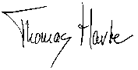 | Date  March 10, 2007
Jeffrey Jacobsen  Administrative Advisor, W-1188 |  | Date

Revil, A., and Cathles, L. M. 1999. Permeability of shaly sands. Water Resources Research. 35:651-662.
Gebrehawariat, K. 2005. Saturated permeability and volume change behavior of Na-bentonite - sand mixtures, Masters Thesis, University of Idaho

